**Chapter – 1**

**Introduction & Methodology**

**1.1 Introduction of the Company**

Bata Bangladesh is affiliated to the Bata Shoe Organization, the world's largest footwear manufacturing and marketing organization. BATA was started its operation in Bangladesh in 1962, Incorporation in Bangladesh in 1972.

Currently, Bata Bangladesh operates 2 manufacturing plant Tongi and Dhamrai, Bata Bangladesh is producing around 110,000 pairs of shoes daily. It has a modern tannery with the latest technological facilities to process 5 million square feet of leather yearly. The Tannery is equipped with a high-tech effluent treatment plant ensuring a pollution free environment for both workers and locality where we operate. Bata Bangladesh sells all kinds of footwear which are classified in alignment with market sectors as follows:

 Domestic market – under the trademarks of “Bata”, “Power”, “Weinbrenner” “Bubble gummers”, “North Star” and “Marie Claire”, through a countywide distribution network comprising  retail stores, DSPs and  independent dealers.

Overseas market – under the trademarks of its customers, and also markets its own brands to sister companies and the Middle East.

**1.2 Objective of the Study**

The Basic objective is to analyze the business strategy of *Bata Shoe Company (Bangladesh) Ltd* based on company’s financial report performance of previous years, as well as do accounting analysis to identify how financial reports are dependent & manipulated by different accounting policies, also evaluating Company’s future performance with the help of prospective analysis.

**1.3 Methodology:**

**1.3.1 Statistical Technique**

We used bar chart and line chart to interpret the processed data.

**1.3.2 Nature of Data**

Data had been used during the preparation of this report, is secondary data.

**1.3.3 Sources of Data**

This report was prepared mainly based on the secondary data available in the market. The secondary data was collected from the internet, newspapers and the company’s annual reports. The report prepared from the analysis of the raw data is of the formal type and the information from the secondary data was used to support the findings of the financial analysis.

**1.3.4 Period under Consideration**

Data for the last five financial years, starting from 2005 up to 2009, had been taken under consideration while preparing this report. We have considered last 5 years data for the company’s statistical and financial trend analysis.

**1.3.5 Nature of Analysis**

We mainly relied on “Cross Sectional Study” to compare between the two rival firms. To monitor the performance of our company of focus over the years with respect to “Ratio Analysis”, “Cash Flow Statement Analysis”, “Balance Sheet and Income Statement Analysis” which helped us identify any specific trends or fluctuations occurred during the periods taken into consideration for analysis.

The ratio had been analyzed with respect to three viewpoints, benchmarking, time series analysis and cross section analysis.

The strategic analysis is done through their industry analysis & positioning, competitive strategy analysis and corporate strategy analysis.

The accounting analysis is done through asset analysis, liability & equity analysis, revenue analysis & expense analysis.

**1.3.6 Standard of Comparison**

We relied on “Cross Sectional Study” as standard for comparison of the performance of “*Bata Shoe Company (Bangladesh) Ltd*” with “Apex adelchi Footwear Limited”. Due to unavailability of data and also difficulty of calculation of the “Industry Averages”, we carried out ratio analysis of both the companies for the last 5 years and compared their performances with respect to all the major ratios. Finally, we came up with our comments regarding relative performances of each company in due course of time.

We took “Apex adelchi Footwear Limited” as the comparison of “*Bata Shoe Company (Bangladesh) Ltd*” because both are the Footwear industry and enjoying healthy financial position with good demand of their shares.

**1.4 Limitation**

Time was a very big constraint during the process of preparation of this report. As the report had been prepared over a time period of only two months, time had to be budgeted and scheduled very calculatedly. There was very little time that can be used as lagging in case something falls behind schedule.

Also the unavailability of all the annual financial reports of the company and market price had been a bottle neck throughout the entire preparation of the report. Another matter of concern was that, the report considers data only from the last five financial years. This may not be sufficient to clearly show the reasons for the deviations in share prices along those years. A report with analysis of the last ten to fifteen year may have been more precise and accurate.

Moreover many companies practice ambiguous accounting practices to get rid of tax that dilute the actual scenario. Also sometimes, these companies try to make their performance much more lucrative to the Shareholders by means of unethical practice which are completely unnoticeable to general public. Such practice if had taken place might have diluted our findings which are based on the information available in the “Annual Reports”.

**Chapter – 2**

**Analysis & Interpretation of Financial Data**

**2.1 Analysis of Balance Sheet**

**Reconstruction of Balance Sheet Based on Book Value & Market Value of Share**

**Year on Focus: 2008-09**

Book Value per Share is the accounting value of a share, equal to common equity divided by the number of shares outstanding.

Market value is current price of the stock. If the profitability, liquidity, asset and debt management is good market value will probably be as high as can be expected.

The market value of BATA was Tk. 148.90 per share at the end of 2005, and was increased to Tk.528.30 at the end of 2009. Initially the book value of the share of the company is Tk. 54.60 per share and at the year 2009 it become 81.91

From the above data, it is evident that the Market value is substantially greater than the book value.

It is not very abnormal for market value to differ with book value of a firm. The reason is, a company is a going concern and when company issues shares to the public, depending on various factors like demand and supply of the firm’s shares, the prices eventually fluctuate. In other words, if a firm is profitable or at least deemed to be profitable, demand for that firm’s share is higher and consequently the share price of that firm’s share is higher. Of course, this can also occur the other way around. Therefore, it is safe to infer that market value of and book value of a company can vary to quite some extent. As a result market value and book value of the company differs in a great extend. Due to this, this change in value can change the value of the shareholder’s equity and not to mention the value of assets, fixed ones in particular. The same principle is obviously also applicable for *Bata Shoe Company (Bangladesh) Ltd* and any other going concern.

There are lots of factors that indicate fundamental difference of market value and book value, like as below:

**1. Undervaluation of Fixed Assets:** Due to undervaluation of fixed asset, there may be a difference in Book value and Market value.

**2. Over Depreciation of Factory Building and Other Fixed Assets:** Due to over depreciation of factory building and other fixed asset, it may happen. Like The depreciation rate for the factory building was calculated at some percentage but in reality the actual depreciation rate was lower than that. The depreciation rate for other fixed assets was also over estimated than in reality. In other words, depreciation is often overestimated and applied accordingly.

**3. Intangible asset:** Due to intangible asset like goodwill, patent or trademark etc, Market value may differ from Book value.

Now at date 31th December 2009 Market price is BDT 528.30 and Book value is BDT 81.91.

Now based on the current book value of the firm, balance sheet of 2009 can be summarized as follows

|  |  |  |  |
| --- | --- | --- | --- |
| **Assets** | | **Liabilities & equity** | |
| Assets | | Equity | |
| Property, plant and equipment | 508,297,292 | Total Equity | 1,120,487,323 |
| Capital work in progress | 13,860,671 | Liabilities |  |
| Investment in subsidiary | 19,970,000 | Total Non Current Liabilities | 131,959,233 |
| Deferred tax assets | 16,000,000 | Total Current Liabilities | 1,470,517,469 |
| Total Non current Assets | 7,648,471,963 | Total Liabilities | 1,602,476,702 |
| Total current Assets | 2,164,836,062 |  | |
| **Total Assets** | **2,772,964,025** | **Total Liabilities and Equity** | **2,772,964,025** |

The new balance sheet will eliminate the difference between the market price and book value per share. Because of the market price of the share, value of total equity will be increased and therefore value of liability & owners equity will be increased. To apply matching principle, value of the asset should get increased since source of fund is overvalued. Here we have added a certain amount to intangible assets which is goodwill.

|  |  |  |  |
| --- | --- | --- | --- |
| **Assets** | | **Liabilities & equity** | |
| Assets | | Equity | |
| **Property, plant and equipment** | **3,508,297,292** | **Total Equity** | **8,210,831,323** |
| **Intangible assets(goodwill)** | **4,090,344,000** | Liabilities | |
| Capital work in progress | 13,860,671 | Total Non Current Liabilities | 131,959,233 |
| Investment in subsidiary | 19,970,000 | Total Current Liabilities | 1,470,517,469 |
| Deferred tax assets | 16,000,000 | Total Liabilities | 1,602,476,702 |
| Total Non current Assets | 7,648,471,963 |  | |
| Total current Assets | 2,164,836,062 |  | |
| **Total Assets** | **9,813,308,025** | **Total Liabilities and Equity** | **9,813,308,025** |

**2.2 Analysis of Cash Flow Statement**

Cash and Equivalent of cash are the most liquid assets for the company. Good management of cash is very important for company and operating activities requires good management of cash. Cash flows are the cash receipts and the cash disbursements of the company that is the inflows and outflows of cash. It is an analysis over a period of time revealing the availability, or lack of cash. More simply put the difference between **cash in vs. cash out**. Since money does not flow in and out at an equal rate, in most businesses, an analysis of cash flow is important, especially of businesses that are cyclical in nature, or subject to external forces.

From the financial statements we can have a look to the cash flow statement of *Bata Shoe Company (Bangladesh) Ltd.* from the years 2005 to 2009. After analyzing that statement we can have an idea of the cash dealings of the company of the years under our study. Here we will make some comments on different components of the cash flow statements for these years sequentially from 2005 to 2009. For this purpose we have divided this analysis into three parts based on different types of activities considered to prepare the cash flow statement. These parts are described below briefly.

**2.2.1 Net Cash Flow from Operating Activities**

Through operating the business the cash comes in is cash inflow from operating activities. The operating activities contain net income, specific current assets and liabilities, depreciation etc. This section shows how much cash came into the company and how much cash went out of the company during the normal course of business.

Figure 2-1: Cash Flow from Operating Activities

**Comments on Operating Activities**

From 2005 to 2007 there was a downward movement in cash inflow from operating activities and the main reason of this decreasing is the world economic recession. But from 2007 to 2009 there was an upward movement in cash inflow and in 2009 BATA got the height cash inflow than comparatively others analyzing years. Increasing cash refers to increasing current assets and liquidity as well as profit also. It indicates that BATA performance in operating activities better than the past 5 years.

**2.2.2 Net Cash Flow from Investing Activities:**

This section shows that how much cash came into (inflow) the company and how much cash went out (outflow) of the company from its investment activities during the time.



Figure 2-2: Cash Flow from Investing Activities

**Comments on investing activities**

The graph shows a downward movement of cash flow from investment activities curve. The investment is height in 2009 than the previous 5 years. This investment is considered as non current assets of BATA so the good news is that the increases in non current assets generate more return which increases profit.

**2.2.3 Net Cash Flow from Financing Activities:**

This section shows that how much cash came into (inflow) the company and how much cash went out (outflow) of the company from its financing activities during the time. This section represents the net cash flow from the financial activity.



Figure 2-3: Cash Flow from Financing Activities

**Comments on financing activities:**

For the first three years from basing year the changes was so inconsistence but for the last three years the trend was somehow stable or predictable within a range. But the last year 2009 cash out flow was higher than among the 5 analyzing years. One good news is that the more debt increases the more Bata Company gets tax advantages which increases EPS for Bata. One Good news is that the company is paying more dividend which decreases their liabilities.

**2.3 Ratio Analysis**

Ratio analysis is the calculation and comparison of ratios which are derived from the information in a company's financial statements. The level and historical trends of these ratios can be used to make inferences about a company's financial condition, its operations and attractiveness as an investment. To evaluate a firm’s financial condition and performance, the financial analyst usually performs analysis on various aspects to find out the financial health of the firm; among which ratio analysis is one of the most important and commonly used methods. In this study various ratio analyses will be done to understand the financial condition of the company and to compare this condition with its rival firm. The financial ratios can be analyzed based on three criteria:

* **Benchmark Analysis:** A benchmark is a point of reference with which the financial ratios of the specific company can be compared. For example, the current ratio of 2:1 is considered to be ideal for a company and it is assumed to be the benchmark.
* **Time Series Analysis:** It involves comparing a present ratio with past and expected future ratios for the company. For instance, the current ratio (the ratio of current assets to current liabilities) for the present year could be compared with the current ratio for the previous years. When financial ratios are arranged over a period of years, the analyst can study the composition of change and determine whether there has been an improvement or deterioration in the firm’s financial condition and performance over time.
* **Cross Section Analysis:** The third method of comparison involves comparing the ratios of one with those of similar firms or with industry averages at the same point in time. Such a comparison gives insight into the relative financial condition and performance of the firm. It also helps us to identify any significant deviation from any applicable industry average.
* In this paper, ratios of *Bata Shoe Company (Bangladesh) Ltd* and Apexadelchi Footwear Ltd are calculated and analyzed based on bench mark, time series and cross sectional analysis.

**2.3.1 Liquidity Ratio**

A liquid asset is one that can be easily converted to cash without significant loss of its original value. Liquidity or Short Term Solvency ratios are used to determine a company's ability to pay off its short-terms debts obligations. The higher the value of the ratios, the larger will be the margin of safety that the company possesses to cover short-term debts. It shows the relationship of a firm’s cash and other current assets to its current liabilities. Different types of liquidity ratios are discussed below.

**Current Ratio:**

Current Ratio is the ratio of current assets to current liabilities. The current ratio indicates the ability of a company to pay its current liabilities from current assets that shows the strength of the company’s working capital position. Current ratio of 2:1 is considered to be a healthy condition for most business organization.

The ratio is calculated as follows:

**Current Ratio = Current Assets / Current Liabilities**

The following table shows the current ratio data of the 2 companies-

|  |  |  |  |  |  |
| --- | --- | --- | --- | --- | --- |
| **Company** | **2005** | **2006** | **2007** | **2008** | **2009** |
| **Bata** | 1.538 | 1.539 | 1.420 | 1.454 | 1.472 |
| **Apex** |  | 1.009 | 1.016 | 1.031 | 1.071 |

According to Benchmark analysis the current ratio of 2:1 is considered to be ideal for a company. Considering the operating year 2005-2009 the current ratio of BATA has gone down at 2007. This is not necessarily a bad news, the huge investment of working in progress reduces the current asset and the increase of liabilities in this year is liable for this decline of the ratio. Comparing with rival firm APEX, BATA is in far better position in terms of liquidity.

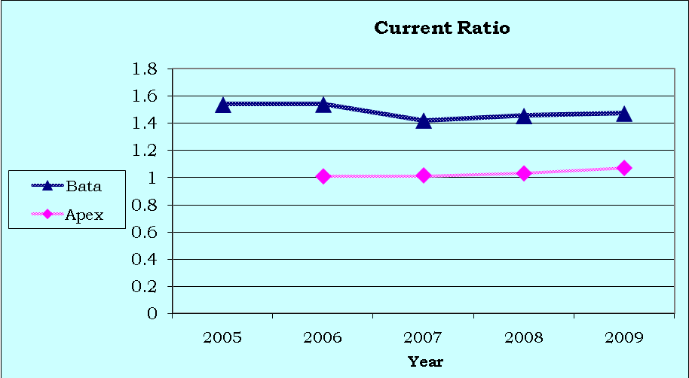

Figure 2-4: Current Ratio of BATA and APEX for the years 2005-2009

**Quick Ratio:**

The Quick ratio or acid-test measures a company's ability to meet its short-term obligations with its most liquid assets. Inventories typically are the least liquid of a firm’s current assets – they are the assets on which require more time to be sold and losses are most likely to occur in the event of liquidation. Therefore, it is important to measure the firm’s ability to pay off short term obligations without having to rely on the sale of inventories. Quick ratio of 1:1 is considered to be a healthy condition for most businesses. It is calculated as follows.

**Quick Ratio= (Current Assets- Inventories)/ Current Liabilities**

The following table shows the quick ratio data of the two companies-

|  |  |  |  |  |  |
| --- | --- | --- | --- | --- | --- |
| **Company** | **2005** | **2006** | **2007** | **2008** | **2009** |
| **Bata** | 0.619 | 0.624 | 0.403 | 0.399 | 0.497 |
| **Apex** |  | 0.503 | 0.581 | 0.591 | 0.583 |

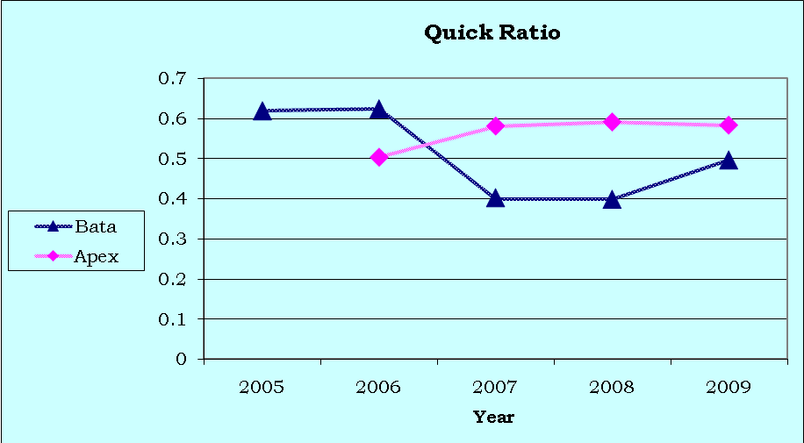Compared to the benchmark of quick ratio 1:1 is ideal for a company. The trend of quick ratio of BATA Shows that the ratio has gown down in 2007 due to the increase of inventories is about 32.65% respect to year of 2006. On the other hand, rival firm APEX is doing better compared to BATA in 2007.Considering the year 2006 to 2008 liabilities increase about 24.35% which indicates huge investment and declining the quick ratio. One more time, this is not a bad news for BATA because company will get benefit in future in this inflationary economy. As a consequence, quick ratio is increasing up to 2009 for BATA but rival firm is playing opposite role (i.e. stable quick ratio). This indicates the good ability of BATA to meet its short-term obligations with its own liquid assets.

Figure 2-5: Quick Ratio of BATA and APEX for the years 2005-2009

**Cash Ratio**

Cash Ratio is the ratio of a company's total cash and cash equivalents to its current liabilities. The cash ratio is most commonly used as a measure of company liquidity. It can determine how quickly the company can repay its short-term debt. It shows cash solvency of the firm. We can find cash ratio in the following way.

**Cash Ratio = Cash/Current Liabilities**

|  |  |  |  |  |  |
| --- | --- | --- | --- | --- | --- |
| **Company** | **2005** | **2006** | **2007** | **2008** | **2009** |
| **Bata** | 32% | 37% | 23% | 19% | 24% |
| **Apex** |  | 6% | 4.5% | 5% | 2% |

From the above table, we can see that normally the cash ratio of BATA is higher compared to APEX, which reflects that BATA has higher cash to meet its current liabilities. Though cash ratio below 30% is considered as “point to make attention” but BATA have significantly better cash ratio compared to his main rival APEX all through the last four years. Point to be noted that BATA started its journey on 1962 where APEX Shoe started its journey on 1990 in Bangladesh.

**2.3.2 Asset Management Ratio**

A set of ratios that measure how effectively a firm manages its assets compared to its sales. These ratios are designed to find out whether the total amount of each type of asset as reported on the balance sheet appear reasonable, too high, or too low considering current and projected sales levels. Asset Management Ratio is done based on inventory turnover ratio, days sales outstanding and fixed asset and total asset turnover ratio.

**Inventory Turnover Ratio**

Inventory Turnover Ratio tells how often a business's inventory turns over during the course of the year. Inventories are the least liquid form of asset and a high inventory turnover ratio is generally positive. On the other hand, an unusually high ratio compared to the average for the industry could mean that the business is losing sales because of inadequate stock on hand. The ratio is calculated as follows:

**Inventory turnover ratio= Cost of goods sold /Inventories**

The following table shows the inventory turnover ratio data of the 2 companies-

|  |  |  |  |  |  |
| --- | --- | --- | --- | --- | --- |
| **Company** | **2005** | **2006** | **2007** | **2008** | **2009** |
| **Bata** | 3.401 | 3.908 | 3.468 | 3.166 | 3.485 |
| **Apex** |  | 3.907 | 4.206 | 4.766 | 4.342 |

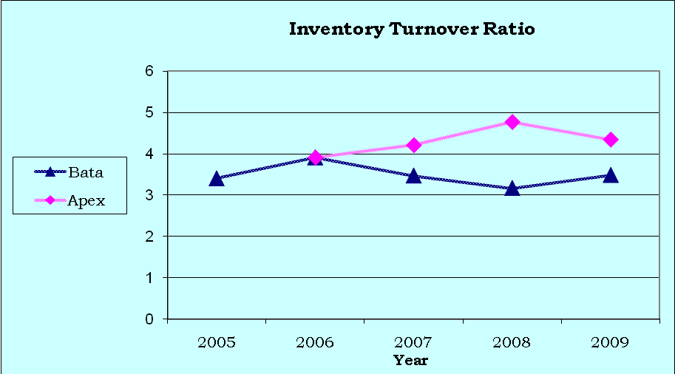The trend line of inventory ratio shows the ups and downs inventory turnover ratio from 2005 to 2009 but in 2009 it remains more or less same as 2005. This is good news but comparing with rival it is not the healthy position. Considering the year 2006 to 2008 the inventories are increased about 47.69%.Due to holding excess inventories the ratio is poor and it’s not bad news because company will get the future benefit. If we consider the year 2009 the trend is coming upward from 2008 and continuing with this the company can achieve their landmark easily.

Figure 2-7: Inventory Turnover Ratio of BATA and APEX for the years 2005-2009

**Days Sales Outstanding**

DSO is called the average collection period, is used to evaluate the firm’s ability to collect its credit sales in a timely manner. It is calculated by dividing accounts receivable by average sales per day which indicates the average length of time it takes the firm to collect its credit sales. DSO is calculated as follows:

**Days Sales Outstanding (DSO) =Receivables/Average sales per day**

**= Receivables/ [Annual sales/360]**

The following table shows the DSO data of the 2 companies-

|  |  |  |  |  |  |
| --- | --- | --- | --- | --- | --- |
| **Company** | **2005** | **2006** | **2007** | **2008** | **2009** |
| **Bata** | 22.322 | 10.8101 | 3.579 | 6.189 | 7.277 |
| **Apex** |  | 65.7004 | 56.453 | 57.891 | 43.807 |

Over the years DSO is decreasing, from 2005 to 2007. There is a little increase in DSO in 2008-2009 but it is not significant. Though the DSO ratio is increasing in 2007-2009, it is negligible. Considering the rival firm among the overall operating year 2005-2009 BATA is doing excellent which reflects better credit policy of the company.

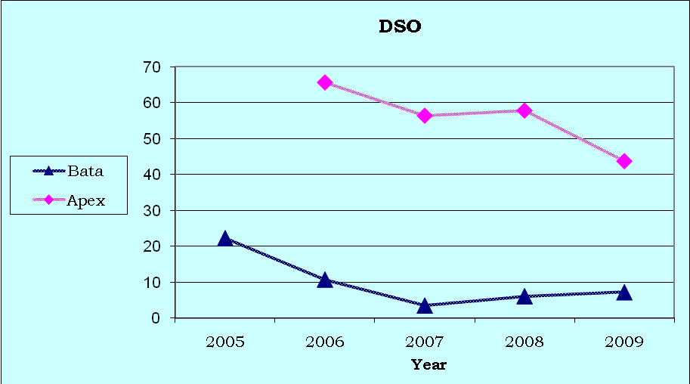

Figure 2-8: Days Sales Outstanding of BATA and APEX for the years 2005-2009

**Fixed Asset Turnover Ratio**

Fixed assets turnover ratio measures how effectively the firm uses its plant and equipment to help generate sales. So, fixed Asset Turnover ratio measures the amount of sales generated for every dollar's worth of fixed assets. The fixed asset turnover ratio is calculated by dividing sale by total fixed assets. It is calculated as follows:

**Fixed Assets Turnover Ratio = Sales/ Net Fixed Assets**

The following table shows the fixed asset turnover ratio data of the 2 companies-

|  |  |  |  |  |  |
| --- | --- | --- | --- | --- | --- |
| **Company** | **2005** | **2006** | **2007** | **2008** | **2009** |
| **Bata** | 8.72 | 11.61 | 15.34 | 16.23 | 21.47 |
| **Apex** |  | 10.812 | 13.53 | 11.77 | 18.615 |

The fixed asset turnover ratio is increasing among the operating year 2005-2009. High trend of fixed asset ratio is responsible for the increase of sales is about 64.12%. So, BATA is maintaining a good steady fixed asset turnover ratio, which is a good news for the company.

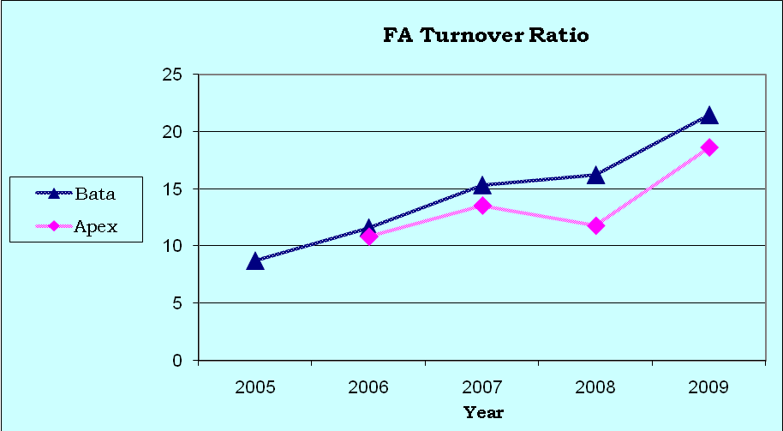

Figure 2-9: Fixed Asset Turnover Ratio of BATA and APEX for the years 2005-2009

**Total Asset Turnover Ratio**

Total Asset Turnover ratio measures the amount of sales generated for every dollar's worth of total assets. The total asset turnover ratio is calculated by dividing sale by total assets. It is calculated as follows:

**Total Assets Turnover Ratio = Sales/ Total Assets**

The following table shows the total asset turnover ratio data of the 2 companies-

|  |  |  |  |  |  |
| --- | --- | --- | --- | --- | --- |
| **Company** | **2005** | **2006** | **2007** | **2008** | **2009** |
| **Bata** | 1.6405 | 1.891 | 1.765 | 1.849 | 1.834 |
| **Apex** |  | 1.658 | 1.589 | 1.733 | 1.953 |

Considering the rival, BATA is maintaining a higher total asset turnover ratio until 2008 but in 2009 rival cross the company. In 2009 total asset turnover ratio decreases although sales increases, is about 8.06 %. Because of, the huge investment in fixed asset like plant, machineries etc significantly increases the total asset. This is also good news for the company, though they have lower total asset turnover ratio. But high investment in fixed asset will return a effective benefit in future.

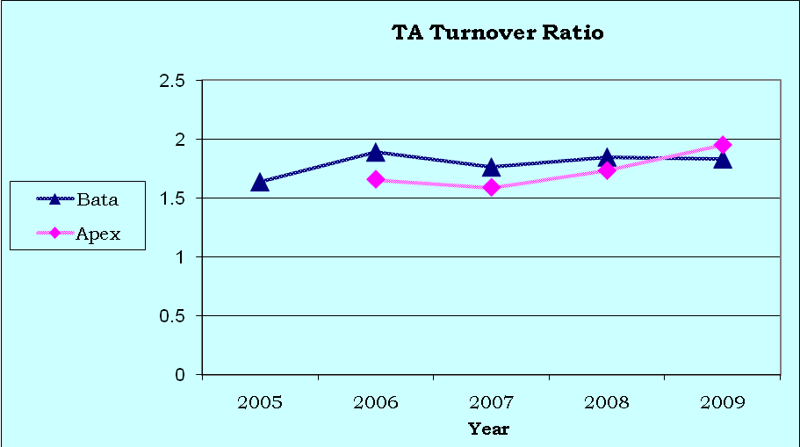

Figure 2-10: Total Asset Turnover Ratio of BATA and APEX for the years 2005-2009

**2.3.3 Debt Management Ratio**

Debt Management ratios help to evaluate a company's long-term solvency measuring the extent to which the company is using long-term debt. This ratio reflects how effectively a firm is managing its debts. It helps the analyst to determine the extent to which borrowed funds have been used to finance assets and review how well operating profits can cover fixed charges such as interest.

**Debt Ratio**

The debt ratio indicates how much of a company's assets are provided through debt or the percentage of the firm’s assets financed by creditors. Total debt includes both current liabilities and long term liabilities. Creditors prefer low debt ratios, because the lower the ratio, the greater the cushion against creditor’s losses in the event of liquidation. The owners on the other hand can benefit from leverage because it magnifies earnings, and thus the return to stockholder. But, too much debt often leads to financial difficulty, which eventually might cause bankruptcy. It is calculated as follows:

**Debt Ratio= Total Debt/ Total Assets**

The following table shows the debt ratio data of the 2 companies-

|  |  |  |  |  |  |
| --- | --- | --- | --- | --- | --- |
| **Company** | **2005** | **2006** | **2007** | **2008** | **2009** |
| **Bata** | 59.99% | 60.00% | 63.47% | 61.10% | 58.80% |
| **Apex** |  | 82.60% | 86.90% | 85.80% | 92.10% |

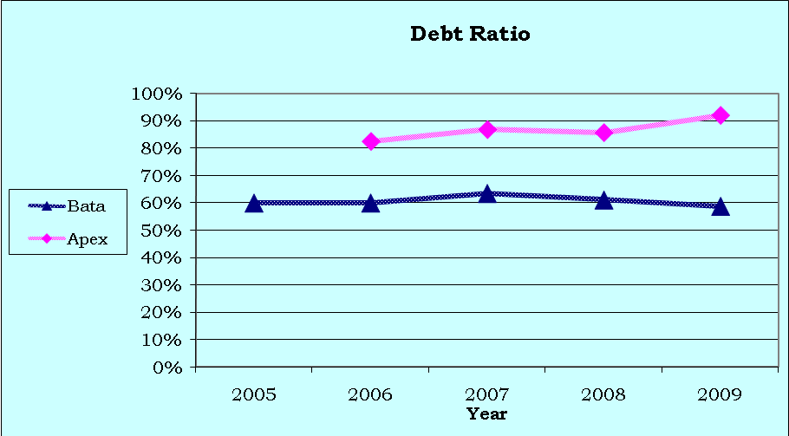 Regarding the operating year 2005-2009 Debt ratio is decreasing for BATA, except the year 2007. More or less it is remaining same .On the other hand the rival is playing opposite role. But declining debt ratio is good news for company because lower the debt ratio, the greater the cushion against creditor’s losses in the event of liquidation. Debt ratio is increasing dramatically for rival rather than the company is remaining the steady growth rate that depicts the healthy financial strength of the company BATA.

Figure 2-11: Debt Ratio of BATA and APEX for the years 2005-2009

**Times Interest Earned (TIE) Ratio**

The TIE ratio measures the extent to which earnings before interest and taxes (EBIT), also called operating income, can decline before the firm is unable to meet its annual interest cost. Failure to meet this obligation can bring legal action by the firm’s creditor, possibly resulting in bankruptcy. The TIE ratio is computed by dividing earnings before interest and taxes (EBIT) by interest charges. It measures the ability of the firm to meet its annual interest payments. The TIE ratio is calculated as follows:

**Time interest earned ratio = EBIT/ Interest charges**

The following table shows the times interest ratio data of the 2 companies-

|  |  |  |  |  |  |
| --- | --- | --- | --- | --- | --- |
| **Company** | **2005** | **2006** | **2007** | **2008** | **2009** |
| **Bata** | 92.35 | 158.37 | 151.71 | 123.87 | 161.62 |
| **Apex** |  | 1.57 | 2.14 | 1.88 | 1.74 |

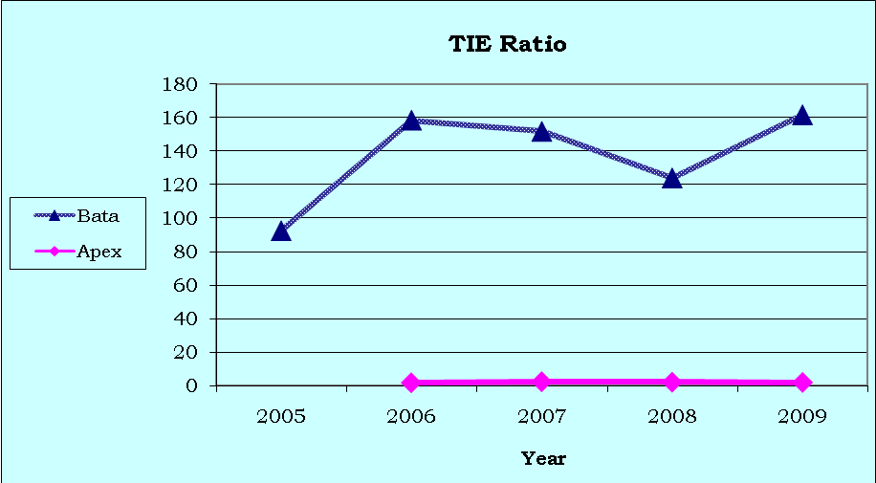Over the years BATA has a strong position in TIE ratio compare to APEX. In 2005 to 2006 there is a sharp growth in TIE ratio of BATA after than the trend is declining until 2008, due to increase the amount of interest i.e. 94.40% considering the year 2006 to 2008. In 2009 it is increased again and so it’s good news for the company. Considering the rival, Bata is doing excellent.

Figure 2-12: TIE Ratio of BATA and APEX for the years 2005-2009

**2.3.4 Profitability Ratio**

A group of ratios that show the combined effect of liquidity, asset management, and debt management on operating results .It is the net result of a number of policies and decisions.

**Profit Margin on Sales**

Profit Margin is the ratio measures net income per dollar of sales and is calculated as net income divided by revenues, or net profits divided by sales. It measures how much out of every dollar of sales a company actually keeps in earnings. Profit margin is very useful when comparing companies in similar industries. A higher profit margin indicates a more profitable company that has better control over its costs compared to its competitors. Profit margin is displayed as a percentage; a 20% profit margin, for example, means the company has a net income of $0.20 for each dollar of sales. It is calculated as follows:

**Profit margin on sales = Net Income/ Sales**

The following table shows the profit margin on sale data of the two companies-

|  |  |  |  |  |  |
| --- | --- | --- | --- | --- | --- |
| **Company** | **2005** | **2006** | **2007** | **2008** | **2009** |
| **Bata** | 6.75% | 7.17% | 7.14% | 9.72% | 9.00% |
| **Apex** |  | 1.70% | 3.81% | 3.37% | 4.31% |

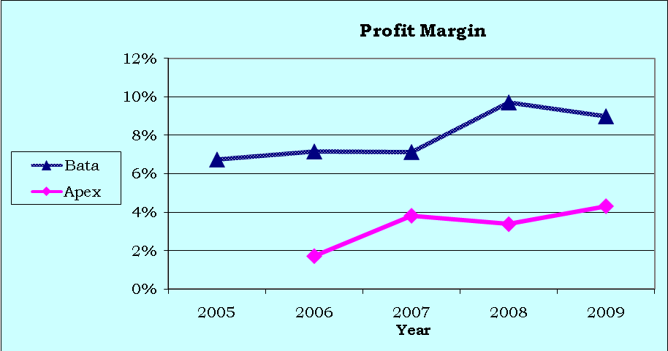Profit margin on sales is increasing over the time period of 2005 to 2007 slowly for BATA and 2008 there is a peak sale. In 2009 there is a little fall but still it is high above from the rival company APEX. This is good news for the company-

Figure 2-13: Profit Margin of BATA and APEX for the years 2005-2009

**Return on Asset (ROA)**

Return on Asset (ROA)isan indicator of a company which deals with profit relative to its total assets. It gives an idea as to how efficient management is at using its assets to generate earnings. It is calculated by dividing a company's annual earnings by its total assets, ROA is displayed as a percentage. Sometimes this is referred to as "return on investment". The ROA after interest and taxes are computed as follows:

**Return on Asset (ROA) = Net Income / Total Assets**

The following table shows the ROA data of the 2 companies-

|  |  |  |  |  |  |
| --- | --- | --- | --- | --- | --- |
| **Company** | **2005** | **2006** | **2007** | **2008** | **2009** |
| **Bata** | 11.09% | 13.53% | 14.43% | 17.98% | 16.50% |
| **Apex** |  | 5.84% | 3.32% | 5.84% | 6.07% |

ROA of BATA is increasing from 2005 to 2008 and it is higher from the comparing company APEX. But in the year 2009 the trend goes down slightly this is not a bad news in a sense that BATA invested huge in fixed asset in between these years which eventually reduce the ROA.

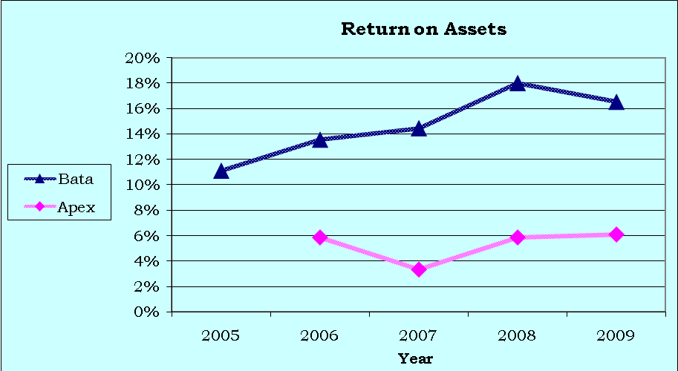

Figure 2-14: ROA of BATA and APEX for the years 2005-2009

**Return on Equity (ROE)**

Return on Equity (ROE) measures the rate of return on common stockholders’ equity. It measures a company's profitability by revealing how much profit a company generates with the money shareholders have invested. The return on equity (ROE) is measured as follows:

**Return on Equity (ROE) = Net income / Total Shareholders’ Equity**

The following table shows the ROE data of the 2 companies-

|  |  |  |  |  |  |
| --- | --- | --- | --- | --- | --- |
| **Company** | **2005** | **2006** | **2007** | **2008** | **2009** |
| **Bata** | 27.66% | 33.83% | 39.49% | 46.23% | 40.10% |
| **Apex** |  | 19.91% | 46.54% | 33.72% | 28.77% |

The ROE of BATA is increasing sharply from the year 2005 to 2008 and slightly goes down in 2009 .On the other hand, considering the rival company APEX is drastically gone down from 2007 to till 2009. The decreasing trend of BATA is responsible for the 15% increase of equity. It indicates that the rate of return on the common stockholders’ investment is rising over the year which is a good indicator for the company in future.

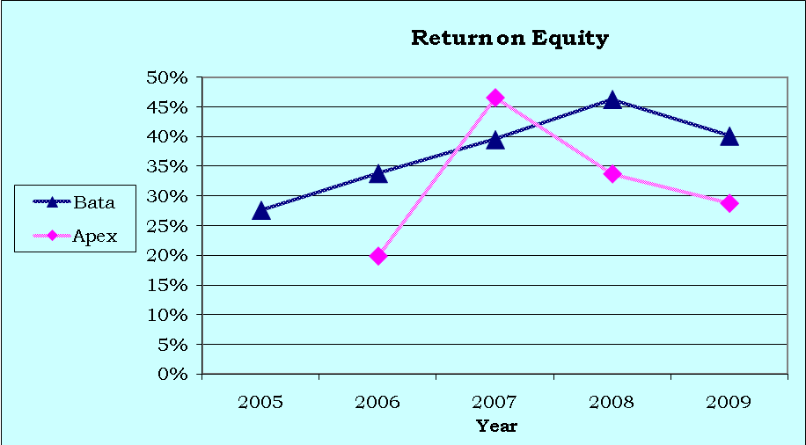

Figure 2-15: ROE of BATA and APEX for the years 2005-2009

**DuPont Analysis**

* ROA is increasing from 2005 to 2008, which implies the higher net income. Also the ROA is in very better position compared to main rival APEX.
* Fixed Asset Turnover Ratio is increased from 2005 to 2009. It may be happen for higher sales or disposal of fixed asset. But from the annual report it was found that the disposed amount of fixed asset is not that much significant affect on these ratios. This implies that they have a clean improvement in sales.
* Profit margin is increased over the years. Point to be noted that 2008 was the year of recession. But in 2008 they have increased their profit margin in huge amount. By analyzing the scenario about what make this thing happen, found that, they have increased their advertisement expense by 37% on that year.
* Regarding the operating year 2005-2009 Debt ratio is decreasing for BATA, except the year 2007. But declining debt ratio is good news for company because lower the debt ratio, the greater the cushion against creditor’s losses in the event of liquidation.

**2.3.5 Market Value Ratio**

This is a set of ratio that relates the firm’s stock price to its earnings and book value per share. These ratios give management an indication of what investors think of the company’s past performance and future prospect. If the firm’s liquidity, asset management, debt management, and profitability ratios are all good then market value ratios will be high which will lead to an increase in the stock price of the company.

**Earnings per Share**

Earnings per Share (EPS)are the portion of a company's profit allocated to each outstanding share of common stock. It serves as an indicator of a company's profitability. It is generally considered to be the single most important variable in determining a share's price. It is also a major component used to calculate the price-to-earnings valuation ratio. It is calculated as follows:

**EPS = Net Income/ Number of Shares Outstanding**

The following table shows the EPS data of the 2 companies-

|  |  |  |  |  |  |
| --- | --- | --- | --- | --- | --- |
| **Company** | **2005** | **2006** | **2007** | **2008** | **2009** |
| **Bata** | 151.10 | 202.5 | 237.5 | 328.5 | 328.5 |
| **Apex** |  | 66.56 | 225.81 | 168.74 | 188.03 |

EPS of BATA has been increasing at healthy rate over the years. This is good news because this will help to attract the investors and thus the company can collect more money from stock market. The EPS of BATA is increased from TK 151.10 to TK 328.50 during 2005 to 2009 which helps to increase the share price. From the year 2008 to 2009 it remains constant due to the huge investment in work in progress it’s also a good news for the company.

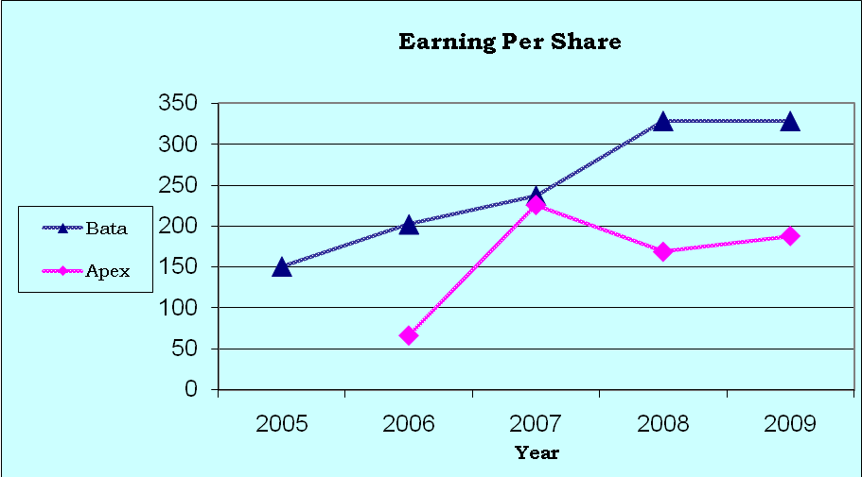

Figure 2-16: EPS of BATA and APEX for the years 2005-2009

**Price/Earning (P/E) Ratio**

This is the ratio of the price per share to earnings per share. It shows how much investors are willing to pay per dollar of reported profit. It is calculated as follows:

**P/E Ratio = Market Price per Share/ Earnings per Share**

The following table shows the P/E ratio data of the 2 companies-

|  |  |  |  |  |  |
| --- | --- | --- | --- | --- | --- |
| **Company** | **2005** | **2006** | **2007** | **2008** | **2009** |
| **Bata** | 9.85 | 5.995 | 9.414 | 9.76 | 16.08 |
| **Apex** |  | 6.989 | 9.614 | 14.134 | 13.737 |

Considering the year 2005 to 2006 the P/E ratio decreases and after than 2006 to 2009 it is transparent that BATA has a healthy growth in P/E ratio. In 2009 comparing to APEX (P/E ratio is 13.737) BATA is continuing with higher ratio. This indicates the demand and trust for this share is increasing respect to the investors. The investors willing to pay 16.08 taka for earning 1 taka profit from the company.

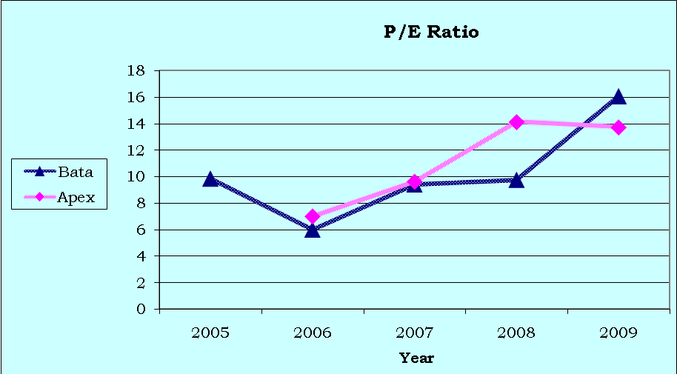

Figure 2-17: P/E Ratio of BATA and APEX for the years 2005-2009

**Book Value per Share**

Common stockholders' equity is determined on a per-share basis. Book value per share is calculated by subtracting liabilities and the par value of any outstanding preferred stock from assets and dividing the remainder by the number of outstanding shares of stock. It is calculated as follows:

**Book Value per Share=Equity/Number of Shares Outstanding**

The following table shows the Book value per share data of the 2 companies-

|  |  |  |  |  |  |
| --- | --- | --- | --- | --- | --- |
| **Company** | **2005** | **2006** | **2007** | **2008** | **2009** |
| **Bata** | 54.6 | 59.85 | 60.13 | 71.06 | 81.91 |
| **Apex** |  | 33.43 | 48.51 | 50.39 | 65.34 |

The book value per share is increasing over the year 2005 to 2009. On the other hand, rival is maintaining lower Book Value Per Share. But increasing trend of BATA in book value per share is a good indicator for the company. So, the level of equity is rising over the year which makes good sense for BATA.

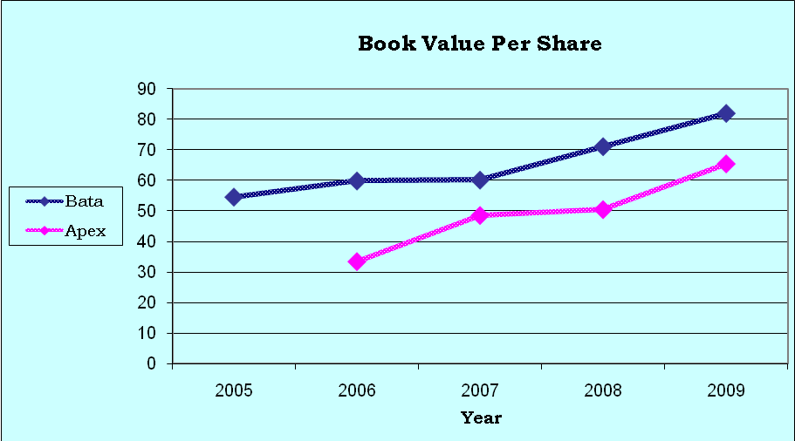

Figure 2-18: Book Value per Share of BATA and APEX for the years 2005-2009

**4.5.4**

**Market/Book (M/B) Ratio**

The ratio of a stock’s market price to its book value gives another suggestion of how investors regard the company. Companies with relatively high rates of return on equity generally sell at higher multiples of book value than those with low returns. The formula for Market/Book Value is given below:

**Market /Book Ratio = Market Price per Share / Book Value per Share**

The following table shows the M/B ratio data of the two companies-

|  |  |  |  |  |  |
| --- | --- | --- | --- | --- | --- |
| **Company** | **2005** | **2006** | **2007** | **2008** | **2009** |
| **Bata** | 2.72 | 2.02 | 3.72 | 4.52 | 6.45 |
| **Apex** |  | 1.39 | 4.47 | 4.77 | 3.96 |

The cross section analysis indicates that the market/book ratio of BATA is much higher than APEX. The market value per share of APEX is not increasing at faster rate compared to the book value per share. Due to these, investors are willing to pay more for the book value of BATA than that of the rival company which implies that trust of investors is going up over the years 2005 to 2009 and the investors are very much confident about the prospect of BATA.

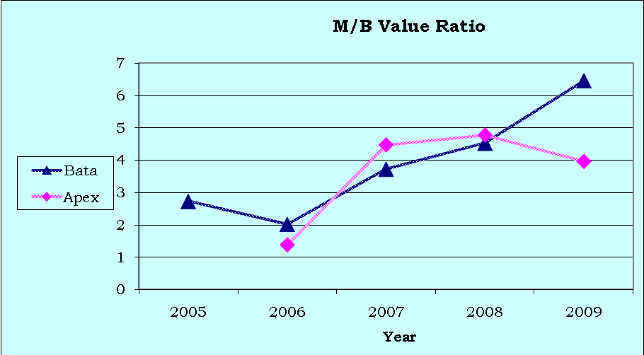

Figure 2-19: M/B ratio of BATA and APEX for the years 2006-2009

**Chapter – 3**

**Strategic Analysis**

**3.1 Industry Analysis**

**Footwear Industry of Bangladesh**

The foot wear industry in Bangladesh is in growth stage now. The industry mainly composed by BATA, APEX, some local brand and imported footwear from abroad; mainly china. The majority of consumers of mid-level income are mainly looking for BATA & Apex. Currently a new brand named “FORTUNA” enters in to the market. Fortuna previously 100% exported their footwear. Now they are entering in to the local market. In near future in KEPZ a big KOREAN shoe manufacturer will be going launch their journey in Bangladesh. Scenario may be different than. They have freedom to choose pricing structure as there are no specific obligations regarding this issue.

Conceptual framework for industry analysis has been provided by Porter. He developed a five-factor model for industry analysis, as shown in the exhibit. The model identifies five key structural features that determine the strength of the competitive forces within an industry and hence industry profitability. Analysis of shoe Industry of Bangladesh in respect to Bata shoes with Porters Model of Industry Competition has been summarized as followed.

**Rivalry among existing firms**

Though Bata has enjoying quite a good market share and know the market for long the market competition is intensifying day by day. In the decade the only worry for Bata was independent sellers who have the minimal establishment costs and in many cases sale shoes of high quality of minimal cost or poor quality shoes. But the situation has been changed much since now not only the independent sellers but also the regional and world famous brands are now in Bangladesh. So the competition has now much more intense. Bata Bangladesh has to think both of their old threats as well as new competitors who has much more organized structure than the old competitors.

**Threat of New Entrant**

Threat of new entrants is high in Bangladesh because Apex is already entered into the market as a domestic shoe industry with high expectation and good management. Apart from that foreign competitors like Liberty of India which already taking a grip into the shoe market especially the women segment. There are also some other foreign shoe manufacturer like Nike, Reebok, Addidas and Woodland. There are also some other domestic companies like Baly, Pagasus, and Homeland etc. Also in newly constructed KEPZ a huge Korean Shoe Manufacturer will going to launch their journey in Bangladesh. So the road ahead for Bata is not smooth at all and to forget the independent sellers and smuggled shoe sellers who already have the highest market share. Bata has to go for variety as well as their durability which they known for long.

**Threat of Substitute Products**

One can’t think of much substitute of shoes. There are not too many bare footed people now days. At least they wear a sandal. So the threat of substitute is not that much.

**Bargaining Power of Suppliers**

The bargaining power of suppliers is relatively moderate. The number of suppliers is huge. And the upcoming and other shoe companies buy in so much quantity that the suppliers have to satisfy them even if by increasing quality and by decreasing price. The threat of forward integration by the suppliers is high as brand identity is not a critical issue in the shoe industry in many cases.

**Bargaining Power of Buyers**

Bargaining power of buyers is increasing day by day as new shoe companies with optimistic future plan and changing trend and quality consciousness in increasing day by day. People want durable shoes as well as modern designs. So to satisfy the customers the companies have to keep up with the trend as well. The entrance of foreign brands like Nike, Reebok doesn’t make the scenario easier. So we say that the competition is just heating up in the shoe industry. No one can take easy even the establish brand like Bata who have more than 35 years of experience in Bangladeshi market. So they must aware of the situation and work and take steps accordingly.

**NEW ENTRANTS**

Nike, Reebok, Woodland

KOREAN Shoe Co. in KEPZ

**MAJOR COMPETITORS**

Apex, Independent sellers,

Reebok, Liberty

Smuggled shoes

Fortuna Shoes

**SUPPLIERS**

Rubber from local source. Leather from local source. Some sole from other subsidiaries of Bata like India and China Bata.

**BUYERS**

Infant, teen, young, old. Lower- middle to upper class

**SUBSTITUTE**

Low quality footwear

Figure 3-1: Five forces of competition for BATA Shoe Company (Bangladesh) Ltd.

**SWOT ANALYSIS of BATA SHOE COMPANY (BANGLADESH)LTD.**

* **Strengths:**
  + Brand Image of the company
  + Quality Product
  + Differentiated line of products
  + Competitive Pricing
  + Strong distribution channel
  + Modern manufacturing facilities
  + Brand loyalty at mass level
    - **Weaknesses:**
* Insufficient promotional activities
* Bata at present conducts all the store management activity manually. This results lots of lengthy paper works, errors & waste of time.
* Inability to catch the present trend in time
  + **Opportunities:**
* Despite political turbulence a segment of our middle-class is coming up with reasonable buying power. Many of them are women who are decision maker so the city store concept of Bata can attract them as whole of the family footwear can be available there.
* Consumer like differentiated products. They like to shop in a store where they serve the whole family.
* More competition results in more campaign for products.
* Business Expansion in Shoe care products
* Utilize outsourcing especially the synergy sources to achieve competitive pricing
* Franchisee opportunity with global brands like Nike, Reebok, Hush Puppy
* Market expansion opportunity in high fashion & value for money footwear market for all categories of shoes through Retail channels
  + **Threat:**
* Political instability affects the supply of raw materials and distribution of finished products.
* Uncontrolled counterfeit of Bata products
* New companies like Apex, Homeland, Pagasus of Bangladesh and the foreign companies like Nike, Reebok, Addidas are already in the market with good quality product. Have to keep up with them respect of quality. Also a KOREAN shoe company is going to start its journey on KEPZ.
* Smuggling of shoes and many stores in the city like the ones in elephant road are the major market leaders. As they don’t have to pay for large amount of money for establishment, production, quality and advertising so they can sell at a much lower price than established brands like Bata.
* Rapid market expansion program by organized competitors like APEX.

**3.2 Competitive Strategy Analysis**

The profitability of a firm is influenced not only by its industry structure but also by the strategic choice it makes in positioning itself in the industry. There are many ways to characterize a firm’s business strategy. There are two generic competitive strategies: 1) Cost Leadership & 2) Product Differentiation; both these strategies can potentially allow a firm to build a sustainable competitive advantage.

BATA have some significant features, these are:

* Little advertisement expenditure due to brand image.
* Low expense for distribution network because of their huge own distribution channel.
* Low input cost due to own tannery (Dhamrai Plant) and A-Z machineries of shoe manufacturing process.
* Little investment in risky research and development.
* Focus on product designs that reduce manufacturing costs.
* Efficient organizational processes.

So it is obvious that BATA following the “Cost Leadership” Strategy. But they have different types of product on footwear. So it is following a mix of cost leadership & product differentiation.

**3.3 Corporate Strategy Analysis**

This refers to the corporate decision whether to concentrate on single line of business or to diversify the business among different lines. It relates to the goal of wealth maximization of share holders. Conflicting views have been observed. The portfolio theory says that diversification is more economic on the part of the investors rather than the firm. Unlike 1970’s recent trend of US companies is to reduce diversity. On the other hand, the global trend of group of companies or multi-business organization still continues with some success.

BATA mainly focus on footwear business. They are not diversifying their business in any other line. Because:

* They have huge history in footwear manufacturing which started in 1894.
* They have Expertise knowledge in leather processes and footwear manufacturing.
* Brand name in Footwear industry.
* Well established distribution channel.

**Chapter – 4**

**Accounting Analysis**

**4.1 Asset Analysis**

**Disposal of Fixed Asset:**

Every year they sell out some portion of their fixed asset. Some firms do this to show higher cash balance in the balance sheet. We analyze the cash ratio of BATA including & excluding the value of this disposed fixed asset to find out any significant change in cash ratio is observed. We analyze the data for 2009 & 2005

In 2009 cash ratio = 23.94%

Without the addition of cash coming from this disposal, cash ratio = 23.6%

In 2005 cash ratio = 32.38%

Without the addition of cash coming from this disposal, cash ratio = 31.99%

So in both case it is observed that the cash ratio is not change significantly. This implies that BATA is not focusing on cash realization for betterment of any ratio to have some financial benefit. They are mainly selling out their obsolete fixed asset as a routine disposal.

**Analysis of Leased Asset:**

We analyzed the financial report of last five years and find out that there is a lease proportion in 2007 & 2008 and it is only for motor-vehicle purpose. In 2009 there is no leased item in the annual report. But from the information given by an insider, we find out that BATA are still continuing with their leased motor-vehicles.

So we try to find out is there any intention to show better ROA by not including those leased portion.

We calculate the revised ROA for 2009 considering the value of leased item of 2008 is included in 2009 asset.

ROA = 16.50%

Revised ROA = 16.46%

This implies that, the ROA is not change significantly if the leased asset is excluded.

So their intention of not showing the leased item is not clear. May be specific transportation department have some issues relating this leased item, which need further investigation.

**4.2 Liability & Equity Analysis**

Firms have two broad classes of financial claims on their assets: liabilities and equity. The key distinction between these claims is the extent to which their payoffs can be specified contractually. The firm’s obligations under liabilities are specified relatively clearly, whereas equity claims tend to be difficult to specify.

The economic differences between liabilities and equity are reflected in their accounting definitions. Liabilities are defined as economic obligations that arise from benefits received in the past, and for which the amount and timing is known with reasonable certainty. Liabilities include obligations to customers that have paid in advance for products or services; commitments to public and private providers of debt financing; obligations to federal and local governments for taxes; commitments to employees for unpaid wages, pensions, and other retirement benefits; and obligations from court or government fines or environmental cleanup orders.

For accounting purposes, equity financing is defined as the claim on the gap between assets and liabilities. It can therefore be thought of as a residual claim. Equity funds can come from issues of common and preferred stock, from profits that are reinvested, and from any reserves set aside from profits.

The liabilities of BATA are disclosed in note section of every annual report. The analysis of liability is done by each and every item inspection. Here main focus is given to “provident fund” and “pension fund” liability. Because these two liabilities are largely depends on management decision & policies.

Insider information is taken for details understanding of these two liability recording.

Table below represents the liability recorded in pension fund & provident fund over the years 2004-2009

|  |  |  |  |  |  |  |
| --- | --- | --- | --- | --- | --- | --- |
| Years | 2004 | 2005 | 2006 | 2007 | 2008 | 2009 |
| Pension Fund | * | * | 1,007,105 | 1,512,856 | 1,481,437 | 1,323,668 |
| Provident Fund | * | * | 3,444,770 | 3,950,924 | 4,873,490 | 6,626,798 |

* In 2004 & 2005 annual report BATA was not disclosed the pension fund & provident fund liability separately.

**Policy of BATA Shoe Company (Bangladesh) Ltd. for Provident Fund**

Company contributes to provident fund according to the employee’s pay scale & grade of the employee.

An employee is eligible to get the benefit of provident fund when he/she work with BATA at least 3 years. If an employee leaves the job after passing 3 years with BATA than BATA will give the actual provident fund savings. If an employee leaves the job after passing 7 years with BATA than BATA will give the double amount of the savings of provident fund.

Thus the liability recorded for provident fund in three ways; these are:

Service duration : first 3 years – No liability

Service duration : 3 to 7 years – Actual amount of provident fund savings

Service duration : 7 years+ – Double amount of actual provident fund savings

**4.3 Revenue Analysis**

Revenues are economic resources earned during a time period. Firms earn revenues from a variety of different sources. Manufacturers of consumer goods earn revenues from sales of their products to distributors and to consumers.

Revenue recognition occurs when two critical uncertainties are resolved: the product or service has been provided, and cash collection is reasonably likely. Management typically has the best information on these uncertainties.

Bata have some provision of Doubt full Debt in Account Receivables. In 2007 the amount was 21,749,888 TK and in 2008 it was 18,106,773 TK and in 2009 it was 16,467,870 TK.

Now the effect of bad debt on current ratio & ROA is shown in below table:

**Effect on ROA**

|  |  |  |  |
| --- | --- | --- | --- |
|  | 2007 | 2008 | 2009 |
| With provision for doubt full debt | 14.42% | 17.98% | 16.50% |
| Without provision for doubt full debt | 14.28% | 17.96% | 16.40% |

**Effect on Current Ratio**

|  |  |  |  |
| --- | --- | --- | --- |
|  | 2007 | 2008 | 2009 |
| With provision for doubt full debt | 1.42 | 1.45 | 1.47 |
| Without provision for doubt full debt | 1.44 | 1.47 | 1.48 |

**4.4 Expense Analysis**

**Depreciation Technique:**

They are following two different depreciation methods for their two different plants.

Tongi Plant: Reducing Balance Method

Dhamrai Plant: Straight Line Method

But they are not disclosing their asset differently for their two plants.

**Employee Training Program**

From the annual report of 2009 we find out that they trained 555 employees in 2008-2009. Among them some of the employees were trained at international level. They incurred an expense against it. They also have certain benefit out of those employees. But it is difficult to show the benefit in balance sheet whether it is BATA’s asset or employee’s asset.

**Chapter – 5**

**Prospective Analysis**

With the different factors positively contribute to the growth of the stock price of Bata Shoe Company (Bangladesh) ltd, we have analyzed the trend of different variables from the five year financial statement and detected the growth or reduction of every item. After that we have selected few components which show a growing trend and positively contribute to the growth of Stock Price.

|  |  |  |  |  |
| --- | --- | --- | --- | --- |
|  | 2006-2007 | 2007-2008 | 2008-2009 | Avg. Growth rate(for 3years) |
| Sales Revenue | 17.75% | 1.61% | 8.04% | 9.13% |
| Net Income | 17.26% | 38.34% | -0.002% | 18.53% |

The sustainable growth rate of sales for 2009 is calculated as gs = 15.27%, using following equation:



Where,

T =Ratio of total assets to sales

p *=*Net profit margin on sales

d *=*dividend payout ratio

D = Total Debt

E = Equity

Another growth to be considered is the growth rate of Bangladesh GDP. It is as follow:

|  |  |  |  |  |  |
| --- | --- | --- | --- | --- | --- |
| Year | 2005 | 2006 | 2007 | 2008 | 2009 |
| GDP growth rate (%) | 4.9 | 6.4 | 6.6 | 6.3 | 4.9 |

In the long run it will be sustain as 4% we can assume. So another scenario analysis is done by using 4% growth rate.

**Growth Rate: Scenario-1**

Scenario-1, is assuming the growth rate of 9.13% as average growth of last 3years sales.

Assuming 9.13% growth rate, it has been found that the company has excess fund, which can be financed distributed to payoff long term debt and reduce the obligations of interest expenses. The projection says that assuming 9.13% growth rate, after 5 years in 2014 EPS of the company would be 50.85 as well as considering constant P/E ratio as constant factor, in year 2014 share price would be BDT 817.71.

The total scenario is illustrated on the next page.

**Growth Rate: Scenario-2**

Scenario-2, is assuming the growth rate of 18.53% as average growth of last 3years net income.

Assuming 18.53% growth rate, it has been found that the company required additional fund to run to sustain the business in these growth rate. The projection says that assuming 18.53% growth rate, after 5 years in 2014 EPS of the company would be 76.86 as well as considering constant P/E ratio as constant factor, in year 2014 share price would be BDT 1236.01.

The total scenario is illustrated on the next page.

**Growth Rate: Scenario-3**

Scenario-3, is assuming the growth rate of 15.27% as sustainable growth rate.

Assuming 15.27% growth rate, it has been found that the company has some excess fund, which can be financed distributed to payoff long term debt and reduce the obligations of interest expenses. The projection says that assuming 15.27% growth rate, after 5 years in 2014 EPS of the company would be 66.85 as well as considering constant P/E ratio as constant factor, in year 2014 share price would be BDT 1075.13.

The total scenario is illustrated on the next page.

**Growth Rate: Scenario-4**

Scenario-4, is assuming the growth rate of 4% as long-term avg. GDP growth rate.

Assuming 4% growth rate, it has been found that the company has huge excess fund, which can be financed distributed to payoff long term debt and reduce the obligations of interest expenses. The projection says that assuming 4% growth rate, after 5 years in 2014 EPS of the company would be 39.97 as well as considering constant P/E ratio as constant factor, in year 2014 share price would be BDT 642.76.

The total scenario is illustrated on the next page.

**Future Market Price Projection in Different Growth Rate**

|  |  |  |  |  |  |  |
| --- | --- | --- | --- | --- | --- | --- |
| Year | 2009 | 2010 | 2011 | 2012 | 2013 | 2014 |
| Avg Sales growth (9.13%) | 528.3 | 573.53 | 629.17 | 686.61 | 749.3 | 817.71 |
| Avg Net Income growth (18.53%) | 528.3 | 626.19 | 742.23 | 879.76 | 1042.78 | 1236.01 |
| Sustainable growth (15.27%) | 528.3 | 608.97 | 701.96 | 809.155 | 932.71 | 1075.13 |
| GDP growth (4%) | 528.3 | 549.43 | 571.41 | 594.27 | 618.04 | 642.76 |

Figure 5-1: Projection of Future Share Price at Different Growth Rate

## Which growth rate assumption is more appropriate?

Bangladesh current GDP growth rate is 4.9% (year 2009), and considering longer period average GDP growth rate it comes down to around 4%. As an assumption of 4% growth for next 5 years would be most appropriate. Considering recent world wide recession economic condition & concern of saving world environment, it would be very optimistic to assume higher growth rate for future for a footwear company.

## Plug Variables

The pro forma statements from the above section indicate the firm will have excess fund if it will grow at all options as all growth rates are lower than the sustainable growth rate of 15.27%. The company can decrease its debts by the extra fund, thus will decrease the debt equity ratio. As the company decided to maintain a constant retention rate, it ends up with extra fund at the end of the year. In the current recession of economy, it will be risky to do any new investment. So, the company can pay off its debt which will give an encouraging signal to the shareholders. The table below lists the change is capital structure of the company.

The assumptions are made in preparing the pro forma income statement and balance sheet & projecting future share price.

* Initially all assets, including fixed assets, accounts payable vary directly with sales.
* Long term debt and common stock won’t vary with sales as management decision is to keep a constant long term debt and common stock.
* As the company decided to maintain a constant retention rate, the company will pay dividend every year at the same rate.

**Scenario Analysis**

In this case study, the growth rate of 4% has been selected as the constant growth rate and the pro forma statement has been generated based on this growth rate. For scenario analysis, both optimistic and pessimistic scenarios are being considered.

We have taken the 4% growth rate in normal situation. If we want to be optimistic enough to predict that the economy will have a high growth and the company will also able to grow at 6% to 8%. On the other hand, the situation can also be worse enough to have a growth lower than the normal and the company may face a growth of 2% or even -0%. After analyzing the scenario of different situation we can say that the projected growth rate is appropriate for the company which will help the company to operate in the market even if the situation is worse. It gives a positive indication towards the company and increases the shareholders confidence to invest in the company’s share.

The optimistic & pessimistic scenario is illustrated on the next page.

**Chapter – 6**

**Findings & Conclusion**

BATA Shoe Company (Bangladesh) Ltd. is in this business since 1962. Current market price/share of BATA is BDT 528.3; on the other hand company’s book value is only BDT 81.91, which means market price is more than 6.45 times higher than the book value; and it tells as there is some positive information in company’s financial performance which leads the M-B Value 6.45. Based on market price if we re-construct the balance sheet, we are have to introduce ‘Goodwill’ as intangible asset, for BATA the value of goodwill comes BDT 40.90 Billion, this goodwill basically shows the confidence of the shareholders & investors on BATA backed by some positive news.

Time series & Cross functional analysis also provide some good information. Over the years DSO is decreasing. BATA is doing excellent which reflects better credit policy of the company. Regarding the operating year 2005-2009 Debt ratio is decreasing for BATA, except the year 2007. More or less it is remaining same .On the other hand the rival is playing opposite role. But declining debt ratio is good news for company because lower the debt ratio, the greater the cushion against creditor’s losses in the event of liquidation. TIE ratio is much better than the industry rival APEX. Because Apex has huge loan and they have to pay huge interest on that loan. On the other hand BATA has a minimal loan obligation which results in a lower interest rate and better TIE ratio. This significantly increases the market reputation of BATA.

Profit Margin of BATA has a highly increasing trend as well as significantly better than competitor. It is happening due to both increase in sales revenue as well as well maintained lower selling & distribution expense. As BATA has better profit margin, asset management ratio & debt ratio, obviously Return on Asset (ROA) & Return on Equity (ROE) would be better in both time series & cross section analysis.

Based on strategic analysis of footwear industry, there is a scope of product differentiation and also cost leadership. So with the objective of maximizing profit BATA has gone for cost control approach. In the Financial analysis we found that BATA is having higher amount of sales with the tight administrative expense, having cost control on distribution & transportation expense the company is achieving higher net income. With the strategy of increasing efficiency level of distribution channel the company can achieve the higher profit margin.

In projecting 4% growth rate, it has been found that the company has huge excess fund, which can be financed distributed to payoff long term debt and reduce the obligations of interest expenses. The projection says that assuming 4% growth rate, after 5 years in 2014 EPS of the company would be 39.97 as well as considering constant P/E ratio as constant factor, in year 2014 share price would be BDT 642.76.

## Initially we assumed many growth variables, but the growth rate assumption is more appropriate; considering current world wide economic condition, Bangladesh’s long term average GDP growth rate of 4% as an assumption would be most appropriate, as it would be very optimistic to assume higher growth rate. As well as, considering the increasing concern of saving world environment, it would be very optimistic to assume higher growth rate for future for a footwear company.

**R**eferences

* Annual Reports (2005-2009) of Bata Shoe Company (Bangladesh) Ltd.
* Annual Reports (2005-2009) of Apex adelchi Footwear Limited.
* Fundamentals of Financial Management by *James. C. Van Horne, John M. Wachowicz, Jr*
* Business Analysis & Valuation Using Financial Statements by *Palepu, Healy, Bernard*