**Chapter – 1**

**Introduction & Methodology**

**1.1 Introduction of the Company**

Bata Bangladesh is affiliated to the Bata Shoe Organization, the world's largest footwear manufacturing and marketing organization. BATA was started its operation in Bangladesh in 1962, Incorporation in Bangladesh in 1972.

Currently, Bata Bangladesh operates 2 manufacturing plant Tongi and Dhamrai, Bata Bangladesh is producing around 110,000 pairs of shoes daily. It has a modern tannery with the latest technological facilities to process 5 million square feet of leather yearly. The Tannery is equipped with a high-tech effluent treatment plant ensuring a pollution free environment for both workers and locality where we operate. Bata Bangladesh sells all kinds of footwear which are classified in alignment with market sectors as follows:

 Domestic market – under the trademarks of “Bata”, “Power”, “Weinbrenner” “Bubble gummers”, “North Star” and “Marie Claire”, through a countywide distribution network comprising  retail stores, DSPs and  independent dealers.

Overseas market – under the trademarks of its customers, and also markets its own brands to sister companies and the Middle East.

**1.2 Objective of the Study**

The Basic objective is to analyze and monitor the sensitiveness of the stock price of the Bata Bangladesh Ltd through financial analysis based on company’s financial report performance of previous years. As well as Regression analysis should be used to judge the stock price movements of the company and also evaluating Company’s future performance with the help of prospective analysis.

**1.3 Methodology:**

**1.3.1 Statistical Technique**

We used bar chart and line chart to interpret the processed data. Regression analysis is done through Microsoft Excel.

**1.3.2 Nature of Data**

Data had been used during the preparation of this report, is secondary data.

**1.3.3 Sources of Data**

This report was prepared mainly based on the secondary data available in the market. The secondary data was collected from the internet, newspapers and the company’s annual reports. The report prepared from the analysis of the raw data is of the formal type and the information from the secondary data was used to support the findings of the financial analysis.

**1.3.4 Period under Consideration**

Data for the last five financial years, starting from 2005 up to 2009, had been taken under consideration while preparing this report. We have considered last 5 years data for the company’s statistical and financial trend analysis.

**1.3.5 Nature of Analysis**

We mainly relied on “Cross Sectional Study” to compare between the two rival firms. To monitor the performance of our company of focus over the years with respect to “Ratio Analysis”, “Cash Flow Statement Analysis”, “Balance Sheet and Income Statement Analysis” which helped us identify any specific trends or fluctuations occurred during the periods taken into consideration for analysis.

The ratio had been analyzed with respect to three viewpoints, benchmarking, time series analysis and cross section analysis.

The regression analysis is done through using market price of share with dummy variable.

The capital investment decision is done for the investment of US $ 1.5 million in 2010 and the NPV of the project is calculated for different scenario.

**1.3.6 Standard of Comparison**

We relied on “Cross Sectional Study” as standard for comparison of the performance of “*Bata Shoe Company (Bangladesh) Ltd*” with “Apex adelchi Footwear Limited”. Due to unavailability of data and also difficulty of calculation of the “Industry Averages”, we carried out ratio analysis of both the companies for the last 5 years and compared their performances with respect to all the major ratios. Finally, we came up with our comments regarding relative performances of each company in due course of time.

We took “Apex adelchi Footwear Limited” as the comparison of “*Bata Shoe Company (Bangladesh) Ltd*” because both are the Footwear industry and enjoying healthy financial position with good demand of their shares.

**1.4 Limitation**

Time was a very big constraint during the process of preparation of this report. As the report had been prepared over a time period of only two months, time had to be budgeted and scheduled very calculatedly. There was very little time that can be used as lagging in case something falls behind schedule.

Also the unavailability of all the annual financial reports of the company and market price had been a bottle neck throughout the entire preparation of the report. Another matter of concern was that, the report considers data only from the last five financial years. This may not be sufficient to clearly show the reasons for the deviations in share prices along those years. A report with analysis of the last ten to fifteen year may have been more precise and accurate.

**Chapter – 2**

**Analysis & Interpretation of Financial Data**

**2.1 Analysis of Balance Sheet**

**Reconstruction of Balance Sheet Based on Book Value & Market Value of Share**

**Year on Focus: 2008-09**

Book Value per Share is the accounting value of a share, equal to common equity divided by the number of shares outstanding.

Market value is current price of the stock. If the profitability, liquidity, asset and debt management is good market value will probably be as high as can be expected.

The market value of BATA was Tk. 148.90 per share at the end of 2005, and was increased to Tk.528.30 at the end of 2009. Initially the book value of the share of the company is Tk. 54.60 per share and at the year 2009 it become 81.91

From the above data, it is evident that the Market value is substantially greater than the book value.

It is not very abnormal for market value to differ with book value of a firm. The reason is, a company is a going concern and when company issues shares to the public, depending on various factors like demand and supply of the firm’s shares, the prices eventually fluctuate. In other words, if a firm is profitable or at least deemed to be profitable, demand for that firm’s share is higher and consequently the share price of that firm’s share is higher. Of course, this can also occur the other way around. Therefore, it is safe to infer that market value of and book value of a company can vary to quite some extent. As a result market value and book value of the company differs in a great extend. Due to this, this change in value can change the value of the shareholder’s equity and not to mention the value of assets, fixed ones in particular. The same principle is obviously also applicable for *Bata Shoe Company (Bangladesh) Ltd* and any other going concern.

There are lots of factors that indicate fundamental difference of market value and book value, like as below:

**1. Undervaluation of Fixed Assets:** Due to undervaluation of fixed asset, there may be a difference in Book value and Market value.

**2. Over Depreciation of Factory Building and Other Fixed Assets:** Due to over depreciation of factory building and other fixed asset, it may happen. Like The depreciation rate for the factory building was calculated at some percentage but in reality the actual depreciation rate was lower than that. The depreciation rate for other fixed assets was also over estimated than in reality. In other words, depreciation is often overestimated and applied accordingly.

**3. Intangible asset:** Due to intangible asset like goodwill, patent or trademark etc, Market value may differ from Book value.

Now at date 31th December 2009 Market price is BDT 528.30 and Book value is BDT 81.91.

Now based on the current book value of the firm, balance sheet of 2009 can be summarized as follows

|  |  |  |  |
| --- | --- | --- | --- |
| **Assets** | | **Liabilities & equity** | |
| Assets | | Equity | |
| Property, plant and equipment | 508,297,292 | Total Equity | 1,120,487,323 |
| Capital work in progress | 13,860,671 | Liabilities |  |
| Investment in subsidiary | 19,970,000 | Total Non Current Liabilities | 131,959,233 |
| Deferred tax assets | 16,000,000 | Total Current Liabilities | 1,470,517,469 |
| Total Non current Assets | 7,648,471,963 | Total Liabilities | 1,602,476,702 |
| Total current Assets | 2,164,836,062 |  | |
| **Total Assets** | **2,772,964,025** | **Total Liabilities and Equity** | **2,772,964,025** |

The new balance sheet will eliminate the difference between the market price and book value per share. Because of the market price of the share, value of total equity will be increased and therefore value of liability & owners equity will be increased. To apply matching principle, value of the asset should get increased since source of fund is overvalued. Here we have added a certain amount to intangible assets which is goodwill.

|  |  |  |  |
| --- | --- | --- | --- |
| **Assets** | | **Liabilities & equity** | |
| Assets | | Equity | |
| **Property, plant and equipment** | **3,508,297,292** | **Total Equity** | **8,210,831,323** |
| **Intangible assets(goodwill)** | **4,090,344,000** | Liabilities | |
| Capital work in progress | 13,860,671 | Total Non Current Liabilities | 131,959,233 |
| Investment in subsidiary | 19,970,000 | Total Current Liabilities | 1,470,517,469 |
| Deferred tax assets | 16,000,000 | Total Liabilities | 1,602,476,702 |
| Total Non current Assets | 7,648,471,963 |  | |
| Total current Assets | 2,164,836,062 |  | |
| **Total Assets** | **9,813,308,025** | **Total Liabilities and Equity** | **9,813,308,025** |

**2.2 Analysis of Cash Flow Statement**

Cash and Equivalent of cash are the most liquid assets for the company. Good management of cash is very important for company and operating activities requires good management of cash. Cash flows are the cash receipts and the cash disbursements of the company that is the inflows and outflows of cash. It is an analysis over a period of time revealing the availability, or lack of cash. More simply put the difference between **cash in vs. cash out**. Since money does not flow in and out at an equal rate, in most businesses, an analysis of cash flow is important, especially of businesses that are cyclical in nature, or subject to external forces.

From the financial statements we can have a look to the cash flow statement of *Bata Shoe Company (Bangladesh) Ltd.* from the years 2005 to 2009. After analyzing that statement we can have an idea of the cash dealings of the company of the years under our study. Here we will make some comments on different components of the cash flow statements for these years sequentially from 2005 to 2009. For this purpose we have divided this analysis into three parts based on different types of activities considered to prepare the cash flow statement. These parts are described below briefly.

**2.2.1 Net Cash Flow from Operating Activities**

Through operating the business the cash comes in is cash inflow from operating activities. The operating activities contain net income, specific current assets and liabilities, depreciation etc. This section shows how much cash came into the company and how much cash went out of the company during the normal course of business.

Figure 2-1: Cash Flow from Operating Activities

**Comments on Operating Activities**

From 2005 to 2007 there was a downward movement in cash inflow from operating activities and the main reason of this decreasing is the world economic recession. But from 2007 to 2009 there was an upward movement in cash inflow and in 2009 BATA got the height cash inflow than comparatively others analyzing years. Increasing cash refers to increasing current assets and liquidity as well as profit also. It indicates that BATA performance in operating activities better than the past 5 years.

**2.2.2 Net Cash Flow from Investing Activities:**

This section shows that how much cash came into (inflow) the company and how much cash went out (outflow) of the company from its investment activities during the time.



Figure 2-2: Cash Flow from Investing Activities

**Comments on investing activities**

The graph shows a downward movement of cash flow from investment activities curve. The investment is height in 2009 than the previous 5 years. This investment is considered as non current assets of BATA so the good news is that the increases in non current assets generate more return which increases profit.

**2.2.3 Net Cash Flow from Financing Activities:**

This section shows that how much cash came into (inflow) the company and how much cash went out (outflow) of the company from its financing activities during the time. This section represents the net cash flow from the financial activity.



Figure 2-3: Cash Flow from Financing Activities

**Comments on financing activities:**

For the first three years from basing year the changes was so inconsistence but for the last three years the trend was somehow stable or predictable within a range. But the last year 2009 cash out flow was higher than among the 5 analyzing years. One good news is that the more debt increases the more Bata Company gets tax advantages which increases EPS for Bata. One Good news is that the company is paying more dividend which decreases their liabilities.

**2.3 Ratio Analysis**

Ratio analysis is the calculation and comparison of ratios which are derived from the information in a company's financial statements. The level and historical trends of these ratios can be used to make inferences about a company's financial condition, its operations and attractiveness as an investment. To evaluate a firm’s financial condition and performance, the financial analyst usually performs analysis on various aspects to find out the financial health of the firm; among which ratio analysis is one of the most important and commonly used methods. In this study various ratio analyses will be done to understand the financial condition of the company and to compare this condition with its rival firm. The financial ratios can be analyzed based on three criteria:

* **Benchmark Analysis:** A benchmark is a point of reference with which the financial ratios of the specific company can be compared. For example, the current ratio of 2:1 is considered to be ideal for a company and it is assumed to be the benchmark.
* **Time Series Analysis:** It involves comparing a present ratio with past and expected future ratios for the company. For instance, the current ratio (the ratio of current assets to current liabilities) for the present year could be compared with the current ratio for the previous years. When financial ratios are arranged over a period of years, the analyst can study the composition of change and determine whether there has been an improvement or deterioration in the firm’s financial condition and performance over time.
* **Cross Section Analysis:** The third method of comparison involves comparing the ratios of one with those of similar firms or with industry averages at the same point in time. Such a comparison gives insight into the relative financial condition and performance of the firm. It also helps us to identify any significant deviation from any applicable industry average.
* In this paper, ratios of *Bata Shoe Company (Bangladesh) Ltd* and Apexadelchi Footwear Ltd are calculated and analyzed based on bench mark, time series and cross sectional analysis.

**2.3.1 Liquidity Ratio**

A liquid asset is one that can be easily converted to cash without significant loss of its original value. Liquidity or Short Term Solvency ratios are used to determine a company's ability to pay off its short-terms debts obligations. The higher the value of the ratios, the larger will be the margin of safety that the company possesses to cover short-term debts. It shows the relationship of a firm’s cash and other current assets to its current liabilities. Different types of liquidity ratios are discussed below.

**Current Ratio:**

Current Ratio is the ratio of current assets to current liabilities. The current ratio indicates the ability of a company to pay its current liabilities from current assets that shows the strength of the company’s working capital position. Current ratio of 2:1 is considered to be a healthy condition for most business organization.

The ratio is calculated as follows:

**Current Ratio = Current Assets / Current Liabilities**

The following table shows the current ratio data of the 2 companies-

|  |  |  |  |  |  |
| --- | --- | --- | --- | --- | --- |
| **Company** | **2005** | **2006** | **2007** | **2008** | **2009** |
| **Bata** | 1.538 | 1.539 | 1.420 | 1.454 | 1.472 |
| **Apex** |  | 1.009 | 1.016 | 1.031 | 1.071 |

According to Benchmark analysis the current ratio of 2:1 is considered to be ideal for a company. Considering the operating year 2005-2009 the current ratio of BATA has gone down at 2007. This is not necessarily a bad news, the huge investment of working in progress reduces the current asset and the increase of liabilities in this year is liable for this decline of the ratio. Comparing with rival firm APEX, BATA is in far better position in terms of liquidity.

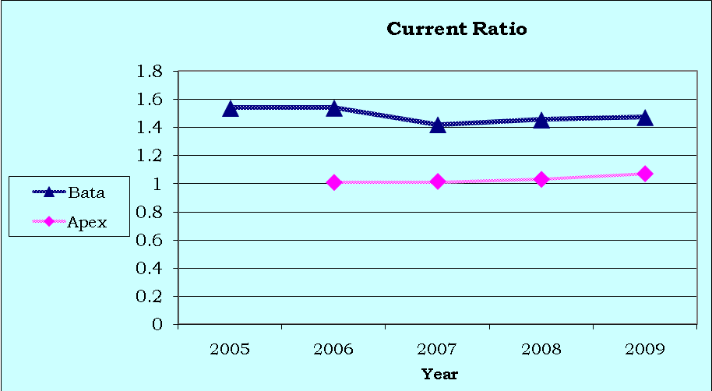

Figure 2-4: Current Ratio of BATA and APEX for the years 2005-2009

**Quick Ratio:**

The Quick ratio or acid-test measures a company's ability to meet its short-term obligations with its most liquid assets. Inventories typically are the least liquid of a firm’s current assets – they are the assets on which require more time to be sold and losses are most likely to occur in the event of liquidation. Therefore, it is important to measure the firm’s ability to pay off short term obligations without having to rely on the sale of inventories. Quick ratio of 1:1 is considered to be a healthy condition for most businesses. It is calculated as follows.

**Quick Ratio= (Current Assets- Inventories)/ Current Liabilities**

The following table shows the quick ratio data of the two companies-

|  |  |  |  |  |  |
| --- | --- | --- | --- | --- | --- |
| **Company** | **2005** | **2006** | **2007** | **2008** | **2009** |
| **Bata** | 0.619 | 0.624 | 0.403 | 0.399 | 0.497 |
| **Apex** |  | 0.503 | 0.581 | 0.591 | 0.583 |

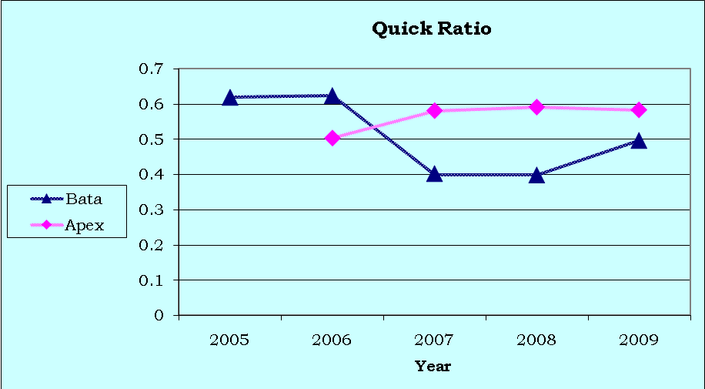Compared to the benchmark of quick ratio 1:1 is ideal for a company. The trend of quick ratio of BATA Shows that the ratio has gown down in 2007 due to the increase of inventories is about 32.65% respect to year of 2006. On the other hand, rival firm APEX is doing better compared to BATA in 2007.Considering the year 2006 to 2008 liabilities increase about 24.35% which indicates huge investment and declining the quick ratio. One more time, this is not a bad news for BATA because company will get benefit in future in this inflationary economy. As a consequence, quick ratio is increasing up to 2009 for BATA but rival firm is playing opposite role (i.e. stable quick ratio). This indicates the good ability of BATA to meet its short-term obligations with its own liquid assets.

Figure 2-5: Quick Ratio of BATA and APEX for the years 2005-2009

**Cash Ratio**

Cash Ratio is the ratio of a company's total cash and cash equivalents to its current liabilities. The cash ratio is most commonly used as a measure of company liquidity. It can determine how quickly the company can repay its short-term debt. It shows cash solvency of the firm. We can find cash ratio in the following way.

**Cash Ratio = Cash/Current Liabilities**

|  |  |  |  |  |  |
| --- | --- | --- | --- | --- | --- |
| **Company** | **2005** | **2006** | **2007** | **2008** | **2009** |
| **Bata** | 32% | 37% | 23% | 19% | 24% |
| **Apex** |  | 6% | 4.5% | 5% | 2% |

From the above table, we can see that normally the cash ratio of BATA is higher compared to APEX, which reflects that BATA has higher cash to meet its current liabilities. Though cash ratio below 30% is considered as “point to make attention” but BATA have significantly better cash ratio compared to his main rival APEX all through the last four years. Point to be noted that BATA started its journey on 1962 where APEX Shoe started its journey on 1990 in Bangladesh.

**2.3.2 Asset Management Ratio**

A set of ratios that measure how effectively a firm manages its assets compared to its sales. These ratios are designed to find out whether the total amount of each type of asset as reported on the balance sheet appear reasonable, too high, or too low considering current and projected sales levels. Asset Management Ratio is done based on inventory turnover ratio, days sales outstanding and fixed asset and total asset turnover ratio.

**Inventory Turnover Ratio**

Inventory Turnover Ratio tells how often a business's inventory turns over during the course of the year. Inventories are the least liquid form of asset and a high inventory turnover ratio is generally positive. On the other hand, an unusually high ratio compared to the average for the industry could mean that the business is losing sales because of inadequate stock on hand. The ratio is calculated as follows:

**Inventory turnover ratio= Cost of goods sold /Inventories**

The following table shows the inventory turnover ratio data of the 2 companies-

|  |  |  |  |  |  |
| --- | --- | --- | --- | --- | --- |
| **Company** | **2005** | **2006** | **2007** | **2008** | **2009** |
| **Bata** | 3.401 | 3.908 | 3.468 | 3.166 | 3.485 |
| **Apex** |  | 3.907 | 4.206 | 4.766 | 4.342 |

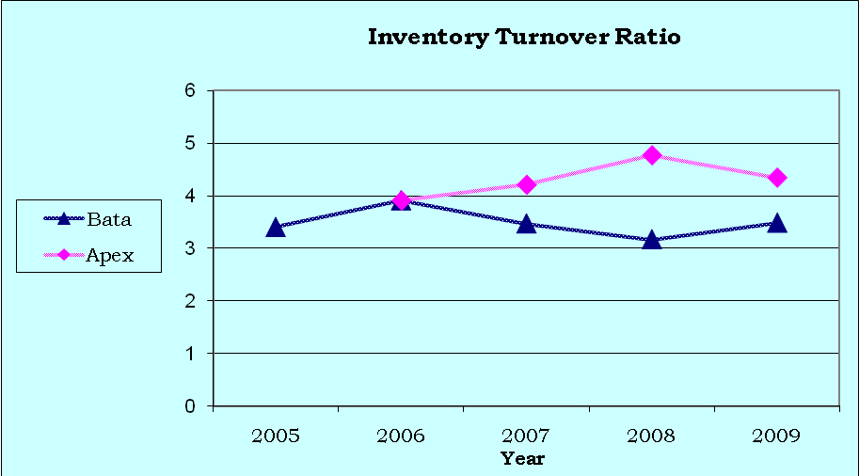The trend line of inventory ratio shows the ups and downs inventory turnover ratio from 2005 to 2009 but in 2009 it remains more or less same as 2005. This is good news but comparing with rival it is not the healthy position. Considering the year 2006 to 2008 the inventories are increased about 47.69%.Due to holding excess inventories the ratio is poor and it’s not bad news because company will get the future benefit. If we consider the year 2009 the trend is coming upward from 2008 and continuing with this the company can achieve their landmark easily.

Figure 2-7: Inventory Turnover Ratio of BATA and APEX for the years 2005-2009

**Days Sales Outstanding**

DSO is called the average collection period, is used to evaluate the firm’s ability to collect its credit sales in a timely manner. It is calculated by dividing accounts receivable by average sales per day which indicates the average length of time it takes the firm to collect its credit sales. DSO is calculated as follows:

**Days Sales Outstanding (DSO) =Receivables/Average sales per day**

**= Receivables/ [Annual sales/360]**

The following table shows the DSO data of the 2 companies-

|  |  |  |  |  |  |
| --- | --- | --- | --- | --- | --- |
| **Company** | **2005** | **2006** | **2007** | **2008** | **2009** |
| **Bata** | 22.322 | 10.8101 | 3.579 | 6.189 | 7.277 |
| **Apex** |  | 65.7004 | 56.453 | 57.891 | 43.807 |

Over the years DSO is decreasing, from 2005 to 2007. There is a little increase in DSO in 2008-2009 but it is not significant. Though the DSO ratio is increasing in 2007-2009, it is negligible. Considering the rival firm among the overall operating year 2005-2009 BATA is doing excellent which reflects better credit policy of the company.

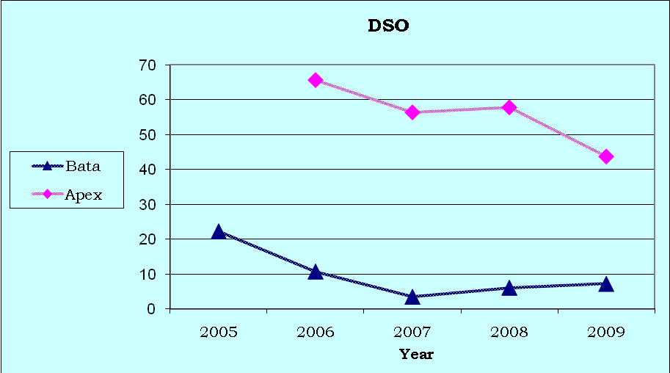

Figure 2-8: Days Sales Outstanding of BATA and APEX for the years 2005-2009

**Fixed Asset Turnover Ratio**

Fixed assets turnover ratio measures how effectively the firm uses its plant and equipment to help generate sales. So, fixed Asset Turnover ratio measures the amount of sales generated for every dollar's worth of fixed assets. The fixed asset turnover ratio is calculated by dividing sale by total fixed assets. It is calculated as follows:

**Fixed Assets Turnover Ratio = Sales/ Net Fixed Assets**

The following table shows the fixed asset turnover ratio data of the 2 companies-

|  |  |  |  |  |  |
| --- | --- | --- | --- | --- | --- |
| **Company** | **2005** | **2006** | **2007** | **2008** | **2009** |
| **Bata** | 8.72 | 11.61 | 15.34 | 16.23 | 21.47 |
| **Apex** |  | 10.812 | 13.53 | 11.77 | 18.615 |

The fixed asset turnover ratio is increasing among the operating year 2005-2009. High trend of fixed asset ratio is responsible for the increase of sales is about 64.12%. So, BATA is maintaining a good steady fixed asset turnover ratio, which is a good news for the company.

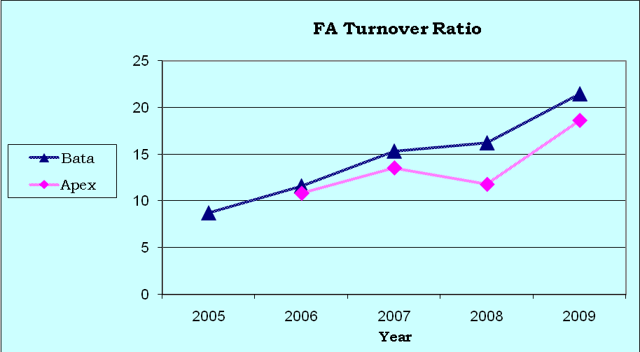

Figure 2-9: Fixed Asset Turnover Ratio of BATA and APEX for the years 2005-2009

**Total Asset Turnover Ratio**

Total Asset Turnover ratio measures the amount of sales generated for every dollar's worth of total assets. The total asset turnover ratio is calculated by dividing sale by total assets. It is calculated as follows:

**Total Assets Turnover Ratio = Sales/ Total Assets**

The following table shows the total asset turnover ratio data of the 2 companies-

|  |  |  |  |  |  |
| --- | --- | --- | --- | --- | --- |
| **Company** | **2005** | **2006** | **2007** | **2008** | **2009** |
| **Bata** | 1.6405 | 1.891 | 1.765 | 1.849 | 1.834 |
| **Apex** |  | 1.658 | 1.589 | 1.733 | 1.953 |

Considering the rival, BATA is maintaining a higher total asset turnover ratio until 2008 but in 2009 rival cross the company. In 2009 total asset turnover ratio decreases although sales increases, is about 8.06 %. Because of, the huge investment in fixed asset like plant, machineries etc significantly increases the total asset. This is also good news for the company, though they have lower total asset turnover ratio. But high investment in fixed asset will return a effective benefit in future.

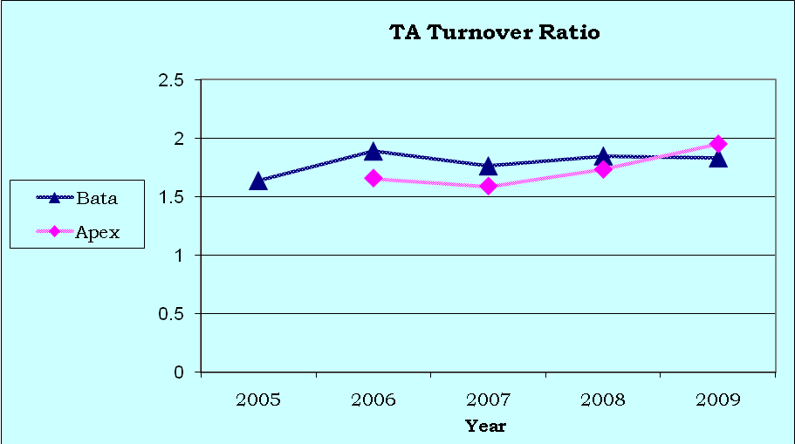

Figure 2-10: Total Asset Turnover Ratio of BATA and APEX for the years 2005-2009

**2.3.3 Debt Management Ratio**

Debt Management ratios help to evaluate a company's long-term solvency measuring the extent to which the company is using long-term debt. This ratio reflects how effectively a firm is managing its debts. It helps the analyst to determine the extent to which borrowed funds have been used to finance assets and review how well operating profits can cover fixed charges such as interest.

**Debt Ratio**

The debt ratio indicates how much of a company's assets are provided through debt or the percentage of the firm’s assets financed by creditors. Total debt includes both current liabilities and long term liabilities. Creditors prefer low debt ratios, because the lower the ratio, the greater the cushion against creditor’s losses in the event of liquidation. The owners on the other hand can benefit from leverage because it magnifies earnings, and thus the return to stockholder. But, too much debt often leads to financial difficulty, which eventually might cause bankruptcy. It is calculated as follows:

**Debt Ratio= Total Debt/ Total Assets**

The following table shows the debt ratio data of the 2 companies-

|  |  |  |  |  |  |
| --- | --- | --- | --- | --- | --- |
| **Company** | **2005** | **2006** | **2007** | **2008** | **2009** |
| **Bata** | 59.99% | 60.00% | 63.47% | 61.10% | 58.80% |
| **Apex** |  | 82.60% | 86.90% | 85.80% | 92.10% |

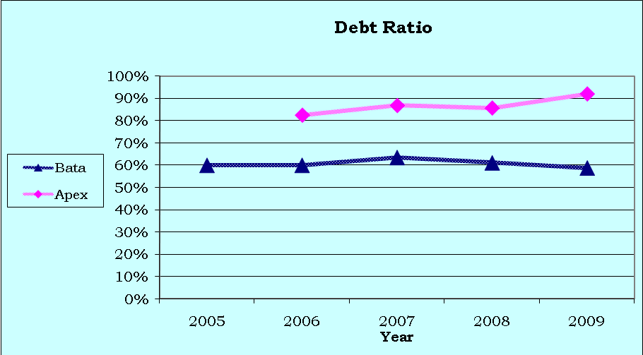 Regarding the operating year 2005-2009 Debt ratio is decreasing for BATA, except the year 2007. More or less it is remaining same .On the other hand the rival is playing opposite role. But declining debt ratio is good news for company because lower the debt ratio, the greater the cushion against creditor’s losses in the event of liquidation. Debt ratio is increasing dramatically for rival rather than the company is remaining the steady growth rate that depicts the healthy financial strength of the company BATA.

Figure 2-11: Debt Ratio of BATA and APEX for the years 2005-2009

**Times Interest Earned (TIE) Ratio**

The TIE ratio measures the extent to which earnings before interest and taxes (EBIT), also called operating income, can decline before the firm is unable to meet its annual interest cost. Failure to meet this obligation can bring legal action by the firm’s creditor, possibly resulting in bankruptcy. The TIE ratio is computed by dividing earnings before interest and taxes (EBIT) by interest charges. It measures the ability of the firm to meet its annual interest payments. The TIE ratio is calculated as follows:

**Time interest earned ratio = EBIT/ Interest charges**

The following table shows the times interest ratio data of the 2 companies-

|  |  |  |  |  |  |
| --- | --- | --- | --- | --- | --- |
| **Company** | **2005** | **2006** | **2007** | **2008** | **2009** |
| **Bata** | 92.35 | 158.37 | 151.71 | 123.87 | 161.62 |
| **Apex** |  | 1.57 | 2.14 | 1.88 | 1.74 |

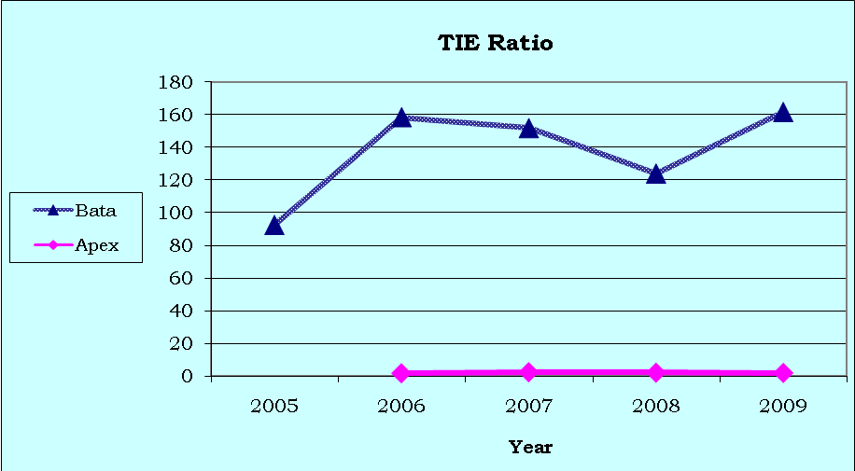Over the years BATA has a strong position in TIE ratio compare to APEX. In 2005 to 2006 there is a sharp growth in TIE ratio of BATA after than the trend is declining until 2008, due to increase the amount of interest i.e. 94.40% considering the year 2006 to 2008. In 2009 it is increased again and so it’s good news for the company. Considering the rival, Bata is doing excellent.

Figure 2-12: TIE Ratio of BATA and APEX for the years 2005-2009

**2.3.4 Profitability Ratio**

A group of ratios that show the combined effect of liquidity, asset management, and debt management on operating results .It is the net result of a number of policies and decisions.

**Profit Margin on Sales**

Profit Margin is the ratio measures net income per dollar of sales and is calculated as net income divided by revenues, or net profits divided by sales. It measures how much out of every dollar of sales a company actually keeps in earnings. Profit margin is very useful when comparing companies in similar industries. A higher profit margin indicates a more profitable company that has better control over its costs compared to its competitors. Profit margin is displayed as a percentage; a 20% profit margin, for example, means the company has a net income of $0.20 for each dollar of sales. It is calculated as follows:

**Profit margin on sales = Net Income/ Sales**

The following table shows the profit margin on sale data of the two companies-

|  |  |  |  |  |  |
| --- | --- | --- | --- | --- | --- |
| **Company** | **2005** | **2006** | **2007** | **2008** | **2009** |
| **Bata** | 6.75% | 7.17% | 7.14% | 9.72% | 9.00% |
| **Apex** |  | 1.70% | 3.81% | 3.37% | 4.31% |

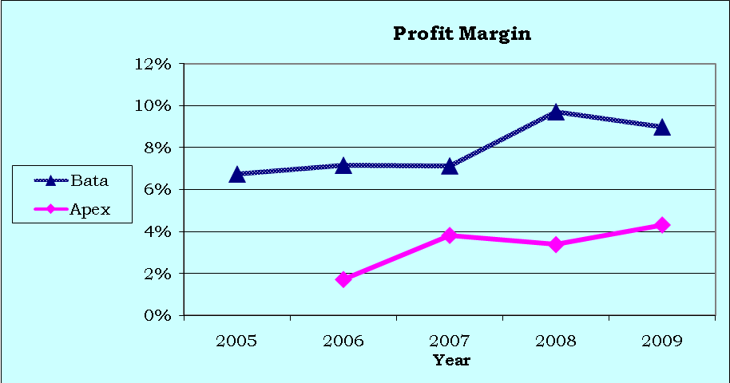Profit margin on sales is increasing over the time period of 2005 to 2007 slowly for BATA and 2008 there is a peak sale. In 2009 there is a little fall but still it is high above from the rival company APEX. This is good news for the company-

Figure 2-13: Profit Margin of BATA and APEX for the years 2005-2009

**Return on Asset (ROA)**

Return on Asset (ROA)isan indicator of a company which deals with profit relative to its total assets. It gives an idea as to how efficient management is at using its assets to generate earnings. It is calculated by dividing a company's annual earnings by its total assets, ROA is displayed as a percentage. Sometimes this is referred to as "return on investment". The ROA after interest and taxes are computed as follows:

**Return on Asset (ROA) = Net Income / Total Assets**

The following table shows the ROA data of the 2 companies-

|  |  |  |  |  |  |
| --- | --- | --- | --- | --- | --- |
| **Company** | **2005** | **2006** | **2007** | **2008** | **2009** |
| **Bata** | 11.09% | 13.53% | 14.43% | 17.98% | 16.50% |
| **Apex** |  | 5.84% | 3.32% | 5.84% | 6.07% |

ROA of BATA is increasing from 2005 to 2008 and it is higher from the comparing company APEX. But in the year 2009 the trend goes down slightly this is not a bad news in a sense that BATA invested huge in fixed asset in between these years which eventually reduce the ROA.

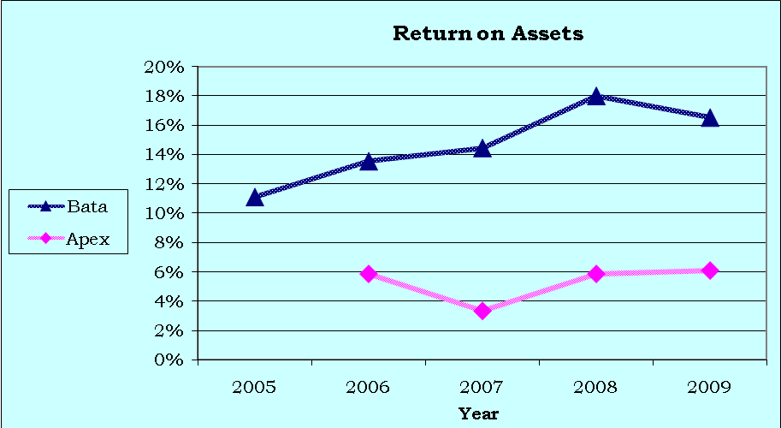

Figure 2-14: ROA of BATA and APEX for the years 2005-2009

**Return on Equity (ROE)**

Return on Equity (ROE) measures the rate of return on common stockholders’ equity. It measures a company's profitability by revealing how much profit a company generates with the money shareholders have invested. The return on equity (ROE) is measured as follows:

**Return on Equity (ROE) = Net income / Total Shareholders’ Equity**

The following table shows the ROE data of the 2 companies-

|  |  |  |  |  |  |
| --- | --- | --- | --- | --- | --- |
| **Company** | **2005** | **2006** | **2007** | **2008** | **2009** |
| **Bata** | 27.66% | 33.83% | 39.49% | 46.23% | 40.10% |
| **Apex** |  | 19.91% | 46.54% | 33.72% | 28.77% |

The ROE of BATA is increasing sharply from the year 2005 to 2008 and slightly goes down in 2009 .On the other hand, considering the rival company APEX is drastically gone down from 2007 to till 2009. The decreasing trend of BATA is responsible for the 15% increase of equity. It indicates that the rate of return on the common stockholders’ investment is rising over the year which is a good indicator for the company in future.

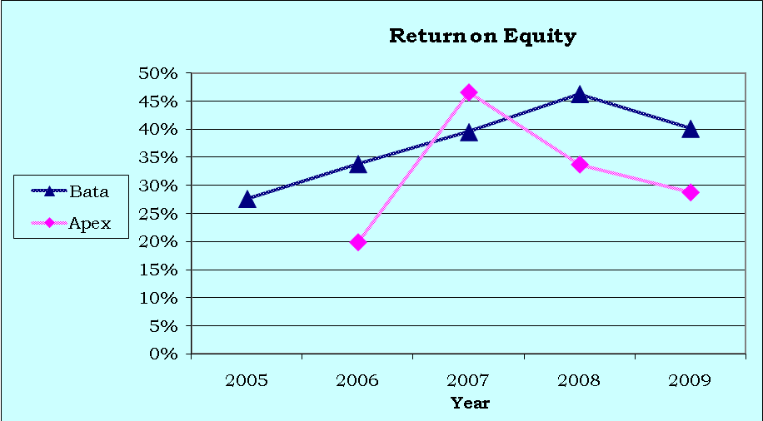

Figure 2-15: ROE of BATA and APEX for the years 2005-2009

**DuPont Analysis**

* ROA is increasing from 2005 to 2008, which implies the higher net income. Also the ROA is in very better position compared to main rival APEX.
* Fixed Asset Turnover Ratio is increased from 2005 to 2009. It may be happen for higher sales or disposal of fixed asset. But from the annual report it was found that the disposed amount of fixed asset is not that much significant affect on these ratios. This implies that they have a clean improvement in sales.
* Profit margin is increased over the years. Point to be noted that 2008 was the year of recession. But in 2008 they have increased their profit margin in huge amount. By analyzing the scenario about what make this thing happen, found that, they have increased their advertisement expense by 37% on that year.
* Regarding the operating year 2005-2009 Debt ratio is decreasing for BATA, except the year 2007. But declining debt ratio is good news for company because lower the debt ratio, the greater the cushion against creditor’s losses in the event of liquidation.

**2.3.5 Market Value Ratio**

This is a set of ratio that relates the firm’s stock price to its earnings and book value per share. These ratios give management an indication of what investors think of the company’s past performance and future prospect. If the firm’s liquidity, asset management, debt management, and profitability ratios are all good then market value ratios will be high which will lead to an increase in the stock price of the company.

**Earnings per Share**

Earnings per Share (EPS)are the portion of a company's profit allocated to each outstanding share of common stock. It serves as an indicator of a company's profitability. It is generally considered to be the single most important variable in determining a share's price. It is also a major component used to calculate the price-to-earnings valuation ratio. It is calculated as follows:

**EPS = Net Income/ Number of Shares Outstanding**

The following table shows the EPS data of the 2 companies-

|  |  |  |  |  |  |
| --- | --- | --- | --- | --- | --- |
| **Company** | **2005** | **2006** | **2007** | **2008** | **2009** |
| **Bata** | 151.10 | 202.5 | 237.5 | 328.5 | 328.5 |
| **Apex** |  | 66.56 | 225.81 | 168.74 | 188.03 |

EPS of BATA has been increasing at healthy rate over the years. This is good news because this will help to attract the investors and thus the company can collect more money from stock market. The EPS of BATA is increased from TK 151.10 to TK 328.50 during 2005 to 2009 which helps to increase the share price. From the year 2008 to 2009 it remains constant due to the huge investment in work in progress it’s also a good news for the company.

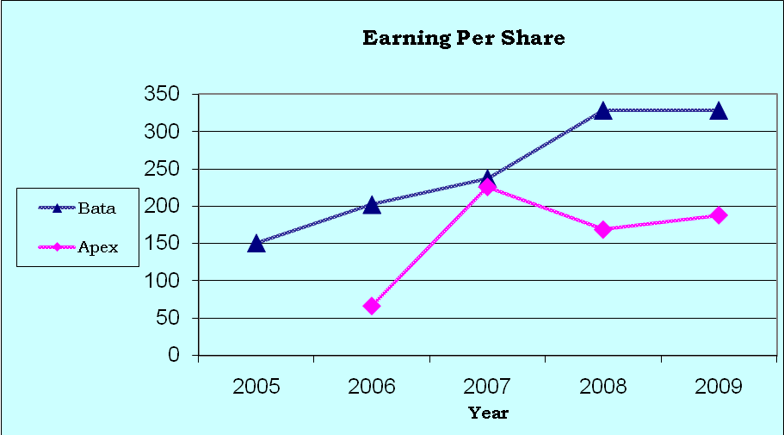

Figure 2-16: EPS of BATA and APEX for the years 2005-2009

**Price/Earning (P/E) Ratio**

This is the ratio of the price per share to earnings per share. It shows how much investors are willing to pay per dollar of reported profit. It is calculated as follows:

**P/E Ratio = Market Price per Share/ Earnings per Share**

The following table shows the P/E ratio data of the 2 companies-

|  |  |  |  |  |  |
| --- | --- | --- | --- | --- | --- |
| **Company** | **2005** | **2006** | **2007** | **2008** | **2009** |
| **Bata** | 9.85 | 5.995 | 9.414 | 9.76 | 16.08 |
| **Apex** |  | 6.989 | 9.614 | 14.134 | 13.737 |

Considering the year 2005 to 2006 the P/E ratio decreases and after than 2006 to 2009 it is transparent that BATA has a healthy growth in P/E ratio. In 2009 comparing to APEX (P/E ratio is 13.737) BATA is continuing with higher ratio. This indicates the demand and trust for this share is increasing respect to the investors. The investors willing to pay 16.08 taka for earning 1 taka profit from the company.

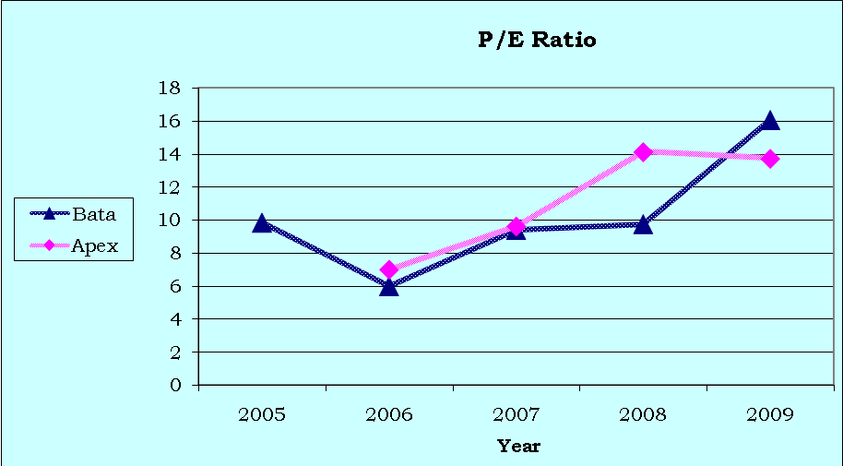

Figure 2-17: P/E Ratio of BATA and APEX for the years 2005-2009

**Book Value per Share**

Common stockholders' equity is determined on a per-share basis. Book value per share is calculated by subtracting liabilities and the par value of any outstanding preferred stock from assets and dividing the remainder by the number of outstanding shares of stock. It is calculated as follows:

**Book Value per Share=Equity/Number of Shares Outstanding**

The following table shows the Book value per share data of the 2 companies-

|  |  |  |  |  |  |
| --- | --- | --- | --- | --- | --- |
| **Company** | **2005** | **2006** | **2007** | **2008** | **2009** |
| **Bata** | 54.6 | 59.85 | 60.13 | 71.06 | 81.91 |
| **Apex** |  | 33.43 | 48.51 | 50.39 | 65.34 |

The book value per share is increasing over the year 2005 to 2009. On the other hand, rival is maintaining lower Book Value Per Share. But increasing trend of BATA in book value per share is a good indicator for the company. So, the level of equity is rising over the year which makes good sense for BATA.

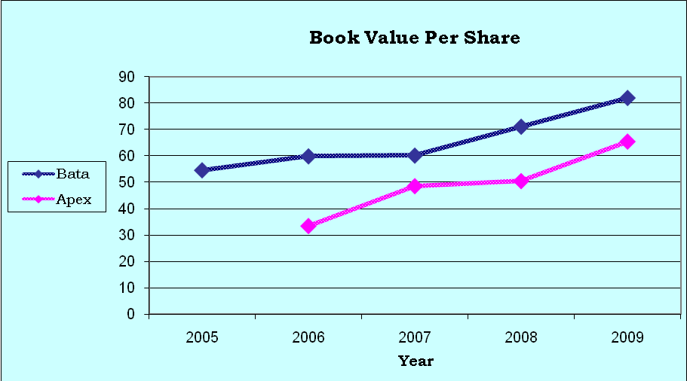

Figure 2-18: Book Value per Share of BATA and APEX for the years 2005-2009

**4.5.4**

**Market/Book (M/B) Ratio**

The ratio of a stock’s market price to its book value gives another suggestion of how investors regard the company. Companies with relatively high rates of return on equity generally sell at higher multiples of book value than those with low returns. The formula for Market/Book Value is given below:

**Market /Book Ratio = Market Price per Share / Book Value per Share**

The following table shows the M/B ratio data of the two companies-

|  |  |  |  |  |  |
| --- | --- | --- | --- | --- | --- |
| **Company** | **2005** | **2006** | **2007** | **2008** | **2009** |
| **Bata** | 2.72 | 2.02 | 3.72 | 4.52 | 6.45 |
| **Apex** |  | 1.39 | 4.47 | 4.77 | 3.96 |

The cross section analysis indicates that the market/book ratio of BATA is much higher than APEX. The market value per share of APEX is not increasing at faster rate compared to the book value per share. Due to these, investors are willing to pay more for the book value of BATA than that of the rival company which implies that trust of investors is going up over the years 2005 to 2009 and the investors are very much confident about the prospect of BATA.

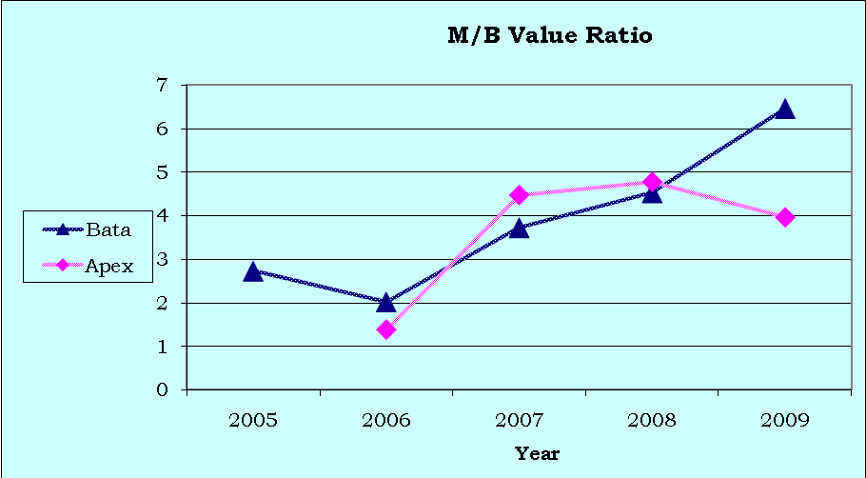

Figure 2-19: M/B ratio of BATA and APEX for the years 2006-2009

**Chapter – 3**

**Enquiry into Stock Price Movement**

In this chapter we will consider the stock price movement of Bata Shoe Company Limited with special emphasis on the stock price movement between for 2007 to 2009. Daily stock price is affected due to various factors that can be a macroeconomic variable as well as company specific variable.

In this section we will consider the corporate decision factors like Dividend Declaration Date, Record Date and Special declaration from the company where the company has informed that the Board of Directors of the company has decided in a resolution by circulation dated October 10, 2009 that the company shall incorporate a 100% Export Oriented Company as a fully owned subsidiary company of Bata Shoe Company (Bangladesh) Limited.

We have made some regression analysis between the share price of Bata and various company specific factors to understand the relations between the share price movement of Bata and the various factors.

Regression Analysis for Dividend declaration date 2007

|  |  |  |
| --- | --- | --- |
| Dividend declaration | | |
| 8-Nov-07 | | |
| Date | Price | Dummy Variable |
| 19 Sep,2007 | 194.2 | 0 |
| 20 Sep,2007 | 199.6 | 0 |
| 23 Sep,2007 | 200.3 | 0 |
| 24 Sep,2007 | 198.6 | 0 |
| 25 Sep,2007 | 196.6 | 0 |
| 26 Sep,2007 | 195.3 | 0 |
| 27 Sep,2007 | 194.9 | 0 |
| 30 Sep,2007 | 195.5 | 0 |
| 01 Oct,2007 | 197.9 | 0 |
| 02 Oct,2007 | 199 | 0 |
| 03 Oct,2007 | 197.3 | 0 |
| 04 Oct,2007 | 198.1 | 0 |
| 07 Oct,2007 | 202.1 | 0 |
| 08 Oct,2007 | 199.9 | 0 |
| 09 Oct,2007 | 202.7 | 0 |
| 16 Oct,2007 | 204.9 | 0 |
| 17 Oct,2007 | 200.7 | 0 |
| 18 Oct,2007 | 201.9 | 0 |
| 22 Oct,2007 | 202.3 | 0 |
| 23 Oct,2007 | 202.6 | 0 |
| 24 Oct,2007 | 199.2 | 0 |
| 25 Oct,2007 | 200.4 | 0 |
| 28 Oct,2007 | 200.8 | 0 |
| 29 Oct,2007 | 200 | 0 |
| 30 Oct,2007 | 205.4 | 0 |
| 31 Oct,2007 | 210.7 | 0 |
| 01 Nov,2007 | 207.7 | 0 |
| 04 Nov,2007 | 211 | 0 |
| 05 Nov,2007 | 207.9 | 0 |
| 06 Nov,2007 | 207.4 | 0 |
| 08 Nov,2007 | 212 | 1 |
| 11 Nov,2007 | 211.9 | 1 |
| 12 Nov,2007 | 224.4 | 1 |
| 13 Nov,2007 | 229.2 | 1 |
| 14 Nov,2007 | 232 | 1 |
| 15 Nov,2007 | 237.9 | 1 |
| 18 Nov,2007 | 271.3 | 1 |
| 19 Nov,2007 | 274.6 | 1 |
| 20 Nov,2007 | 269.7 | 1 |
| 21 Nov,2007 | 265.9 | 1 |
| 22 Nov,2007 | 262.6 | 1 |
| 25 Nov,2007 | 252 | 1 |
| 26 Nov,2007 | 265.3 | 1 |
| 27 Nov,2007 | 255.8 | 1 |
| 28 Nov,2007 | 251.8 | 1 |
| 29 Nov,2007 | 249.1 | 1 |
| 02 Dec,2007 | 244.7 | 1 |
| 04 Dec,2007 | 237.5 | 1 |
| 05 Dec,2007 | 230.1 | 1 |
| 06 Dec,2007 | 231.5 | 1 |
| 09 Dec,2007 | 232.5 | 1 |
| 10 Dec,2007 | 238.6 | 1 |
| 11 Dec,2007 | 239.5 | 1 |
| 12 Dec,2007 | 235.3 | 1 |
| 13 Dec,2007 | 232.2 | 1 |
| 17 Dec,2007 | 227.8 | 1 |
| 18 Dec,2007 | 228.4 | 1 |
| 19 Dec,2007 | 229.7 | 1 |
| 26 Dec,2007 | 226.5 | 1 |
| 27 Dec,2007 | 226.5 | 1 |
| 30 Dec,2007 | 223.6 | 1 |

|  |  |
| --- | --- |
| SUMMARY OUTPUT |  |
|  |  |
| *Regression Statistics* | |
| Multiple R | 0.843942937 |
| R Square | 0.712239682 |
| Adjusted R Square | 0.707362388 |
| Standard Error | 12.65177555 |
| Observations | 61 |

From the result it is found that the value of F is very low (<0.05) which is very significant and the R Square is 0.71 that means a high correlation.

We can see that the t-statistic of the slope coefficient has a P-value of less than 0.05 at 5% significance level. This very low value of p indicates that there is a relationship between the dividend declaration and the stock price change. Also the R-square is quite high of 71.22% which indicates that the 71.22% of scatter plot can be explained by the regression line.

|  |  |  |  |  |  |  |  |  |
| --- | --- | --- | --- | --- | --- | --- | --- | --- |
| SUMMARY OUTPUT |  |  |  |  |  |  |  |  |
|  |  |  |  |  |  |  |  |  |
| *Regression Statistics* | |  |  |  |  |  |  |  |
| Multiple R | 0.843942937 |  |  |  |  |  |  |  |
| R Square | 0.712239682 |  |  |  |  |  |  |  |
| Adjusted R Square | 0.707362388 |  |  |  |  |  |  |  |
| Standard Error | 12.65177555 |  |  |  |  |  |  |  |
| Observations | 61 |  |  |  |  |  |  |  |
|  |  |  |  |  |  |  |  |  |
| ANOVA |  |  |  |  |  |  |  |  |
|  | *df* | *SS* | *MS* | *F* | *Significance F* |  |  |  |
| Regression | 1 | 23374.92522 | 23374.925 | 146.031744 | 1.33949E-17 |  |  |  |
| Residual | 59 | 9443.978054 | 160.06742 |  |  |  |  |  |
| Total | 60 | 32818.90328 |  |  |  |  |  |  |
|  |  |  |  |  |  |  |  |  |
|  | *Coefficients* | *Standard Error* | *t Stat* | *P-value* | *Lower 95%* | *Upper 95%* | *Lower 95.0%* | *Upper 95.0%* |
| Intercept | 201.1633333 | 2.309887621 | 87.087931 | 5.0077E-64 | 196.5412589 | 205.78541 | 196.54126 | 205.78541 |
| Dummy Variable | 39.15602151 | 3.240223161 | 12.084359 | 1.3395E-17 | 32.67234999 | 45.639693 | 32.67235 | 45.639693 |
|  |  |  |  |  |  |  |  |  |

Regression Analysis for Record date 2007

|  |  |  |
| --- | --- | --- |
| Record date | | |
| 3-Dec-07 | | |
| Date | Price | Dummy Variable |
| 18 Oct,2007 | 201.9 | 0 |
| 22 Oct,2007 | 202.3 | 0 |
| 23 Oct,2007 | 202.6 | 0 |
| 24 Oct,2007 | 199.2 | 0 |
| 25 Oct,2007 | 200.4 | 0 |
| 28 Oct,2007 | 200.8 | 0 |
| 29 Oct,2007 | 200 | 0 |
| 30 Oct,2007 | 205.4 | 0 |
| 31 Oct,2007 | 210.7 | 0 |
| 01 Nov,2007 | 207.7 | 0 |
| 04 Nov,2007 | 211 | 0 |
| 05 Nov,2007 | 207.9 | 0 |
| 06 Nov,2007 | 207.4 | 0 |
| 08 Nov,2007 | 212 | 0 |
| 11 Nov,2007 | 211.9 | 0 |
| 12 Nov,2007 | 224.4 | 0 |
| 13 Nov,2007 | 229.2 | 0 |
| 14 Nov,2007 | 232 | 0 |
| 15 Nov,2007 | 237.9 | 0 |
| 18 Nov,2007 | 271.3 | 0 |
| 19 Nov,2007 | 274.6 | 0 |
| 20 Nov,2007 | 269.7 | 0 |
| 21 Nov,2007 | 265.9 | 0 |
| 22 Nov,2007 | 262.6 | 0 |
| 25 Nov,2007 | 252 | 0 |
| 26 Nov,2007 | 265.3 | 0 |
| 27 Nov,2007 | 255.8 | 0 |
| 28 Nov,2007 | 251.8 | 0 |
| 29 Nov,2007 | 249.1 | 0 |
| 02 Dec,2007 | 244.7 | 0 |
| 04 Dec,2007 | 237.5 | 1 |
| 05 Dec,2007 | 230.1 | 1 |
| 06 Dec,2007 | 231.5 | 1 |
| 09 Dec,2007 | 232.5 | 1 |
| 10 Dec,2007 | 238.6 | 1 |
| 11 Dec,2007 | 239.5 | 1 |
| 12 Dec,2007 | 235.3 | 1 |
| 13 Dec,2007 | 232.2 | 1 |
| 17 Dec,2007 | 227.8 | 1 |
| 18 Dec,2007 | 228.4 | 1 |
| 19 Dec,2007 | 229.7 | 1 |
| 26 Dec,2007 | 226.5 | 1 |
| 27 Dec,2007 | 226.5 | 1 |
| 30 Dec,2007 | 223.6 | 1 |
| 01 Jan,2008 | 222.5 | 1 |
| 02 Jan,2008 | 217.9 | 1 |
| 03 Jan,2008 | 218.8 | 1 |
| 06 Jan,2008 | 212.5 | 1 |
| 07 Jan,2008 | 213.6 | 1 |
| 08 Jan,2008 | 210.1 | 1 |
| 09 Jan,2008 | 218.7 | 1 |
| 10 Jan,2008 | 221.1 | 1 |
| 13 Jan,2008 | 218.5 | 1 |
| 14 Jan,2008 | 218.7 | 1 |
| 15 Jan,2008 | 219.3 | 1 |
| 16 Jan,2008 | 221.9 | 1 |
| 17 Jan,2008 | 217 | 1 |
| 21 Jan,2008 | 219.9 | 1 |
| 22 Jan,2008 | 220.7 | 1 |
| 23 Jan,2008 | 218.7 | 1 |

|  |  |
| --- | --- |
| SUMMARY OUTPUT |  |
|  |  |
| *Regression Statistics* | |
| Multiple R | 0.118357711 |
| R Square | 0.014008548 |
| Adjusted R Square | -0.002991305 |
| Standard Error | 19.61167389 |
| Observations | 60 |

From the result it is obvious that there is no significant relation with record date and share price movement, because of low R-square and value of F.

|  |  |  |  |  |  |  |  |  |
| --- | --- | --- | --- | --- | --- | --- | --- | --- |
| SUMMARY OUTPUT |  |  |  |  |  |  |  |  |
|  |  |  |  |  |  |  |  |  |
| *Regression Statistics* | |  |  |  |  |  |  |  |
| Multiple R | 0.1183577 |  |  |  |  |  |  |  |
| R Square | 0.0140085 |  |  |  |  |  |  |  |
| Adjusted R Square | -0.0029913 |  |  |  |  |  |  |  |
| Standard Error | 19.611674 |  |  |  |  |  |  |  |
| Observations | 60 |  |  |  |  |  |  |  |
|  |  |  |  |  |  |  |  |  |
| ANOVA |  |  |  |  |  |  |  |  |
|  | *df* | *SS* | *MS* | *F* | *Significance F* |  |  |  |
| Regression | 1 | 316.9401667 | 316.940167 | 0.82403936 | 0.367758156 |  |  |  |
| Residual | 58 | 22307.82967 | 384.617753 |  |  |  |  |  |
| Total | 59 | 22624.76983 |  |  |  |  |  |  |
|  |  |  |  |  |  |  |  |  |
|  | *Coefficients* | *Standard Error* | *t Stat* | *P-value* | *Lower 95%* | *Upper 95%* | *Lower 95.0%* | *Upper 95.0%* |
| Intercept | 228.91667 | 3.580585394 | 63.9327488 | 1.7836E-55 | 221.7493463 | 236.08399 | 221.749346 | 236.083987 |
| Dummy Variable | -4.5966667 | 5.063712425 | -0.9077661 | 0.36775816 | -14.73278828 | 5.5394549 | -14.732788 | 5.539454948 |
|  |  |  |  |  |  |  |  |  |

Regression Analysis for Dividend declaration date 2008

|  |  |  |
| --- | --- | --- |
| Dividend declaration | | |
| 13-Apr-08 | | |
| Date | Price | Dummy Variable |
| 26 Feb,2009 | 320.2 | 0 |
| 01 Mar,2009 | 327.1 | 0 |
| 02 Mar,2009 | 323.7 | 0 |
| 03 Mar,2009 | 320.2 | 0 |
| 04 Mar,2009 | 324.2 | 0 |
| 05 Mar,2009 | 321.1 | 0 |
| 08 Mar,2009 | 322.1 | 0 |
| 09 Mar,2009 | 324.8 | 0 |
| 11 Mar,2009 | 323.3 | 0 |
| 12 Mar,2009 | 330.7 | 0 |
| 15 Mar,2009 | 330.6 | 0 |
| 16 Mar,2009 | 326.2 | 0 |
| 17 Mar,2009 | 322.7 | 0 |
| 18 Mar,2009 | 319 | 0 |
| 19 Mar,2009 | 316.9 | 0 |
| 22 Mar,2009 | 314.6 | 0 |
| 23 Mar,2009 | 310.2 | 0 |
| 24 Mar,2009 | 312.7 | 0 |
| 25 Mar,2009 | 312.5 | 0 |
| 29 Mar,2009 | 310 | 0 |
| 30 Mar,2009 | 313.5 | 0 |
| 31 Mar,2009 | 312.7 | 0 |
| 01 Apr,2009 | 307.4 | 0 |
| 02 Apr,2009 | 309.1 | 0 |
| 05 Apr,2009 | 300.9 | 0 |
| 06 Apr,2009 | 295.4 | 0 |
| 07 Apr,2009 | 297.2 | 0 |
| 08 Apr,2009 | 295.1 | 0 |
| 09 Apr,2009 | 294.2 | 0 |
| 12 Apr,2009 | 297.8 | 1 |
| 13 Apr,2009 | 308.3 | 1 |
| 15 Apr,2009 | 312.8 | 1 |
| 16 Apr,2009 | 314.6 | 1 |
| 19 Apr,2009 | 321.9 | 1 |
| 20 Apr,2009 | 318.1 | 1 |
| 21 Apr,2009 | 315.2 | 1 |
| 22 Apr,2009 | 315.2 | 1 |
| 26 Apr,2009 | 299.9 | 1 |
| 27 Apr,2009 | 300.2 | 1 |
| 28 Apr,2009 | 293.3 | 1 |
| 29 Apr,2009 | 294.6 | 1 |
| 30 Apr,2009 | 290 | 1 |
| 03 May,2009 | 286.1 | 1 |
| 04 May,2009 | 288.5 | 1 |
| 05 May,2009 | 299.7 | 1 |
| 06 May,2009 | 297.9 | 1 |
| 07 May,2009 | 294.5 | 1 |
| 10 May,2009 | 290.1 | 1 |
| 11 May,2009 | 287.1 | 1 |
| 12 May,2009 | 291.9 | 1 |
| 13 May,2009 | 294.6 | 1 |
| 14 May,2009 | 290.9 | 1 |
| 17 May,2009 | 289.2 | 1 |
| 18 May,2009 | 290.4 | 1 |
| 19 May,2009 | 294.6 | 1 |
| 20 May,2009 | 297.2 | 1 |
| 21 May,2009 | 293.7 | 1 |
| 24 May,2009 | 292.9 | 1 |
| 25 May,2009 | 295 | 1 |
| 26 May,2009 | 297.2 | 1 |
| 27 May,2009 | 293.7 | 1 |

|  |  |
| --- | --- |
| SUMMARY OUTPUT |  |
|  |  |
| *Regression Statistics* | |
| Multiple R | 0.638530134 |
| R Square | 0.407720732 |
| Adjusted R Square | 0.3976821 |
| Standard Error | 10.26167311 |
| Observations | 61 |

From the result it is found that the value of F is very low (<0.05) which is significant and the R Square is 0.4077 that means a little correlation.

The R-square is quite high of 40.77% which indicates that the 40.77% of scatter plot can be explained by the regression line.

|  |  |  |  |  |  |  |  |  |
| --- | --- | --- | --- | --- | --- | --- | --- | --- |
| SUMMARY OUTPUT |  |  |  |  |  |  |  |  |
|  |  |  |  |  |  |  |  |  |
| *Regression Statistics* | |  |  |  |  |  |  |  |
| Multiple R | 0.63853013 |  |  |  |  |  |  |  |
| R Square | 0.40772073 |  |  |  |  |  |  |  |
| Adjusted R Square | 0.3976821 |  |  |  |  |  |  |  |
| Standard Error | 10.2616731 |  |  |  |  |  |  |  |
| Observations | 61 |  |  |  |  |  |  |  |
|  |  |  |  |  |  |  |  |  |
| ANOVA |  |  |  |  |  |  |  |  |
|  | *df* | *SS* | *MS* | *F* | *Significance F* |  |  |  |
| Regression | 1 | 4276.855994 | 4276.85599 | 40.61517 | 3.0847E-08 |  |  |  |
| Residual | 59 | 6212.81417 | 105.301935 |  |  |  |  |  |
| Total | 60 | 10489.67016 |  |  |  |  |  |  |
|  |  |  |  |  |  |  |  |  |
|  | *Coefficients* | *Standard Error* | *t Stat* | *P-value* | *Lower 95%* | *Upper 95%* | *Lower 95.0%* | *Upper 95.0%* |
| Intercept | 315.113793 | 1.905544859 | 165.366767 | 2.1838E-80 | 311.300807 | 318.9267795 | 311.30081 | 318.92678 |
| Dummy Variable | -16.766918 | 2.630928863 | -6.37300322 | 3.0847E-08 | -22.031395 | -11.5024417 | -22.031395 | -11.5024417 |
|  |  |  |  |  |  |  |  |  |

Regression Analysis for Record date 2008

|  |  |  |
| --- | --- | --- |
| Record date | | |
| 8-May-08 | | |
| Date | Price | Dummy Variable |
| 22 Mar,2009 | 314.6 | 0 |
| 23 Mar,2009 | 310.2 | 0 |
| 24 Mar,2009 | 312.7 | 0 |
| 25 Mar,2009 | 312.5 | 0 |
| 29 Mar,2009 | 310 | 0 |
| 30 Mar,2009 | 313.5 | 0 |
| 31 Mar,2009 | 312.7 | 0 |
| 01 Apr,2009 | 307.4 | 0 |
| 02 Apr,2009 | 309.1 | 0 |
| 05 Apr,2009 | 300.9 | 0 |
| 06 Apr,2009 | 295.4 | 0 |
| 07 Apr,2009 | 297.2 | 0 |
| 08 Apr,2009 | 295.1 | 0 |
| 09 Apr,2009 | 294.2 | 0 |
| 12 Apr,2009 | 297.8 | 0 |
| 13 Apr,2009 | 308.3 | 0 |
| 15 Apr,2009 | 312.8 | 0 |
| 16 Apr,2009 | 314.6 | 0 |
| 19 Apr,2009 | 321.9 | 0 |
| 20 Apr,2009 | 318.1 | 0 |
| 21 Apr,2009 | 315.2 | 0 |
| 22 Apr,2009 | 315.2 | 0 |
| 26 Apr,2009 | 299.9 | 0 |
| 27 Apr,2009 | 300.2 | 0 |
| 28 Apr,2009 | 293.3 | 0 |
| 29 Apr,2009 | 294.6 | 0 |
| 30 Apr,2009 | 290 | 0 |
| 03 May,2009 | 286.1 | 0 |
| 04 May,2009 | 288.5 | 0 |
| 05 May,2009 | 299.7 | 0 |
| 06 May,2009 | 297.9 | 1 |
| 07 May,2009 | 294.5 | 1 |
| 12 May,2009 | 291.9 | 1 |
| 13 May,2009 | 294.6 | 1 |
| 14 May,2009 | 290.9 | 1 |
| 17 May,2009 | 289.2 | 1 |
| 18 May,2009 | 290.4 | 1 |
| 19 May,2009 | 294.6 | 1 |
| 20 May,2009 | 297.2 | 1 |
| 21 May,2009 | 293.7 | 1 |
| 24 May,2009 | 292.9 | 1 |
| 25 May,2009 | 295 | 1 |
| 26 May,2009 | 297.2 | 1 |
| 27 May,2009 | 293.7 | 1 |
| 28 May,2009 | 296.4 | 1 |
| 31 May,2009 | 298.1 | 1 |
| 01 Jun,2009 | 300.4 | 1 |
| 02 Jun,2009 | 311.5 | 1 |
| 03 Jun,2009 | 312.6 | 1 |
| 04 Jun,2009 | 313.3 | 1 |
| 07 Jun,2009 | 314.9 | 1 |
| 08 Jun,2009 | 319.6 | 1 |
| 09 Jun,2009 | 324.8 | 1 |
| 10 Jun,2009 | 324.1 | 1 |
| 11 Jun,2009 | 316.3 | 1 |
| 14 Jun,2009 | 318.6 | 1 |
| 15 Jun,2009 | 319.9 | 1 |
| 16 Jun,2009 | 322.1 | 1 |
| 17 Jun,2009 | 321.7 | 1 |
| 18 Jun,2009 | 325.2 | 1 |
| 21 Jun,2009 | 327 | 1 |

|  |  |
| --- | --- |
| SUMMARY OUTPUT |  |
|  |  |
| *Regression Statistics* | |
| Multiple R | 0.047379813 |
| R Square | 0.002244847 |
| Adjusted R Square | -0.014666258 |
| Standard Error | 11.6768121 |
| Observations | 61 |

From the result it is obvious that there is no significant relation with record date and share price movement, because of low R-square and value of F.

|  |  |  |  |  |  |  |  |  |
| --- | --- | --- | --- | --- | --- | --- | --- | --- |
| SUMMARY OUTPUT |  |  |  |  |  |  |  |  |
|  |  |  |  |  |  |  |  |  |
| *Regression Statistics* | |  |  |  |  |  |  |  |
| Multiple R | 0.04737981 |  |  |  |  |  |  |  |
| R Square | 0.00224485 |  |  |  |  |  |  |  |
| Adjusted R Square | -0.01466626 |  |  |  |  |  |  |  |
| Standard Error | 11.6768121 |  |  |  |  |  |  |  |
| Observations | 61 |  |  |  |  |  |  |  |
|  |  |  |  |  |  |  |  |  |
| ANOVA |  |  |  |  |  |  |  |  |
|  | *df* | *SS* | *MS* | *F* | *Significance F* |  |  |  |
| Regression | 1 | 18.09936348 | 18.0993635 | 0.132743944 | 0.716906384 |  |  |  |
| Residual | 59 | 8044.528505 | 136.347941 |  |  |  |  |  |
| Total | 60 | 8062.627869 |  |  |  |  |  |  |
|  |  |  |  |  |  |  |  |  |
|  | *Coefficients* | *Standard Error* | *t Stat* | *P-value* | *Lower 95%* | *Upper 95%* | *Lower 95.0%* | *Upper 95.0%* |
| Intercept | 304.723333 | 2.131884462 | 142.936139 | 1.16169E-76 | 300.4574424 | 308.9892243 | 300.457442 | 308.989224 |
| Dummy Variable | 1.08956989 | 2.990527049 | 0.36434042 | 0.716906384 | -4.89446086 | 7.073600644 | -4.89446086 | 7.07360064 |
|  |  |  |  |  |  |  |  |  |

Regression Analysis for Dividend declaration date 2009

|  |  |  |
| --- | --- | --- |
| Dividend declaration | | |
| 25-Mar-09 | | |
| Date | Price | Dummy Variable |
| 10 Feb,2009 | 317.8 | 0 |
| 11 Feb,2009 | 309 | 0 |
| 12 Feb,2009 | 320.9 | 0 |
| 15 Feb,2009 | 320.3 | 0 |
| 16 Feb,2009 | 323.9 | 0 |
| 17 Feb,2009 | 336.5 | 0 |
| 18 Feb,2009 | 333.2 | 0 |
| 19 Feb,2009 | 328.9 | 0 |
| 22 Feb,2009 | 337.9 | 0 |
| 23 Feb,2009 | 332.2 | 0 |
| 24 Feb,2009 | 328.8 | 0 |
| 25 Feb,2009 | 323.3 | 0 |
| 26 Feb,2009 | 320.2 | 0 |
| 01 Mar,2009 | 327.1 | 0 |
| 02 Mar,2009 | 323.7 | 0 |
| 03 Mar,2009 | 320.2 | 0 |
| 04 Mar,2009 | 324.2 | 0 |
| 05 Mar,2009 | 321.1 | 0 |
| 08 Mar,2009 | 322.1 | 0 |
| 09 Mar,2009 | 324.8 | 0 |
| 11 Mar,2009 | 323.3 | 0 |
| 12 Mar,2009 | 330.7 | 0 |
| 15 Mar,2009 | 330.6 | 0 |
| 16 Mar,2009 | 326.2 | 0 |
| 17 Mar,2009 | 322.7 | 0 |
| 18 Mar,2009 | 319 | 0 |
| 19 Mar,2009 | 316.9 | 0 |
| 22 Mar,2009 | 314.6 | 0 |
| 23 Mar,2009 | 310.2 | 0 |
| 24 Mar,2009 | 312.7 | 0 |
| 25 Mar,2009 | 312.5 | 1 |
| 29 Mar,2009 | 310 | 1 |
| 30 Mar,2009 | 313.5 | 1 |
| 31 Mar,2009 | 312.7 | 1 |
| 01 Apr,2009 | 307.4 | 1 |
| 02 Apr,2009 | 309.1 | 1 |
| 05 Apr,2009 | 300.9 | 1 |
| 06 Apr,2009 | 295.4 | 1 |
| 07 Apr,2009 | 297.2 | 1 |
| 08 Apr,2009 | 295.1 | 1 |
| 09 Apr,2009 | 294.2 | 1 |
| 12 Apr,2009 | 297.8 | 1 |
| 13 Apr,2009 | 308.3 | 1 |
| 15 Apr,2009 | 312.8 | 1 |
| 16 Apr,2009 | 314.6 | 1 |
| 19 Apr,2009 | 321.9 | 1 |
| 20 Apr,2009 | 318.1 | 1 |
| 21 Apr,2009 | 315.2 | 1 |
| 22 Apr,2009 | 315.2 | 1 |
| 26 Apr,2009 | 299.9 | 1 |
| 27 Apr,2009 | 300.2 | 1 |
| 28 Apr,2009 | 293.3 | 1 |
| 29 Apr,2009 | 294.6 | 1 |
| 30 Apr,2009 | 290 | 1 |
| 03 May,2009 | 286.1 | 1 |
| 04 May,2009 | 288.5 | 1 |
| 05 May,2009 | 299.7 | 1 |
| 06 May,2009 | 297.9 | 1 |
| 07 May,2009 | 294.5 | 1 |
| 10 May,2009 | 290.1 | 1 |
| 11 May,2009 | 287.1 | 1 |

|  |  |
| --- | --- |
| SUMMARY OUTPUT |  |
|  |  |
| *Regression Statistics* | |
| Multiple R | 0.770579776 |
| R Square | 0.593793192 |
| Adjusted R Square | 0.586908331 |
| Standard Error | 8.851443484 |
| Observations | 61 |

From the result it is found that the value of F is very low (<0.05) which is very significant and the R Square is 0.59 that means a high correlation.

We can see that the t-statistic of the slope coefficient has a P-value of less than 0.05 at 5% significance level. This very low value of p indicates that there is a relationship between the dividend declaration and the stock price change. Also the R-square is quite high of 59.38% which indicates that the 59.38% of scatter plot can be explained by the regression line.

|  |  |  |  |  |  |  |  |  |
| --- | --- | --- | --- | --- | --- | --- | --- | --- |
| SUMMARY OUTPUT |  |  |  |  |  |  |  |  |
|  |  |  |  |  |  |  |  |  |
| *Regression Statistics* | |  |  |  |  |  |  |  |
| Multiple R | 0.77057978 |  |  |  |  |  |  |  |
| R Square | 0.59379319 |  |  |  |  |  |  |  |
| Adjusted R Square | 0.58690833 |  |  |  |  |  |  |  |
| Standard Error | 8.85144348 |  |  |  |  |  |  |  |
| Observations | 61 |  |  |  |  |  |  |  |
|  |  |  |  |  |  |  |  |  |
| ANOVA |  |  |  |  |  |  |  |  |
|  | *df* | *SS* | *MS* | *F* | *Significance F* |  |  |  |
| Regression | 1 | 6757.222651 | 6757.222651 | 86.246212 | 3.812E-13 |  |  |  |
| Residual | 59 | 4622.535054 | 78.34805176 |  |  |  |  |  |
| Total | 60 | 11379.7577 |  |  |  |  |  |  |
|  |  |  |  |  |  |  |  |  |
|  | *Coefficients* | *Standard Error* | *t Stat* | *P-value* | *Lower 95%* | *Upper 95%* | *Lower 95.0%* | *Upper 95.0%* |
| Intercept | 323.433333 | 1.616045088 | 200.1388054 | 2.869E-85 | 320.199635 | 326.667032 | 320.199635 | 326.66703 |
| Dummy Variable | -21.052688 | 2.266927046 | -9.286883848 | 3.812E-13 | -25.5887987 | -16.516578 | -25.5887987 | -16.516578 |
|  |  |  |  |  |  |  |  |  |

Regression Analysis for Record date 2009

|  |  |  |
| --- | --- | --- |
| Record date | | |
| 25-Apr-09 | | |
| Date | Price | Dummy Variable |
| 11 Mar,2009 | 323.3 | 0 |
| 12 Mar,2009 | 330.7 | 0 |
| 15 Mar,2009 | 330.6 | 0 |
| 16 Mar,2009 | 326.2 | 0 |
| 17 Mar,2009 | 322.7 | 0 |
| 18 Mar,2009 | 319 | 0 |
| 19 Mar,2009 | 316.9 | 0 |
| 22 Mar,2009 | 314.6 | 0 |
| 23 Mar,2009 | 310.2 | 0 |
| 24 Mar,2009 | 312.7 | 0 |
| 25 Mar,2009 | 312.5 | 0 |
| 29 Mar,2009 | 310 | 0 |
| 30 Mar,2009 | 313.5 | 0 |
| 31 Mar,2009 | 312.7 | 0 |
| 01 Apr,2009 | 307.4 | 0 |
| 02 Apr,2009 | 309.1 | 0 |
| 05 Apr,2009 | 300.9 | 0 |
| 06 Apr,2009 | 295.4 | 0 |
| 07 Apr,2009 | 297.2 | 0 |
| 08 Apr,2009 | 295.1 | 0 |
| 09 Apr,2009 | 294.2 | 0 |
| 12 Apr,2009 | 297.8 | 0 |
| 13 Apr,2009 | 308.3 | 0 |
| 15 Apr,2009 | 312.8 | 0 |
| 16 Apr,2009 | 314.6 | 0 |
| 19 Apr,2009 | 321.9 | 0 |
| 20 Apr,2009 | 318.1 | 0 |
| 21 Apr,2009 | 315.2 | 0 |
| 22 Apr,2009 | 315.2 | 0 |
| 26 Apr,2009 | 299.9 | 1 |
| 27 Apr,2009 | 300.2 | 1 |
| 28 Apr,2009 | 293.3 | 1 |
| 29 Apr,2009 | 294.6 | 1 |
| 30 Apr,2009 | 290 | 1 |
| 03 May,2009 | 286.1 | 1 |
| 04 May,2009 | 288.5 | 1 |
| 05 May,2009 | 299.7 | 1 |
| 06 May,2009 | 297.9 | 1 |
| 07 May,2009 | 294.5 | 1 |
| 10 May,2009 | 290.1 | 1 |
| 11 May,2009 | 287.1 | 1 |
| 12 May,2009 | 291.9 | 1 |
| 13 May,2009 | 294.6 | 1 |
| 14 May,2009 | 290.9 | 1 |
| 17 May,2009 | 289.2 | 1 |
| 18 May,2009 | 290.4 | 1 |
| 19 May,2009 | 294.6 | 1 |
| 20 May,2009 | 297.2 | 1 |
| 21 May,2009 | 293.7 | 1 |
| 24 May,2009 | 292.9 | 1 |
| 25 May,2009 | 295 | 1 |
| 26 May,2009 | 297.2 | 1 |
| 27 May,2009 | 293.7 | 1 |
| 28 May,2009 | 296.4 | 1 |
| 31 May,2009 | 298.1 | 1 |
| 01 Jun,2009 | 300.4 | 1 |
| 02 Jun,2009 | 311.5 | 1 |
| 03 Jun,2009 | 312.6 | 1 |
| 04 Jun,2009 | 313.3 | 1 |
| 07 Jun,2009 | 314.9 | 1 |

|  |  |
| --- | --- |
| SUMMARY OUTPUT |  |
|  |  |
| *Regression Statistics* | |
| Multiple R | 0.673874853 |
| R Square | 0.454107317 |
| Adjusted R Square | 0.444695375 |
| Standard Error | 8.864972625 |
| Observations | 60 |

From the result it is found that the value of F is very low (<0.05) which is very significant and the R Square is 0.45 that means a low correlation.

We can see that the t-statistic of the slope coefficient has a P-value of less than 0.05 at 5% significance level. This very low value of p indicates that there is a relationship between the dividend declaration and the stock price change. Also the R-square is 45.41% which indicates that the 45.41% of scatter plot can be explained by the regression line.

|  |  |  |  |  |  |  |  |  |
| --- | --- | --- | --- | --- | --- | --- | --- | --- |
| SUMMARY OUTPUT |  |  |  |  |  |  |  |  |
|  |  |  |  |  |  |  |  |  |
| *Regression Statistics* | |  |  |  |  |  |  |  |
| Multiple R | 0.67387485 |  |  |  |  |  |  |  |
| R Square | 0.45410732 |  |  |  |  |  |  |  |
| Adjusted R Square | 0.44469537 |  |  |  |  |  |  |  |
| Standard Error | 8.86497262 |  |  |  |  |  |  |  |
| Observations | 60 |  |  |  |  |  |  |  |
|  |  |  |  |  |  |  |  |  |
| ANOVA |  |  |  |  |  |  |  |  |
|  | *df* | *SS* | *MS* | *F* | *Significance F* |  |  |  |
| Regression | 1 | 3791.700435 | 3791.70043 | 48.2479895 | 3.6105E-09 |  |  |  |
| Residual | 58 | 4558.088899 | 78.5877396 |  |  |  |  |  |
| Total | 59 | 8349.789333 |  |  |  |  |  |  |
|  |  |  |  |  |  |  |  |  |
|  | *Coefficients* | *Standard Error* | *t Stat* | *P-value* | *Lower 95%* | *Upper 95%* | *Lower 95.0%* | *Upper 95.0%* |
| Intercept | 312.372414 | 1.646184089 | 189.755457 | 1.0059E-82 | 309.077218 | 315.667609 | 309.0772183 | 315.667609 |
| Dummy Variable | -15.9078977 | 2.290198776 | -6.9460773 | 3.6105E-09 | -20.4922286 | -11.3235668 | -20.4922286 | -11.323567 |
|  |  |  |  |  |  |  |  |  |

Regression Analysis for Special Declaration of the Company in October 2009

|  |  |  |
| --- | --- | --- |
| Special Declaration of 100% export oriented | | |
| 11-Oct-09 | | |
| Date | Price | Dummy Variable |
| 20 Aug,2009 | 408.4 | 0 |
| 23 Aug,2009 | 407.4 | 0 |
| 24 Aug,2009 | 402.3 | 0 |
| 25 Aug,2009 | 398.9 | 0 |
| 26 Aug,2009 | 393.3 | 0 |
| 27 Aug,2009 | 382.5 | 0 |
| 30 Aug,2009 | 378.2 | 0 |
| 31 Aug,2009 | 378.2 | 0 |
| 01 Sep,2009 | 393 | 0 |
| 02 Sep,2009 | 396.4 | 0 |
| 03 Sep,2009 | 396.3 | 0 |
| 06 Sep,2009 | 391.3 | 0 |
| 07 Sep,2009 | 385.6 | 0 |
| 08 Sep,2009 | 393.7 | 0 |
| 09 Sep,2009 | 395.2 | 0 |
| 10 Sep,2009 | 398.3 | 0 |
| 13 Sep,2009 | 396.9 | 0 |
| 14 Sep,2009 | 400.7 | 0 |
| 15 Sep,2009 | 400.9 | 0 |
| 16 Sep,2009 | 412.7 | 0 |
| 17 Sep,2009 | 419.4 | 0 |
| 27 Sep,2009 | 439.7 | 0 |
| 29 Sep,2009 | 438.6 | 0 |
| 30 Sep,2009 | 428.4 | 0 |
| 01 Oct,2009 | 444.4 | 0 |
| 04 Oct,2009 | 458.1 | 0 |
| 05 Oct,2009 | 453.4 | 0 |
| 06 Oct,2009 | 468.4 | 0 |
| 07 Oct,2009 | 450 | 0 |
| 08 Oct,2009 | 507.9 | 1 |
| 11 Oct,2009 | 519.4 | 1 |
| 12 Oct,2009 | 512.7 | 1 |
| 13 Oct,2009 | 559.1 | 1 |
| 14 Oct,2009 | 541.6 | 1 |
| 15 Oct,2009 | 522.9 | 1 |
| 18 Oct,2009 | 510.6 | 1 |
| 19 Oct,2009 | 508.6 | 1 |
| 20 Oct,2009 | 507.9 | 1 |
| 21 Oct,2009 | 501.8 | 1 |
| 22 Oct,2009 | 495.1 | 1 |
| 25 Oct,2009 | 489.4 | 1 |
| 26 Oct,2009 | 496.3 | 1 |
| 27 Oct,2009 | 488.9 | 1 |
| 28 Oct,2009 | 479.6 | 1 |
| 29 Oct,2009 | 501.5 | 1 |
| 01 Nov,2009 | 512.5 | 1 |
| 02 Nov,2009 | 503.7 | 1 |
| 03 Nov,2009 | 506.7 | 1 |
| 04 Nov,2009 | 500.9 | 1 |
| 05 Nov,2009 | 497.2 | 1 |
| 08 Nov,2009 | 491 | 1 |
| 09 Nov,2009 | 479.3 | 1 |
| 10 Nov,2009 | 477.5 | 1 |
| 11 Nov,2009 | 461.9 | 1 |
| 12 Nov,2009 | 450.2 | 1 |
| 15 Nov,2009 | 459.7 | 1 |
| 16 Nov,2009 | 480.9 | 1 |
| 17 Nov,2009 | 478.5 | 1 |
| 18 Nov,2009 | 467.1 | 1 |
| 19 Nov,2009 | 477.2 | 1 |
| 22 Nov,2009 | 470.6 | 1 |

The company has informed that the Board of Directors of the company has decided in a resolution by circulation dated October 10, 2009 that the company shall incorporate a 100% Export Oriented Company as a fully owned subsidiary company of Bata Shoe Company (Bangladesh) Limited. The authorized share capital of the company shall be Tk. 50,000,000.00 divided into 500,000 ordinary shares of Tk. 100.00 each and the initial paid up capital of the company shall be Tk. 20,000,000.00.

|  |  |
| --- | --- |
| SUMMARY OUTPUT |  |
|  |  |
| *Regression Statistics* | |
| Multiple R | 0.870311487 |
| R Square | 0.757442085 |
| Adjusted R Square | 0.753330934 |
| Standard Error | 24.38433633 |
| Observations | 61 |

From the result it is found that the value of F is very low (<0.05) which is very significant and the R Square is 0.75 that means a high correlation.

We can see that the t-statistic of the slope coefficient has a P-value of less than 0.05 at 5% significance level. This very low value of p indicates that there is a relationship between the dividend declaration and the stock price change. Also the R-square is quite high of 75.74% which indicates that the 75.74% of scatter plot can be explained by the regression line.

|  |  |  |  |  |  |  |  |  |
| --- | --- | --- | --- | --- | --- | --- | --- | --- |
| SUMMARY OUTPUT |  |  |  |  |  |  |  |  |
|  |  |  |  |  |  |  |  |  |
| *Regression Statistics* | |  |  |  |  |  |  |  |
| Multiple R | 0.8703115 |  |  |  |  |  |  |  |
| R Square | 0.7574421 |  |  |  |  |  |  |  |
| Adjusted R Square | 0.7533309 |  |  |  |  |  |  |  |
| Standard Error | 24.384336 |  |  |  |  |  |  |  |
| Observations | 61 |  |  |  |  |  |  |  |
|  |  |  |  |  |  |  |  |  |
| ANOVA |  |  |  |  |  |  |  |  |
|  | *df* | *SS* | *MS* | *F* | *Significance F* |  |  |  |
| Regression | 1 | 109548.8624 | 109548.9 | 184.240877 | 8.41014E-20 |  |  |  |
| Residual | 59 | 35081.15565 | 594.5959 |  |  |  |  |  |
| Total | 60 | 144630.018 |  |  |  |  |  |  |
|  |  |  |  |  |  |  |  |  |
|  | *Coefficients* | *Standard Error* | *t Stat* | *P-value* | *Lower 95%* | *Upper 95%* | *Lower 95.0%* | *Upper 95.0%* |
| Intercept | 410.71034 | 4.528057582 | 90.70343 | 4.6234E-65 | 401.6497226 | 419.770967 | 401.6497226 | 419.770967 |
| Dummy Variable | 84.858405 | 6.251753837 | 13.57354 | 8.4101E-20 | 72.34867475 | 97.3681356 | 72.34867475 | 97.3681356 |
|  |  |  |  |  |  |  |  |  |

Table: Summary of Regression Analysis where Stock Price movement of Bata as dependent and other factors as independent variable:

|  |  |  |  |
| --- | --- | --- | --- |
|  | **Declaration Date** | **Record Date** | **Special Declaration from the Company** |
| **2007** | Significant | Not Significant |  |
| **2008** | Significant | Not Significant |  |
| **2009** | Significant | Significant | Significant |

So it can be seen that from 2007 to 2009 along with dividend declaration date there is a significant movement in share price change. But the record dates don’t have any significant impact on share price except in 2009. In 2009 also a special declaration form the company’s board of directors made the share price a significant change. The decision was about to fully incorporation of BATA as an exported oriented factory, thus attract the investors.

**Chapter – 4**

**Capital Investment Decisions**

The investment decision is one of the crucial decisions of modern business. Investments on assets can be many things like as buildings or machinery, patents, software and even in financial assets. Assets are used to perform and make sales for the company and earn profit. When deciding about investment decisions it’s important to calculate the NPV of the investment as well as the capital structure and also the cost of capital of the project.

Bata was made an investment of US $ 1.5 million for machineries in August 2010. These machines increase their weekly production from 32,000 pair to 46,000 pair. The sales of the new product are based on hypothetically and it also follows an average growth of company’s current sales growth rate and gdp growth rate. The variable costs of new production will be 50% of sales .The fixed costs of Tk. 5,000, 000 which is assumed arbitrarily for the new production line.

The life of the project will be five years and the company follows a straight line depreciation method. At the end of the project the salvage value of the machine will become zero.

The cost of the capital for the project assumed to be 15% and the company needs to pay a corporate tax rate of 30% on income which was as before.

|  |  |  |  |  |  |  |  |
| --- | --- | --- | --- | --- | --- | --- | --- |
| Cost of capital | 15% |  |  |  |  |  |  |
| Particulars | Year | | | | | | Remarks |
|  | 2010 | 2011 | 2012 | 2013 | 2014 | 2015 |  |
|  |  |  |  |  |  |  |  |
| Investment | 100,500,000.00 |  |  |  |  |  |  |
| Sales revenue |  | 356,720,000.00 | 379,906,800.00 | 404,600,742.00 | 430,899,790.23 | 458,908,276.59 | 6.5% growth |
| Variable cost |  | 178,360,000.00 | 189,953,400.00 | 202,300,371.00 | 215,449,895.12 | 229,454,138.30 | 50% of sales |
| Fixed Cost |  | 5,000,000.00 | 5,000,000.00 | 5,000,000.00 | 5,000,000.00 | 5,000,000.00 |  |
| Depreciation |  | 20,100,000.00 | 20,100,000.00 | 20,100,000.00 | 20,100,000.00 | 20,100,000.00 | For 5 years |
| EBIT |  | 153,260,000.00 | 164,853,400.00 | 177,200,371.00 | 190,349,895.12 | 204,354,138.30 |  |
| Tax(30%) |  | 45,978,000.00 | 49,456,020.00 | 53,160,111.30 | 57,104,968.53 | 61,306,241.49 |  |
| Net Income |  | 107,282,000.00 | 115,397,380.00 | 124,040,259.70 | 133,244,926.58 | 143,047,896.81 |  |
| Add Back Depriciation |  | 20,100,000.00 | 20,100,000.00 | 20,100,000.00 | 20,100,000.00 | 20,100,000.00 |  |
| Cash flow |  | 127,382,000.00 | 135,497,380.00 | 144,140,259.70 | 153,344,926.58 | 163,147,896.81 |  |
| PV of Cash Flow | (100,500,000.00) | 127,382,000.00 | 117,823,808.70 | 108,990,744.57 | 100,826,778.39 | 93,280,339.51 |  |
|  |  |  |  |  |  |  |  |
| NPV | 447,803,671.17 |  |  |  |  |  |  |

So The NPV is 447,803,671.17 TK which is positive. So they should go for the project and their decision is correct.

**New share price** = (Current Capitalization + NPV of the project) / shares outstanding

= (market price per share on the last day of 2009 * shares outstanding +NPV) / shares outstanding

= (528.30*13680000 + 447803671.17)/ 13680000

= 561.03 TK/share

From the new share price we can see that the project will add some value to the company.

**Scenario Analysis**

For scenario analysis we took three cases

1. Pessimistic
2. Expected
3. Optimistic situation

Now we assume that the sales remain constant for the five year period rather than the company’s existing sales growth rate in each of the three scenarios and sales is considered as the only variable. We took the expected income statement as before, a pessimistic scenario where sales will go down by 13% and an optimistic scenario assuming that sales will increase by 13%.

The variable cost remain constant and the cost of the capital will also same, i.e.; 15%.

|  |  |  |  |  |  |
| --- | --- | --- | --- | --- | --- |
| Cost of capital | 15% |  |  |  |  |
| Particulars | Year | | | | Remarks |
|  | 2010 | 2011(Normal) | 2011(Pessimistic) | 2011(Optimistic) |  |
|  |  |  |  |  |  |
| Investment | 100,500,000.00 |  |  |  |  |
| Sales revenue |  | 356,720,000.00 | 308,562,800.00 | 404,877,200.00 | 13.50% |
| Variable cost |  | 178,360,000.00 | 154,281,400.00 | 202,438,600.00 | 50% of sales |
| Fixed Cost |  | 5,000,000.00 | 5,000,000.00 | 5,000,000.00 |  |
| Depreciation |  | 20,100,000.00 | 20,100,000.00 | 20,100,000.00 | For 5 years |
| EBIT |  | 153,260,000.00 | 129,181,400.00 | 177,338,600.00 |  |
| Tax(30%) |  | 45,978,000.00 | 38,754,420.00 | 53,201,580.00 |  |
| Net Income |  | 107,282,000.00 | 90,426,980.00 | 124,137,020.00 |  |
| Add Back Depreciation | | 20,100,000.00 | 20,100,000.00 | 20,100,000.00 |  |
| Cash flow |  | 127,382,000.00 | 110,526,980.00 | 144,237,020.00 |  |
| PV of Cash Flow | (100,500,000.00) | 127,382,000.00 | 110,526,980.00 | 144,237,020.00 |  |
|  |  |  |  |  |  |

Now, if we calculate the NPV of these three scenarios we can see that,

NPVexpected= - 105,000,000 + 127,382,000* ($\frac{1}{{1.15}^{1}}+ \frac{1}{{1.15}^{2}}+ \frac{1}{{1.15}^{3}}+ \frac{1}{{1.15}^{4}}+ \frac{1}{{1.15}^{5}}$)

=322,004,220.7

NPVpessimistic = - 105,000,000 + 110,526,980* ($\frac{1}{{1.15}^{1}}+ \frac{1}{{1.15}^{2}}+ \frac{1}{{1.15}^{3}}+ \frac{1}{{1.15}^{4}}+ \frac{1}{{1.15}^{5}}$)

=265,265,383

NPVoptimistic = - 105,000,000 + 144,237,020* ($\frac{1}{{1.15}^{1}}+ \frac{1}{{1.15}^{2}}+ \frac{1}{{1.15}^{3}}+ \frac{1}{{1.15}^{4}}+ \frac{1}{{1.15}^{5}}$)

=378,194,017

It is evident that even in case of pessimistic situation the NPV of the project is positive which also provide support to the company to go for new production machineries.

Now we can calculate the future stock price for these three scenarios using the new share price finding process shown earlier in this chapter.

Expected Share Price = (528.30*13680000 + 322,004,220.7)/ 13680000 = 551.83 Tk

Pessimistic share price = (528.30*13680000 + 265,265,383) / 13680000= 547.69 Tk

Optimistic share price = (528.30*13680000 + 378,194,017) / 13680000= 555.95 Tk.

**Chapter – 5**

**Prospective Analysis**

With the different factors positively contribute to the growth of the stock price of Bata Shoe Company (Bangladesh) ltd, we have analyzed the trend of different variables from the five year financial statement and detected the growth or reduction of every item. After that we have selected few components which show a growing trend and positively contribute to the growth of Stock Price.

|  |  |  |  |  |
| --- | --- | --- | --- | --- |
|  | 2006-2007 | 2007-2008 | 2008-2009 | Avg. Growth rate(for 3years) |
| Sales Revenue | 17.75% | 1.61% | 8.04% | 9.13% |
| Net Income | 17.26% | 38.34% | -0.002% | 18.53% |

The sustainable growth rate of sales for 2009 is calculated as gs = 15.27%, using following equation:



Where,

T =Ratio of total assets to sales

p *=*Net profit margin on sales

d *=*dividend payout ratio

D = Total Debt

E = Equity

Another growth to be considered is the growth rate of Bangladesh GDP. It is as follow:

|  |  |  |  |  |  |
| --- | --- | --- | --- | --- | --- |
| Year | 2005 | 2006 | 2007 | 2008 | 2009 |
| GDP growth rate (%) | 4.9 | 6.4 | 6.6 | 6.3 | 4.9 |

In the long run it will be sustain as 4% we can assume. So another scenario analysis is done by using 4% growth rate.

**Growth Rate: Scenario-1**

Scenario-1, is assuming the growth rate of 9.13% as average growth of last 3years sales.

Assuming 9.13% growth rate, it has been found that the company has excess fund, which can be financed distributed to payoff long term debt and reduce the obligations of interest expenses. The projection says that assuming 9.13% growth rate, after 5 years in 2014 EPS of the company would be 50.85 as well as considering constant P/E ratio as constant factor, in year 2014 share price would be BDT 817.71.

The total scenario is illustrated on the next page.

**Growth Rate: Scenario-2**

Scenario-2, is assuming the growth rate of 18.53% as average growth of last 3years net income.

Assuming 18.53% growth rate, it has been found that the company required additional fund to run to sustain the business in these growth rate. The projection says that assuming 18.53% growth rate, after 5 years in 2014 EPS of the company would be 76.86 as well as considering constant P/E ratio as constant factor, in year 2014 share price would be BDT 1236.01.

The total scenario is illustrated on the next page.

**Growth Rate: Scenario-3**

Scenario-3, is assuming the growth rate of 15.27% as sustainable growth rate.

Assuming 15.27% growth rate, it has been found that the company has some excess fund, which can be financed distributed to payoff long term debt and reduce the obligations of interest expenses. The projection says that assuming 15.27% growth rate, after 5 years in 2014 EPS of the company would be 66.85 as well as considering constant P/E ratio as constant factor, in year 2014 share price would be BDT 1075.13.

The total scenario is illustrated on the next page.

**Growth Rate: Scenario-4**

Scenario-4, is assuming the growth rate of 4% as long-term avg. GDP growth rate.

Assuming 4% growth rate, it has been found that the company has huge excess fund, which can be financed distributed to payoff long term debt and reduce the obligations of interest expenses. The projection says that assuming 4% growth rate, after 5 years in 2014 EPS of the company would be 39.97 as well as considering constant P/E ratio as constant factor, in year 2014 share price would be BDT 642.76.

The total scenario is illustrated on the next page.

**Future Market Price Projection in Different Growth Rate**

|  |  |  |  |  |  |  |
| --- | --- | --- | --- | --- | --- | --- |
| Year | 2009 | 2010 | 2011 | 2012 | 2013 | 2014 |
| Avg Sales growth (9.13%) | 528.3 | 573.53 | 629.17 | 686.61 | 749.3 | 817.71 |
| Avg Net Income growth (18.53%) | 528.3 | 626.19 | 742.23 | 879.76 | 1042.78 | 1236.01 |
| Sustainable growth (15.27%) | 528.3 | 608.97 | 701.96 | 809.155 | 932.71 | 1075.13 |
| GDP growth (4%) | 528.3 | 549.43 | 571.41 | 594.27 | 618.04 | 642.76 |

Figure 5-1: Projection of Future Share Price at Different Growth Rate

## Which growth rate assumption is more appropriate?

Bangladesh current GDP growth rate is 4.9% (year 2009), and considering longer period average GDP growth rate it comes down to around 4%. As an assumption of 4% growth for next 5 years would be most appropriate. Considering recent world wide recession economic condition & concern of saving world environment, it would be very optimistic to assume higher growth rate for future for a footwear company.

## Plug Variables

The pro forma statements from the above section indicate the firm will have excess fund if it will grow at all options as all growth rates are lower than the sustainable growth rate of 15.27%. The company can decrease its debts by the extra fund, thus will decrease the debt equity ratio. As the company decided to maintain a constant retention rate, it ends up with extra fund at the end of the year. In the current recession of economy, it will be risky to do any new investment. So, the company can pay off its debt which will give an encouraging signal to the shareholders. The table below lists the change is capital structure of the company.

The assumptions are made in preparing the pro forma income statement and balance sheet & projecting future share price.

* Initially all assets, including fixed assets, accounts payable vary directly with sales.
* Long term debt and common stock won’t vary with sales as management decision is to keep a constant long term debt and common stock.
* As the company decided to maintain a constant retention rate, the company will pay dividend every year at the same rate.

**Scenario Analysis**

In this case study, the growth rate of 4% has been selected as the constant growth rate and the pro forma statement has been generated based on this growth rate. For scenario analysis, both optimistic and pessimistic scenarios are being considered.

We have taken the 4% growth rate in normal situation. If we want to be optimistic enough to predict that the economy will have a high growth and the company will also able to grow at 6% to 8%. On the other hand, the situation can also be worse enough to have a growth lower than the normal and the company may face a growth of 2% or even -0%. After analyzing the scenario of different situation we can say that the projected growth rate is appropriate for the company which will help the company to operate in the market even if the situation is worse. It gives a positive indication towards the company and increases the shareholders confidence to invest in the company’s share.

The optimistic & pessimistic scenario is illustrated on the next page.

**Chapter – 6**

**Findings & Conclusion**

BATA Shoe Company (Bangladesh) Ltd. is in this business since 1962. Current market price/share of BATA is BDT 528.3; on the other hand company’s book value is only BDT 81.91, which means market price is more than 6.45 times higher than the book value; and it tells as there is some positive information in company’s financial performance which leads the M-B Value 6.45. Based on market price if we re-construct the balance sheet, we are have to introduce ‘Goodwill’ as intangible asset, for BATA the value of goodwill comes BDT 40.90 Billion, this goodwill basically shows the confidence of the shareholders & investors on BATA backed by some positive news.

Time series & Cross functional analysis also provide some good information. Over the years DSO is decreasing. BATA is doing excellent which reflects better credit policy of the company. Regarding the operating year 2005-2009 Debt ratio is decreasing for BATA, except the year 2007. More or less it is remaining same .On the other hand the rival is playing opposite role. But declining debt ratio is good news for company because lower the debt ratio, the greater the cushion against creditor’s losses in the event of liquidation. TIE ratio is much better than the industry rival APEX. Because Apex has huge loan and they have to pay huge interest on that loan. On the other hand BATA has a minimal loan obligation which results in a lower interest rate and better TIE ratio. This significantly increases the market reputation of BATA.

Profit Margin of BATA has a highly increasing trend as well as significantly better than competitor. It is happening due to both increase in sales revenue as well as well maintained lower selling & distribution expense. As BATA has better profit margin, asset management ratio & debt ratio, obviously Return on Asset (ROA) & Return on Equity (ROE) would be better in both time series & cross section analysis.

It is found that from 2007 to 2009 along with dividend declaration date there is a significant movement in share price change. But the record dates don’t have any significant impact on share price except in 2009. In 2009 also a special declaration form the company’s board of directors made the share price a significant change. The decision was about to fully incorporation of BATA as an exported oriented factory, thus attract the investors.

In 2010 August Bata was invested on a machine of US $ 1.5 million which increase their weekly productivity from 32000 to 46000 pair. The investment decision analysis found the NPV positive even if in a pessimistic scenario. Thus the investment project of BATA was proved successful.

In projecting 4% growth rate, it has been found that the company has huge excess fund, which can be financed distributed to payoff long term debt and reduce the obligations of interest expenses. The projection says that assuming 4% growth rate, after 5 years in 2014 EPS of the company would be 39.97 as well as considering constant P/E ratio as constant factor, in year 2014 share price would be BDT 642.76.

## Initially we assumed many growth variables, but the growth rate assumption is more appropriate; considering current world wide economic condition, Bangladesh’s long term average GDP growth rate of 4% as an assumption would be most appropriate, as it would be very optimistic to assume higher growth rate. As well as, considering the increasing concern of saving world environment, it would be very optimistic to assume higher growth rate for future for a footwear company.

**R**eferences

* Annual Reports (2005-2009) of Bata Shoe Company (Bangladesh) Ltd.
* Annual Reports (2005-2009) of Apex adelchi Footwear Limited.
* Fundamentals of Financial Management by *James. C. Van Horne, John M. Wachowicz, Jr.*
* Business Analysis & Valuation Using Financial Statements; 4th Edition by *Palepu, Healy, Bernard.*
* Corporate Finance; 9th Edition by *Stephen A. Ross, Randolph W. Westerfield, Jeffrey Jaffe.*
* Quantitative Analysis for Management; 10th Edition by *Barry Render, Ralph M. Stair, Michael E. Hanna, T.N. Badri.*