Corporate Financial Analysis

Company : National Tubes

Course Code : BUS- 639
Course Title : Corporate Finance

Prepared by :
- Khondker Mustafa Tariq ( 083 – 183 – 060)
- Saif Ali ( 092 - 0833 – 060)

Prepared for :
Dr. Masud Rahman
Faculty of Finance
Professor, School of Business
North South University
Dhaka - Bangladesh


26th December, 2009

To
Dr. Masud Rahman
Professor
North South University
MBA Program
14, Kemal Attaturk Avenue
Banani, Dhaka

Submission of the group term paper

Dear Professor Rahman:
We are pleased to submit the group term paper: “Corporate Financial Analysis of National Tubes Ltd.” that you have asked us to prepare in an effort to better understand the corporate finance issues that affects a firm and revolves around it.
We hope this case study on a specific company; in this case National Tubes Ltd. shall be accepted by you as our group term paper.
We greatly value the opportunity you gave us.
Sincerely,

______________________ ________________________
Khondker Mustafa Tariq Saif Ali
ID # 083 183 060 ID # 092 0833 060

Acknowledgment
We would like to thank our respected faculty Professor Masud Rahman for giving us the opportunity to learn from this case study about the corporate finance issues and financial analysis of a specific company. We learned a lot by hand on experience. We know now how to analyze an company’s financial positions and hopefully we will be able to use this in practical life.

Table of Content
Particular | Page No.
Chapter one: Introduction and Methodology | 4
Chapter two: Analysis and interpretation of financial data | 7
Chapter three: An enquiry into the risk category of the firm | 29
Chapter four: A Functional approach to stock price movement | 32
Chapter Five: Prospective Analysis  Chapter Six : Conclusion | 36  44

Chapter 1
Introduction & Methodology

1. Introduction:
NATIONAL TUBES LIMITED has been our selected company, which is the one of the leading steel pipe production company in Bangladesh. National Tubes Ltd. is in this business since 1964, it was nationalized in 1972.

National Tubes mainly produces 2 types of steel pipes, 1) GI pipes for water supply & irrigation, 2) API pipes for transmission & distribution of gas & oil. Regarding the performance, actual production of pipes are 11% higher the set target of the year of last year 2007-08, especially higher production of API pipes facilitates to meet the target. National Tubes also achieved 2007-08 year’s profit target, which is around 39% higher than the set target of the company.

Overall, it is a company with vision of maximizing shareholders’ wealth and its investors have already shown their confidence in the company. Its share price has increased over the years compared to its book value. Furthermore, it enjoys a positive signaling effect from the market and there is a good news for National tubes. In this report, we will try to find out few reasons behind the good news and the positive signaling effect.

Objective:
Find out the difference between book value and market value of the share price and to identify the possible reasons behind this difference, and find if there is any specific hidden discrepancy in the existing financial statements of the company

Making a thorough analysis of the company’s financial statements over the last 5 years through ratio analysis, cash flow analysis and analysis of major components of the balance sheet and trying to identify the actual state of the company since its enlistment in Dhaka Stock Exchange (DSE).

Find out the growth to make the Pro Forma Statements (The Income Statement and the Balance Sheet) and thus forecast the growth potentials of Bangas Ltd along with the stated out the results yielding out after the 5 year long term projection (long term cumulative process), as well as projection of stock price through financial analysis.

To compare the firm’s financial status with one of its rival firm (Olympic Ltd) through ratio analysis with the justification of balancing between the market price and book value of the shares.

3. Methodology:
a) Statistical Techniques: For simplicity of understanding, we relied on column and line chart, as well as scatter chart to some extent.

b) Nature of data: We have used empirical data for our report. Those are secondary in nature.

c) Sources of data: The sources of data are mainly from the annual reports of the company, which are necessary secondary sources. The secondary sources mainly include the last 5 years “Annual Reports” of both “National Tubes Ltd” and “Aziz Pipes Ltd” which have been collected from their respective websites have mainly taken data from annual reports.

e) Nature of analysis: Our analysis, especially with the ratio part considered both time series and cross section. As well as cash flow analysis also has been done.

f) Standard of comparison: We have chosen Aziz Pipes Ltd as our standard of comparison, another listed pipe Production Company in the pipe production industry of Bangladesh, because, it has almost similar product, and target customer base, and which is the only stock market listed opponent of National tubes limited.

4. Limitation:
- Due to different month of year closing date comparison may not be accurate.
- Due to time constraints we could not visit the premise of National Tubes to incorporate more recent information and views of the “Top Management” about the performance & position of the company.
- Some level of difficulty in revealing info of National tubes & Aziz pipes
- Lack of Time
- Lack of technical knowledge-how in higher-level statistical techniques

Chapter 2
Analysis & Interpretation

- Analysis of Balance Sheet: Book Value/share –vs- Market Price /share

Reconstruction of Balance Sheet Based on Book Value & Market Value of Share

Year on Focus: 2008
The equity portion of balance sheet is formed by the share capital; book value of share depends on this amount. When there is a difference between book value and market value, it indicates that there are some intangible assets and/or fair value of existing increase the equity. As a result market value differs from the book value considering these intangible issues.

Market Price/share of National tube was BDT 2489 in 30th June’08; whereas the book value/share of the company was BDT 432. National Tube’s market price was more than 5.7 times higher than their book value per share.

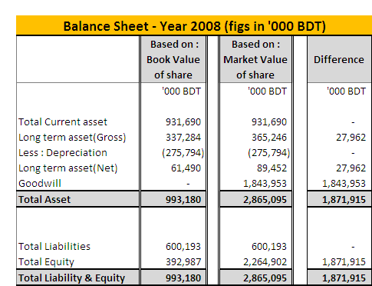
Original & Reconstructed Balance Sheet: 2008

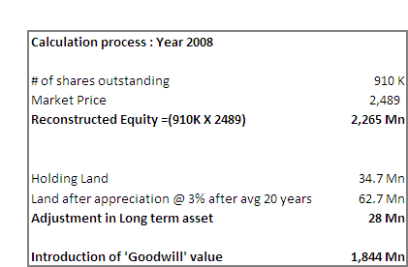

The changes made in the reconstruction are, an increase value in tangible asset as well as introduction of Goodwill as an intangible asset.

Increase value of Tangible Assets (Land) in Reconstructed Balance Sheet:

Naitonal Tubes Ltd is in this business since year 1964, and it’s most natural the company owned some land for business operation. By the accounting method the financial reports kept historical value of this property and considered historical purchasing value as current asset value, which is obviously understated and its current resell value would be higher than the reported one. Value of the tangible asset (Land) of the reconstructed balance sheet is increased by BDT 28 Million in 2008. Land & Building consists of 11% of fixed asset in 2008. Detail purchase time period information of Land is not given in the report. Hence, the appreciation amount is calculated assuming land value appreciates at 3% rate per year for average 20 years (company is operating the business for 45 years).

Introduction of Goodwill in Reconstructed Balance Sheet:

The intangible asset of the reconstructed balance sheet is increased by BDT 1,844 Million in year 2008 from goodwill. This is the main reason why book value per share of National Tubes limited differs from Market Value. It seems the shareholders are happy with the company’s performance, National Tubes has some positive information that has created higher confidence among investor, which leads to increase goodwill & market price. Reasons for the increased goodwill can be found in the company’s good financial performance analysis as well as prospect of future expansion of business.
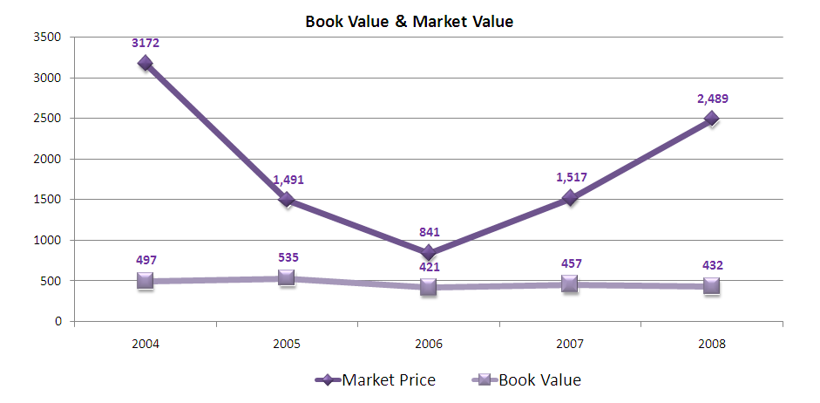
Book Value –v- Market value trend
The trend of book value is almost a linear line, where as Market value shows an interesting trend.
In Year 2004 Market value is more than 6 times higher than book value, but as the time goes difference between market value & book value gradually becomes lower, its mainly due to lower confidence level among the investors, and the company lost its goodwill. But onward 2007 market value has again in an increasing trend, mainly because of higher confidence among investor for its better financial performance. The better financial performance increases the goodwill of the company among the investors.

Performance Ratios: The reflection of reasons for increased goodwill is visible in the company’s performance ratios. Now let us see if the ratios of the company justify this staggering goodwill.

Profitability Ratio: The profitability Ratios show that Profit Margin, ROA, and ROE all are on the increasing trend from last year, before that company has all decreasing trend. Not only that, growth of Profit margin is sharply increased from year 2007 to year 2008. The company’s profitability growth is distinctly better in 2008 compared to performance of till year 2005-07.
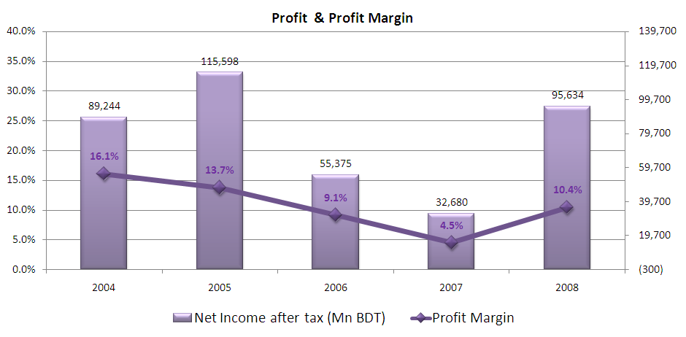
During year 2008 company achieved its target sales volume & sales revenue was higher then the previous year, at the same time National tube has achieved lower selling, administrative & distribution expense contribution (lower expense against per unit of sales). These reasons lead to the profit margin steep higher trend. ROA & ROE are also showing the promising state.
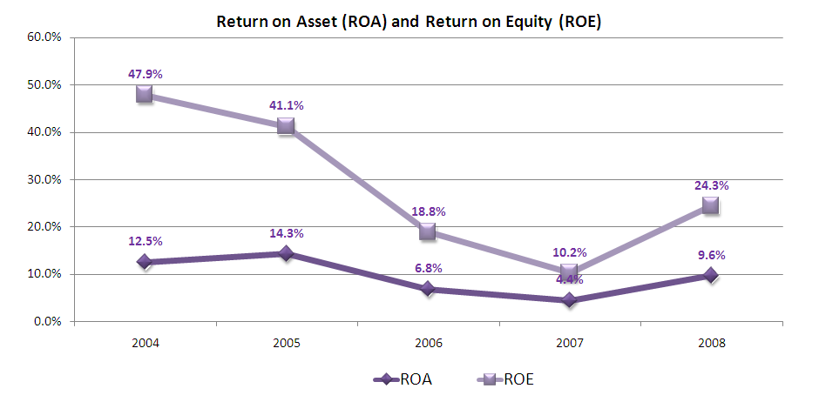
Asset Management Ratio: Though in year 2008 sales of the Company has showed good results in Asset management ratio shows that hampers the efficiency of asset management of the company. Days sales outstanding (DSO) has increased compared to last year as well indicating slower credit sales recovery due to higher amount of sales. Other Asset management ratios are also showing similar indication.
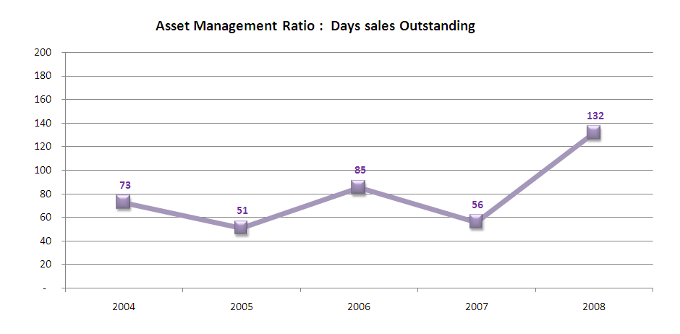

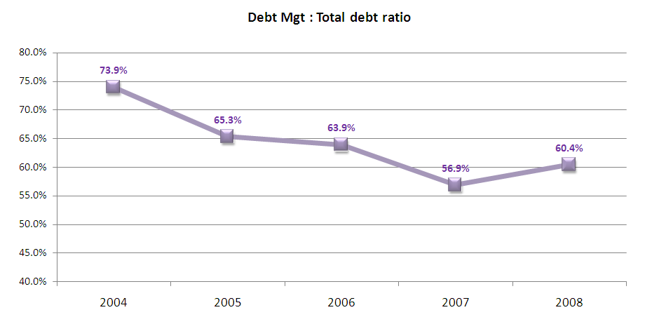
Debt Management Ratio: Some of the debt ratios indicate company’s better future whereas some do ratios do not shows the same opinion about the company’s performance. Debt ratio shows that company is gradually reducing its dependency on dept by increasing the equity amount, thought still it is comparatively higher than average. On the other hand, Times interest Earned & Cash Coverage ratio both shows poor performance in 2006-07 & 2007-08 than previous year, there is a gradual decreasing in the trend. Total picture is that, though company is increasing equity more than debt, but they are also getting the amount of debt in high interest rate.

Short Term Solvency Ratio Liquidity Ratio : The short term solvency ratios of also show stable performance. Considering the current ratio National tubes is more than well equipped to meet its short term obligations as ratio is always more than on an average 2. Thus the company is in strong position & has no chance of immediate Bankruptcy. These also boosts investors’ confidence & justifies the increase market price of National tube. On the contrary, Cash ratio of National Tubes is lower, as because most of there current asset is occupied in inventory & account receivables.
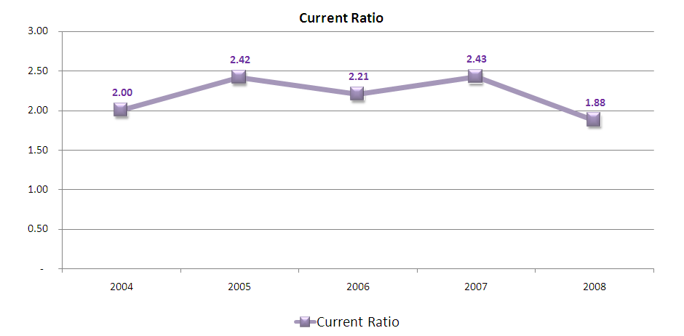

Though the company’s performances indicators as Asset management, Debt management & Liquidity ratios show mixed response, Profitability ratios are significantly improved in last year. This had a positive impact on its shareholders as the market price of this share really escalated to a higher level till now. This justifies the inclusion of Goodwill in the Reconstructed Balance Sheet.

- Analysis of Cash flow Statement:
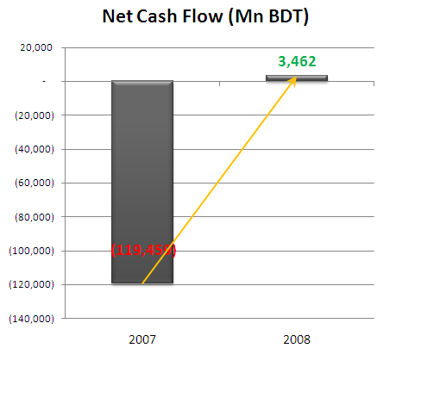
Cash flow statement shows in year 2007 the company has a net outflow scenario, but last year 2008 National tubes had a net inflow of cash. In Year 2008 total net cash inflow was BDT 3462 Mn.

The increase in cash inflow can be contributed to improved situation in cash flow from operating activities as well as cash inflow from financing activities. In year 2006-07 there was cash out flow of 115Mn from ‘operating activities’, but in year 2008 there is lower net cash outflow from operating activities. Again there is a huge cash inflow from financing activities which lead to have overall a net cash inflow in year 2008. In both year impact of cash flow from investment is similar.
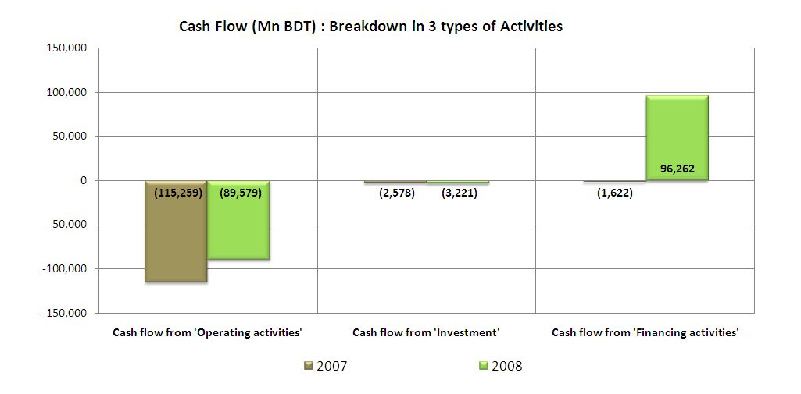
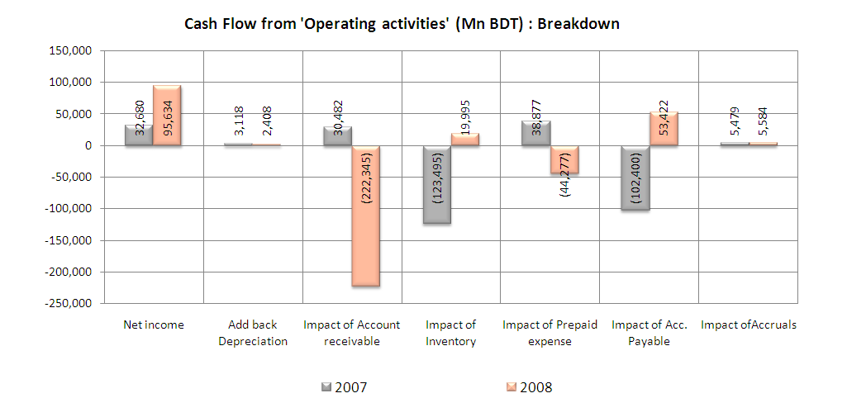
Cash flow from ‘Operating activities’:

As we know that to get a net cash inflow in year 2008, operating activities has a major role, we will further dig down on it. There is a higher net income in year 2008 which have some sort of importance of having net inflow in operating cash, but the main changes has occurred in inventory, account receivable & Account payable . In year 2007 National Tube has higher inventory which caused 123 MBn BDT cash outflow in year 2007. But in the next year they had higher sales and improvement in inventories turnover which caused 19995 Mn BDT cash inflow in year 2008.

High sales simultaneously caused higher account receivable. Impact on Account receivable showing a huge cash outflow, which can also be as interpreted as positive indication, as it show that there will be inflow cash in near future from Acc. receivable as company had a robust growth of sales as well as account receivable.

Impact on Account payable also showing a optimistic indication, as it show that in recent year there was inflow of cash from Acc. payable, which means company has higher production which leads to increase in short term payables. But the company have to monitor strongly that higher conversion of acc. receivable to cash as well as lowering acc. payable to avaiod insolvency as well as bankruptcy. Thus operating cash flow gives a positive indication to the investors to have faith on the company.

Cash flow from ‘Financing activities’:
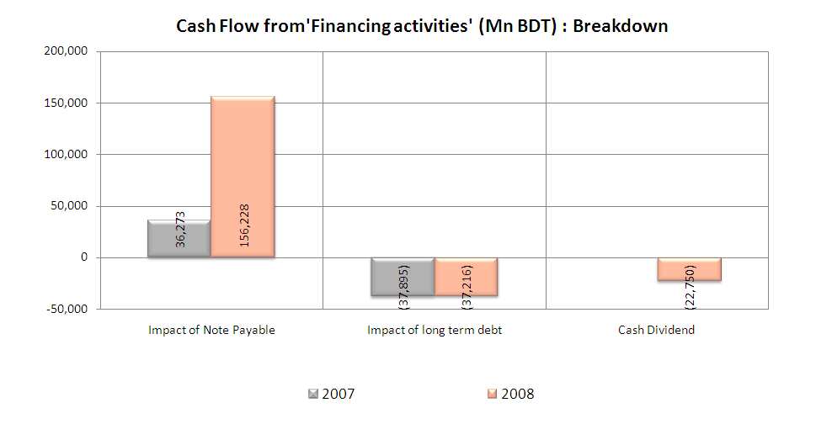
In financing activities in the most recent year net inflow was mainly from note payable to support the production & sales growth of the company which was required.

Investment Activities:
Cash flow from investment activities shows the company makes regular & steady investments, which indicates a long term plan of the company. For this potential future business plan, investors may also motivated about National tubes which leads to increase the market price/share compared to current book value/share of the company.

- Ratio Analysis :

Short-Term Solvency Ratio / Liquidity ratio:
The analysis commences with discussion of National Tube’s ‘liquid position’ with respect to its trends and its competitor Aziz Pipe company.

Current Ratio:
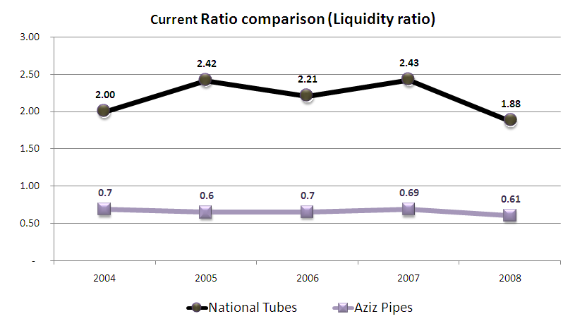
- Bench mark analysis:
From 2004-2007, National Tube Co. has maintained a current ratio of more than the Bench mark 2.0, in the most recent year it has fall down just below the benchmack
- Time series analysis:
National Tube’s current ratio exhibits a maintained trend, in most recent year it has gone down.

- Cross section analysis:
Notional tubes had higher current ratio than Aziz Pipe during last 5 years, as well as gap between them are stable in year by year comparison.
Quick (acid-test) Ratio:
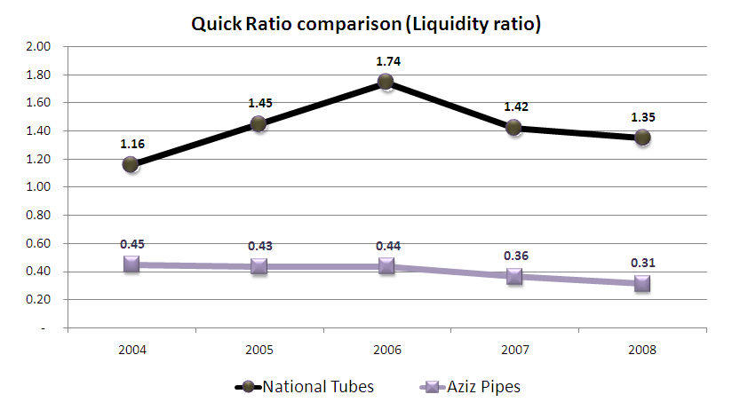
- Bench mark analysis:
Quick ratio of National Tube is higher than the bench mark, where as Aziz pipe has a lower quick ratio than bench mark ratio 1.0.

- Time series analysis:
National tube’s quick ratio has reducing trend in most recent years, but still they are in position to pay off its current liabilities without having to liquidate its inventories.

- Cross section analysis:

As like current ratio, National tubes also had higher quick ratio than Aziz Pipe during last 5 years, as well as gap between them are stable in year by year comparison.

Debt management:
This unit involves the deliberation on the extend to which National tube and Aziz pipe used debt, and if they are benefitted from the leverage:

Total Debt ratio :
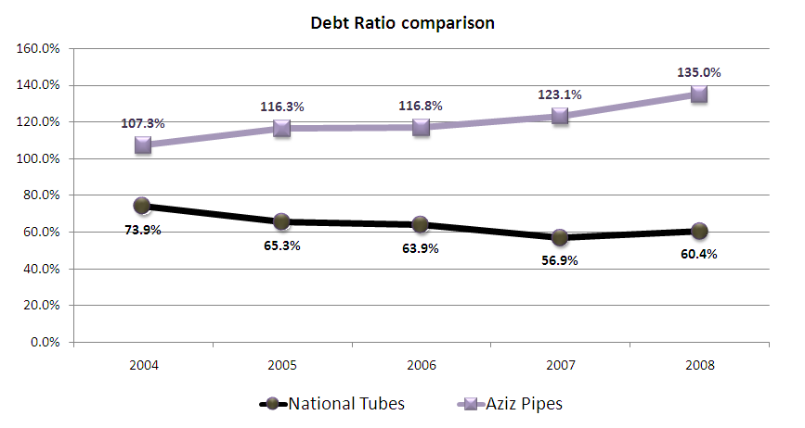
- Bench mark analysis:
The Bench mark debt ratio is 50% and National tube had a higher ratio, which might be alarming if not managed properly.
- Time series analysis:
Though National tube has poor Debt ratio, it is lower in year 2008 compared to year 2005. As most of the debt is current liabilities, it’s a positive sign in operation. Also it’s because they are issuing new shares and increasing equity portion as well as higher production is occurring to have higher acc. payable.

- Cross section analysis:
Both the companies are highly depended on debt, though majority of the debt are current liabilities. Compared to Aziz pipe, National tube has lower ratio. Aziz Pipe is in alarming position to be bankruptcy, as they has negative equity portion due to incurring huge loss each year, and getting more and more debt as source of fund.

TIE ratio:
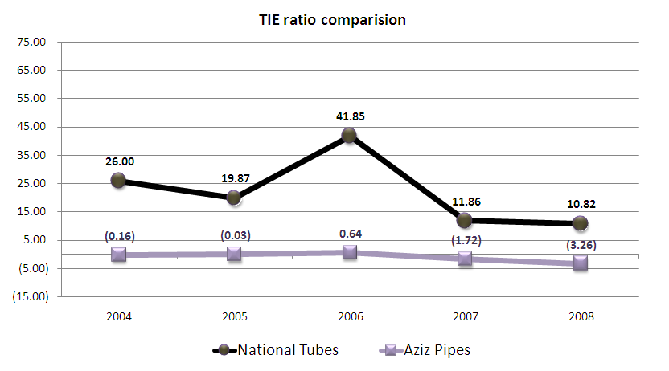

- Time series analysis:
As like poor debt ratio of National tube has a poor TIE ratio gives a negative vibe. To support the growth of the company it has incurred long term debt, and this helped to increase total revenue but at the same time interest has also increased at higher rate & so ratio has a decreasing trend.

- Cross section analysis:

National tube has better TIE ratio than Aziz pipe. In last 2 years Aziz pipe does not have profit, and at the same time they are incurring interest expense, so they have a negative TEI ratio. Aziz pipe is in a really vulnerable position and going to be bankrupt.

Asset Management:
Following section analyzes the effectiveness of the managing assets by Jamuna and Aziz pipe.

Inventory Turnover:

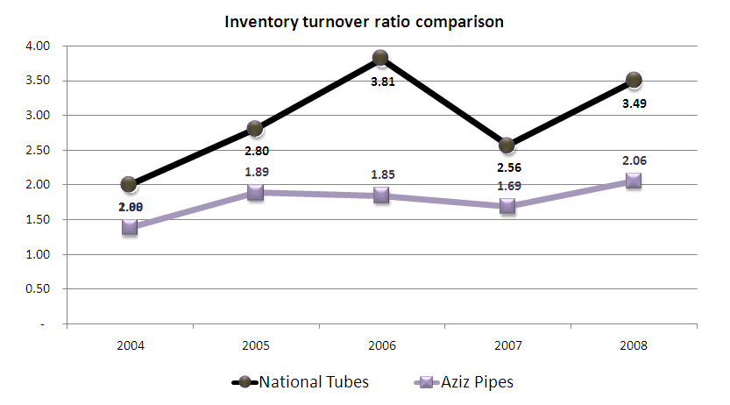
- Time series analysis:
Compared to 2007, in 2008 National Tubes has higher turnover reveals that they are efficiently selling and restocking their products than the last year.

- Cross section analysis:

Both the companies have similar pattern in the ratio. National tube’s inventory turnover ratio is higher then & steeper growth. Both the company had poorest inventory turn over in year 2004, and improved till year 2006, again both of them had lower inventory turnover in 2006, but year 2008 had better performance.
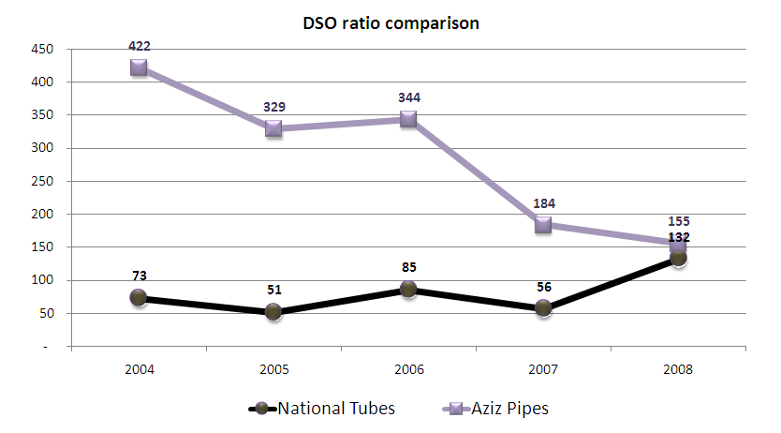
Day sales outstanding (DSO) :

- Time series analysis:
National tube’s Days sales outstanding (DSO) has increased in recent year drastically compared to last year as the company had higher sales which leads to a higher acc. receivable.

- Cross section analysis:
Compared to National tube, Aziz pipe’s DSO was much higher till year 2006. But in 2007 they have improved the performance of cash collection of acc. receivables. In last year both of the company has close DSO ratio.

Total Asset Turnover:

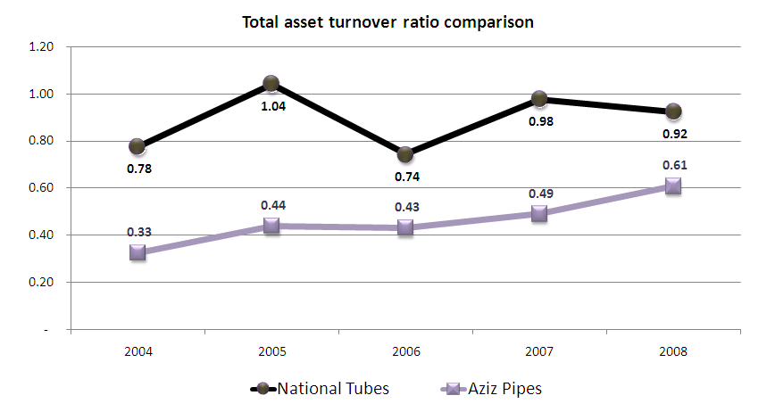
- Time series analysis:

With the time line National tube has almost stable total asset turnover ratio. Its because National tubes has increased their sales revenue with the almost same level of growth in asset in year 2007. In year 2008, growth of sales was comparatively higher than asset growth which caused slight drop down in ratio in year 2008.

- Cross section analysis:

Total asset turnover ratio shows significantly better performance of National tube comparing to Aziz pipe. Having twice of the asset amount of Aziz pipe, National tube has generated 3 times more amount of sales revenue.

Comments on overall asset management:
With a growth in sales National tubes had set a positive vide on efficiency in inventory, but at the same time high sales caused higher acc. receivable.
Profitability Performance:
Profit Margin:
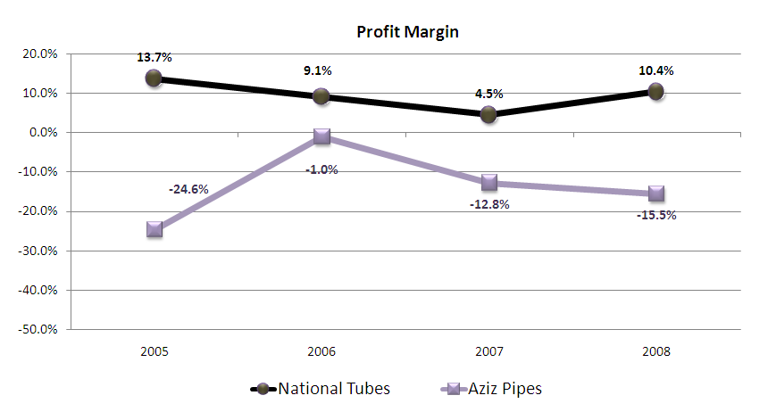
- Time series analysis:
The company’s profitability ratios are distinctly better in 2008 compared to performance of before year 2007. During year 2008 company achieved its target sales volume & sales revenue was higher then the previous year, at the same time National tube has achieved lower selling, administrative & distribution expense contribution (lower expense against per unit of sales). These reasons lead to the profit margin steep higher trend.

- Cross section analysis:

National tube’s profit margin trend is much higher than Aziz pipe, It is really very lucrative information for any investor. Aziz pipe is in a great trouble, as continuously they are incurring loss, and this trend shows that the company will fall into bankruptcy.

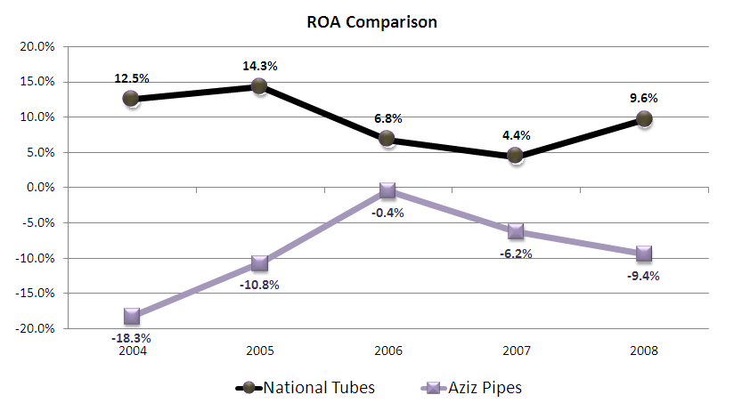
ROA:

- Time series analysis:

With a steady asset turnover & highly growing profit margin, overall ROA of National tube is also in high growth in year 2008.

- Cross section analysis:
As National tube has better ratio is Profit margin as well as Asset turnover ratio than Aziz pipe, National tubes had high above ROA than Aziz pipe. With of double amount of asset of Aziz pipe, National tube is generating 3 times more net income.

ROE:

- Cross section analysis:
As Aziz pipe had negative net income for a several period of time, their retained earning amount has become higher than common stock, so the equity amount of the Aziz pipe is negative. At the same time recent year profitability shows a negative value; so there is no meaning of calculating ROE of Aziz pipe as both the amount is negative.

Comments on overall profitability performance:

Quality inventory management, efficiency in cost control & gearing sales played key roles in ranking outstanding profitability performance of National tube in year 2008.

Market Value Measures:
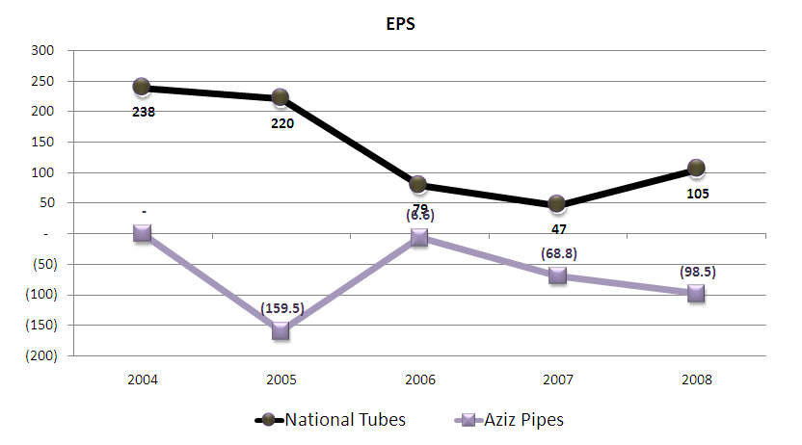
EPS & P-E ratio :

Time series / Cross section analysis:
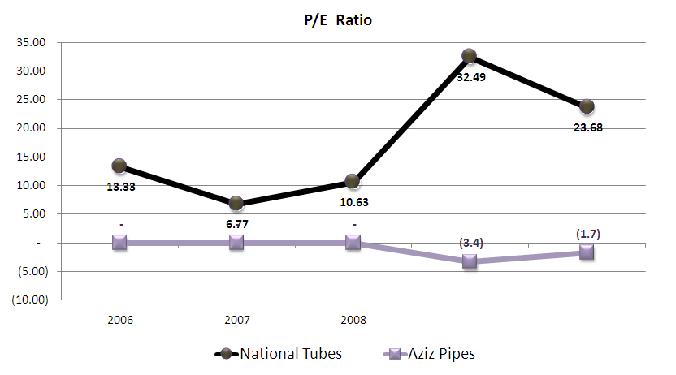
In 2006, National tubes profit has gone down drastically, so market price has also fallen but not at the same rate, which leads to a increase in P/E ratio. In Year 2007, profit was further lower, but market price has increased so P/E ratio has increased highly. Thought lower profit price did not reduced may be investor got some positive signal for future that the company had huge pile of inventory, and this would generate more revenue for the next year with out investing huge amount in inventory, and that may lead the market price high for year 2007. In year 2008 profit has increased, and so market price. Compared to year 2007, in year 2008 company had 3 times more net profit, and at the same time due to higher profit market price has also increased by twice but not 3 times, which lead to a reduction in P/E ratio of National tubes.
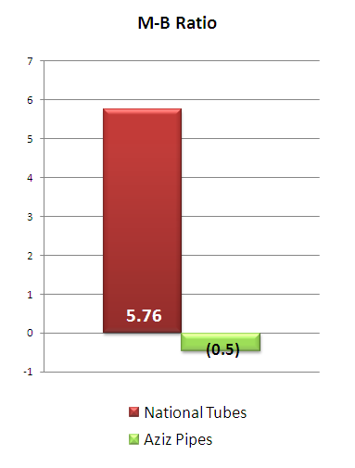
M-B Ratio:
- Cross section analysis:
With an M-B of -0.5 in 2008 and a negative growth , Aziz pipe’s M-B ratio is lower than that of National tube of the same year. This lead to the fact that, present and potential investors are willing to pay more for National tube than for the other pipe manufacturing firms.

- Time series analysis:

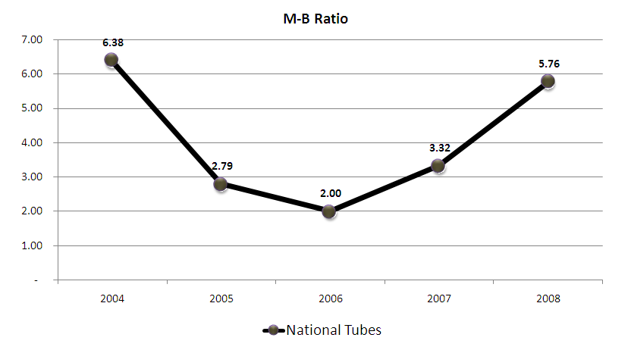
Time series analysis of M-B ratio shows that from year 2004 to year 2006 investors gradually find lack of confidence on future performance of National tubes as net income trend has a negative trend, but from year 2007 it has increased due to their higher production & inventory and in year 2008 it has further increased as investors know than production cost would be lower as the company has already had higher production inventory and sales revenue would be higher.

Chapter 3
Enquiry into Stock price movement
In this chapter we will consider only the stock price movement of the year 2007-2008. Daily stock price is affected due to various factors that can be a macroeconomic variable as well as company specific variable. But in this section we will consider only the corporate decision factors.
Variables can be some the following ones:
- Dividend declaration
- EPS
- Retained earnings
- Capital structure decisions etc
First we will look at the price for the year of 2007.
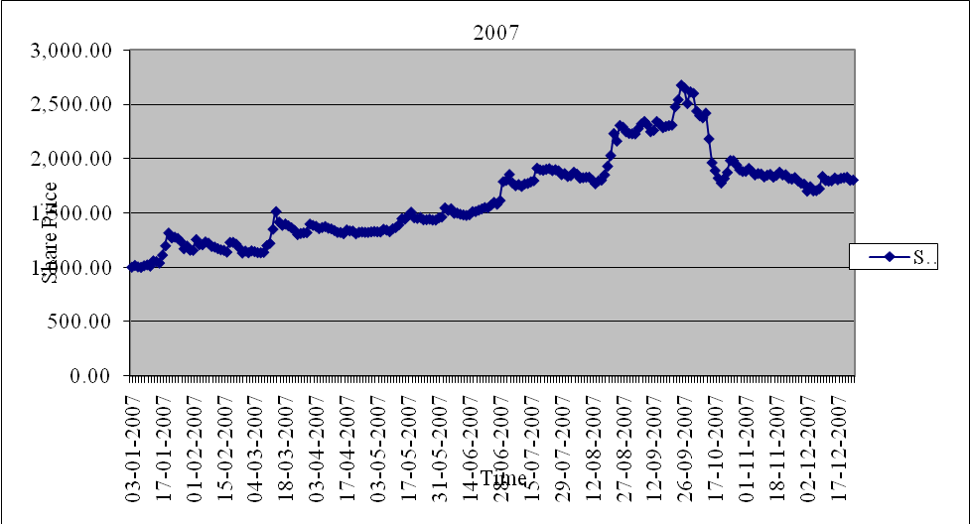

We can see that the price of National Tubes rose continuously throughout the year till the 1st part of august. DSE inquiry tells us that there was no sensitive price information that was undisclosed for the price hike that we see. We can see a significant rise around mid September. We can only conclude that there was a rumor about the dividend declaration that the dividend will be paid very soon. As a result investors started to buy this share which pushed up the share price. Then on 1/10/2007 the company board of directors declared a Cash Dividend @ 10% and Stock Dividend @ 30% for the year 2006- 2007. On 23/09/2007 share price rose by maximum amount of 7.26% within 1 month prior to the dividend declaration date. Then from the date of dividend declaration the stock price started to fall because the investors then started to get rid of the shares. But there is also another factor which accelerated the share price fall is the declaration of lower EPS compared to the earlier year. On 8/10/2007 it was declared that the EPS for this year is 47.26 tk. Compared to earlier year’s EPS of 77.55 tk. After that day investors wanted to get rid of the shares of National Tubes. As a result share price fell even more. So, after the dividend declaration and the declaration of EPS the share lost 31.64% of its value. These are the only significant issue for the year 2007 that affected the stock price of national tubes.
Now for the price of 2008
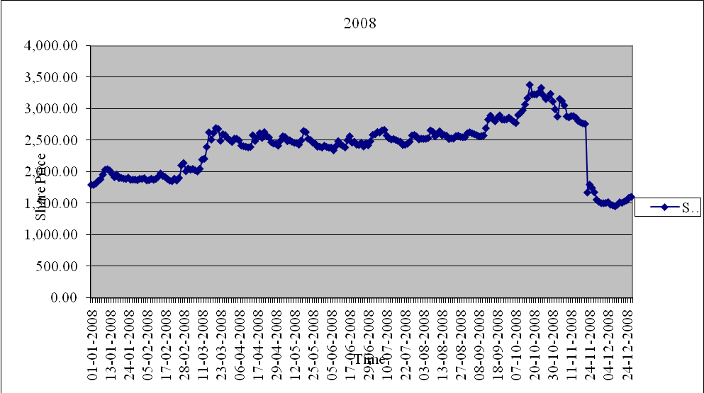
We can see that throughout the year the stock price remained stable but on 9/11/2008 the board of directors announced Cash Dividend @ 25% and Stock Dividend @ 50% for the year 2007- 2008. As a result return on that particular day was 9.8%. But after that day the stock price started to fall as s result of the Ex-date phenomenon.
There is an interesting finding here to be looked at. On 9/11/2008 the company announced a sharp rise in its EPS from the previous year’s EPS. Last year’s EPS was 41.62 tk. And this year’s EPS is 117.18 tk. Although this is a sign for the improved performance of the company the share price fell by 5.75% on the day of declaration.
Also, another interesting finding could be found here. The record date for the dividend declaration was 20/11/2008. But on 19/11/2008 it was declared that on the record date the trading of the share will remain suspended till 23/11/2008 after the record date. When the share trading resumed on 23/11/2008, price of the share fell on that day by 39.55%. this can be noticed in the graph by a significant drop at the end part of the share price movement graph.
We will now take a functional approach to the matter of announcement of EPS for the year.
We have taken the announcement of EPS on 9/11/2008 an important factor which affected the stock price during that period. A regression analysis is done using dummy variable. The regression output summary follows:
Variable | Coefficient | Std. Error | t-Statistic | Prob.
Intercept | 3172.861 | 28.23300 | 112.3813 | 0.0000
Dummy | -986.9137 | 149.8319 | -6.586808 | 0.0000
R-squared | 0.541000 | Mean dependent variable |  | 2666.068
Adjusted R-squared | 0.527885 | S.D. dependent variable |  | 679.8946
S.E. of regression | 467.1596 | Akaike info criterion |  | 15.18376
Sum squared residual | 7638333. | Schwarz criterion |  | 15.27083
Log likelihood | -278.8995 | F-statistic |  | 41.25269
Durbin-Watson stat | 0.279355 | Prob. (F-statistic) |  | 0.000000
We can see that the t-statistic of the slope coefficient has a P-value of 0% at 5% significance level. Also the R-square is very high of 54.1%. and we can say that the model is stable because the F-statistic has P-value of 0% at 5% significant level. So we can say that the t-statistic and F-statistic is statistically significant. So, there is a significant price fluctuation after the declaration of the EPS increase on the date 9/11/2008. And the negative slope indicates that the investors took the news badly somehow and started to dispose the shares and as a result share price started to fall.

Chapter 4
Capital Investment Decision

The investment decision is one of the crucial decisions of modern business. Investments on assets can be many things like as buildings or machinery, patents, software and even in financial assets. Assets are used to perform and make sales for the company and earn profit. When deciding about investment decisions its important to calculate the NPV of the investment as well as the capital structure and also the cost of capital of the project
National Tubes Limited is a company that hasn’t undergone any major investment during the period observed 2002-2008. Therefore we have taken a hypothesis situation of a capital investment for the company in the year 2010. And from 2011 the company will start to operate on the investment. This is a 5 year project. Because the industry national tube is in is saturated and there is not much scope for R & D and marketing research. We will not consider the test part of the whole project. Rather the project will start from 2010 till 2016.
The company is investing in new form of pipe. It is unique in its nature. The production and sales target is 500 metric ton for the coming years.
For this particular case the capital investment is into new machines imported from USA which is specialized in making this kind of pipes in USA. In this case the total investment for this project is 180,000,000 taka. Since this new kind of product for National Tube is going to launch in this project at first we assumed that the company will not achieve more than 20% of the total market size of this product.
The product itself is a established product. With slight differentiated version of this product National Tubes is going to launch it in this project. There is no scope for failure. Since the high demand actually led National Tubes to undergo this huge investment, the management is confident that the investment will fetch a positive value to the company.
Among the most important assumptions, one is that the cost of capital is 13%.

Income Statement of the Project:
Particulars | Assumptions | Year 2010 (taka) | Year 2011-2015 (taka)
Market Size | 2500 metric ton
Market Share | 20% |  | 500 metric ton
Investment | 180 million taka | (180,000,000)
Sales |  |  | 150,000,000
Variable Cost | 32% of Sales |  | (48,000,000)
Fixed Cost | 17 million taka |  | (17,000,000)
EBITDA |  |  | 85,000,000
Less: Depreciation | 180,000,000/5 |  | (36,000,000)
EBIT |  |  | 49,000,000
Tax @ 40% |  |  | (19,600,000)
Net Income |  |  | 29,400,000
Add: Depreciation |  |  | 36,000,000
Cash Flow |  |  | 65,400,000

So, the project NPV at 2010 is, NPV₂₀₁₀ = - 180,000,000 + 65,400,000 * (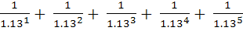)
NPV₂₀₁₀ = -180,000,000 + 65,400,000 * 3.517
= 50,011,800 tk.
So, the NPV of the project is 50,011,800 taka.
Sensitivity Analysis
Now we would like to test the sensitivity of NPV to various inputs of the project. Because we need to know what happens to NPV if some inputs change. This helps give us better understanding of the projects situation to sustain the NPV.
Figures in taka
Sales | 120,000,000 | 150,000,000 | 180,000,000
Percentage change | -20% |  | 20%
NPV | 6,963,720 | 50,011,800 | 93,059,880
Percentage change | -86.08% |  | 86.08%
Relative change | 4.3 |  | 4.3
Fixed Cost | 13,600,000 | 17,000,000 | 20,400,000
% change | -20% |  | 20%
NPV | 57,186,480.00 | 50,011,800 | 42,837,120
% Change | 14.35% |  | -14.35%
Relative change | -0.72 |  | -0.72

From the above analysis we can see that NPV is very sensitive to change in sales but not so much sensitive to the change of fixed cost. NPV changes 4.3% similarly for a 1% change in sales. Whereas, NPV changes 0.72% in the opposite way when fixed cost changes by 1%. Changes in these two variables affect substantially the project and it’s NPV.
New share price = (current capitalization + NPV of the project) / shares outstanding
= (market price per share on the last day of 2008 * shares outstanding +NPV) / shares outstanding
= (1602.50*910,000 + 50,011,800) / 910,000
= 1657.46 taka per share
From the new share price we can see that the project will add value to the company slightly.
Scenario Analysis
For scenario analysis we took three cases
- Pessimistic
- Expected
- Optimistic situation
We will assume that only sales are taken for the scenario analysis. The whole income statement is vertical size statement. Then after calculating the NPV for three scenarios of sales we will find the share price.
We took that in pessimistic scenario sales will drop by 6% and in optimistic scenario sales will increase by 6%.
 | Pessimistic (-6%) | Expected | Optimistic (6%)
Sales | 141,000,000 | 150,000,000 | 159,000,000
Variable Cost | (45,120,000) | (48,000,000) | (50,880,000)
Fixed Cost | (17,000,000) | (17,000,000) | (17,000,000
EBITDA | 78,880,000 | 85,000,000 | 91,120,000
Less: Depreciation | (36,000,000) | (36,000,000) | (36,000,000)
EBIT | 42,880,000 | 49,000,000 | 55,120,000
Tax @ 40% | (17,152,000) | (19,600,000) | (22,048,000)
Net Income | 25,728,000 | 29,400,000 | 33,072,000
Add: Depreciation | 36,000,000 | 36,000,000 | 36,000,000
Cash Flow | 61,728,000 | 65,400,000 | 69,072,000

Now, if we calculate the NPV of these three scenarios we can see that,
NPV_{pessimistic} = 37,097,376 taka
NPV_{optimistic} = 62,926,224 taka
Now we can calculate the future stock price for these three scenarios using the new share price finding process shown earlier in this chapter.
Pessimistic share price = (1602.50*910,000 + 37,097,376) / 910,000 = 1643.26 taka
Optimistic share price = (1602.50*910,000 + 62,926,224) / 910,000 = 1671.65 taka
Expected share price (found earlier) = 1657.46 taka
We can see that according to NPV the future market price of the company changes.

Chapter 5
Prospective Analysis

With the different factors positively contribute to the growth of the stock price of National Tubes, we have analyzed the trend of different variables from the five year financial statement and detected the growth or reduction of every item. After that we have selected few components which show a growing trend and positively contribute to the growth of Stock Price.

As we found that for National Tubes, Market price movement is mostly similar with company’s financial performance as like sales growth & profit growth.
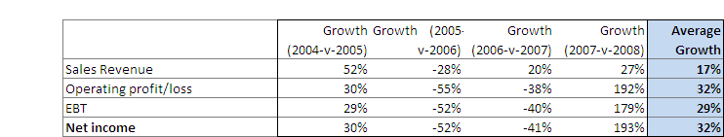

From the income statement we can concentrate on growth rates of sales revenue, operating profit,
EBT and Net income. We are concentrating on average of last 4 years growth performance. From here we will use avg sales growth of 17% for forecasting future market price. As growth rate of operating profit, EBT and Net income is close in figure, we are going to use avg net income growth of 32% for forecast the market price trend.

As the world economy is experiencing the recession and the impact of recession is also started affecting our economy, so it will be a highly optimistic choice if we expect that the company will grow at the rate of 17% or 32%. On the other hand, the other growth rates that have been calculated also give us the indication that we cannot consider them as company growth rate given GDP growth of Bangladesh is 5.5% and world economy is in recession. We can assume that average growth rate for forecasting the share price & value of the company.
Growth Rate : Scenario -1
Assuming growth rate of 17% as average of last 4 years growth of Sales
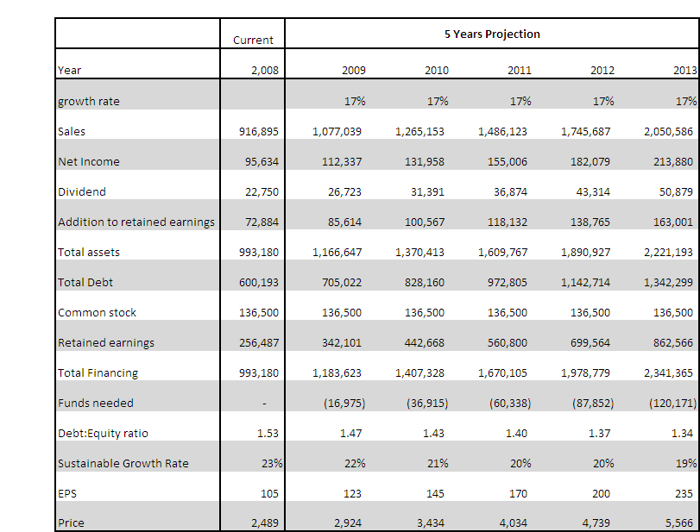

Assuming 17% growth rate, it has been found that the company has excess fund, which can be financed distributed to payoff long term debt and reduce the obligations of interest expenses. The projection says that assuming 17% growth rate, after 5 years in 2013 EPS of the company would be 235 as well as considering current P/E ratio as constant factor, in year 2013 share price would be 5,566.

Growth Rate : Scenario -2
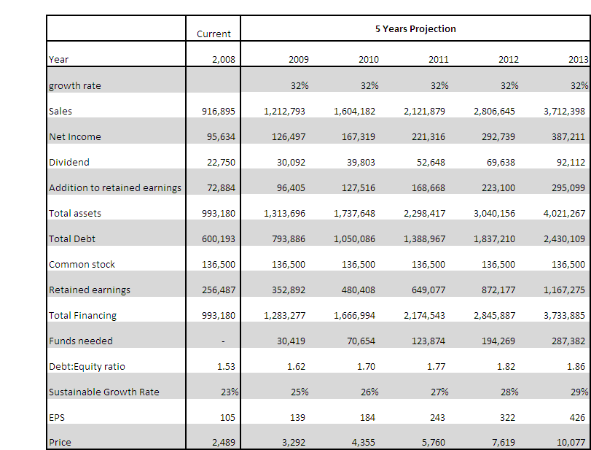
Assuming growth rate of 32% as average of last 4 years growth of Net income

Assuming 32% growth rate, it has been found that the company required additional fund to run to sustain the business in this growth rate. The projection says that assuming 32% growth rate, after 5 years in 2013 EPS of the company would be 426 as well as considering current P/E ratio as constant factor, in year 2013 share price would be 10077.

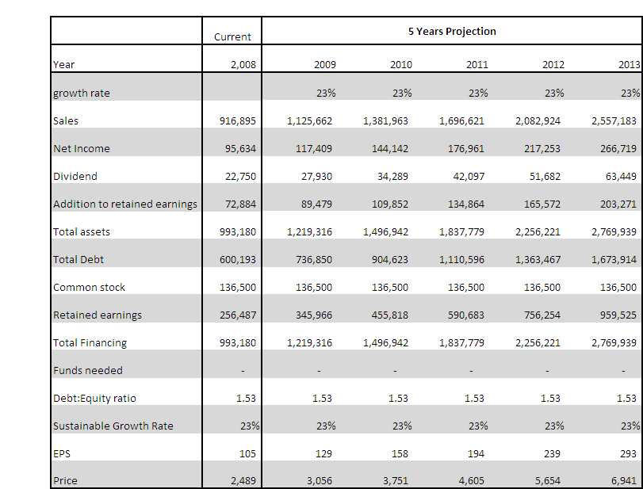
Growth Rate : Scenario -3
Assuming growth rate of 23% as sustainable growth rate

Assuming 23% growth rate, it has been found that the company has no excess fund or no deficite . The projection says that assuming 23% growth rate, after 5 years in 2013 EPS of the company would be 293 as well as considering current P/E ratio as constant factor, in year 2013 share price would be 6941.

Growth Rate : Scenario -4
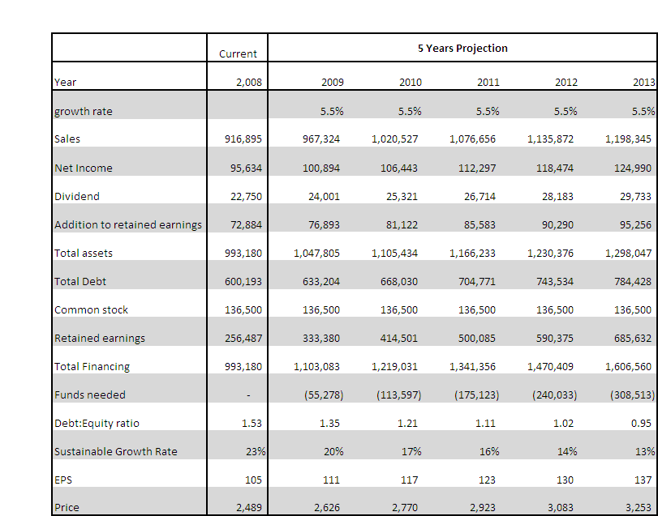
Assuming growth rate of 5.5% as GDP growth rate

Assuming realistic one 5.5% growth rate, it has been found that the company has excess fund, which can be financed distributed to payoff long term debt and reduce the obligations of interest expenses. The projection says that assuming 5.5% growth rate, after 5 years in 2013 EPS of the company would be 137 as well as considering current P/E ratio as constant factor, in year 2013 share price would be 3253.

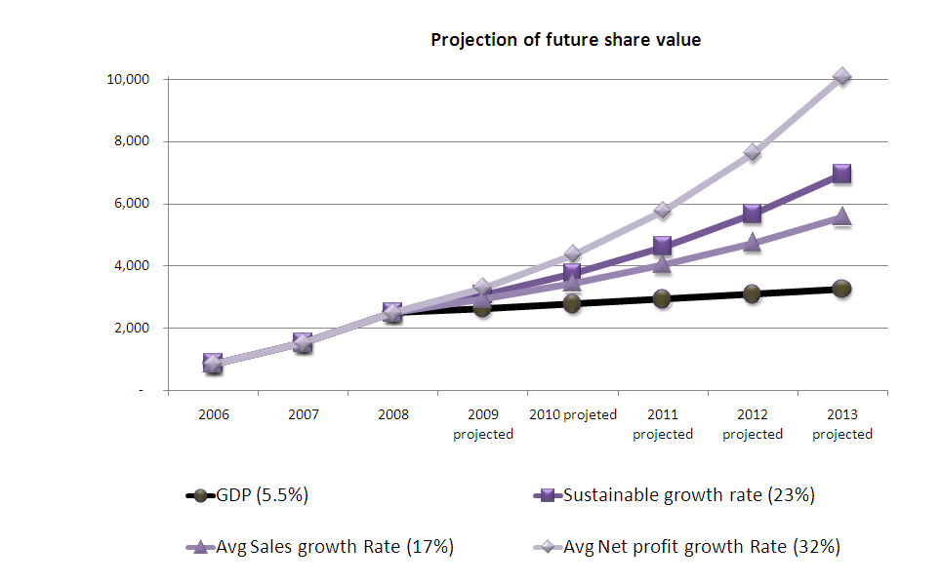
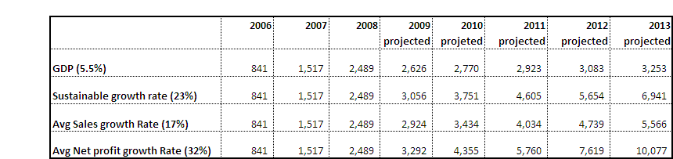
Future Market Price projection in different growth Rate :

Which growth rate assumption is more appropriate?
Considering current world wide economic condition, Bangladesh GDP growth rate of 5.5% as a assumption would be most appropriate, as due to recession period it would be very optimistic to assume higher growth rate.

Plug Variables
The pro forma statements from the above section indicate the firm will have excess fund if it will grow at all options as all growth rates are lower than the sustainable growth rate of 23%. The company can decrease its long term debts by the extra fund, thus will decrease the debt equity ratio. As the company decided to maintain a constant retention rate, it ends up with extra fund at the end of the year. In the current recession of economy, it will be risky to do any new investment. So, the company can payoff its debt which will give an encouraging signal to the shareholders. The table below lists the change is capital structure of the company.

The assumptions are made in preparing the pro forma income statement and balance sheet & projecting future share price.
- Initially all assets, including fixed assets, accounts payable vary directly with sales.
- Long term debt and common stock won’t vary with sales as management decision is to keep a constant long term debt and common stock.
- As the company decided to maintain a constant retention rate, the company will pay dividend every year at the same rate.

Scenario Analysis
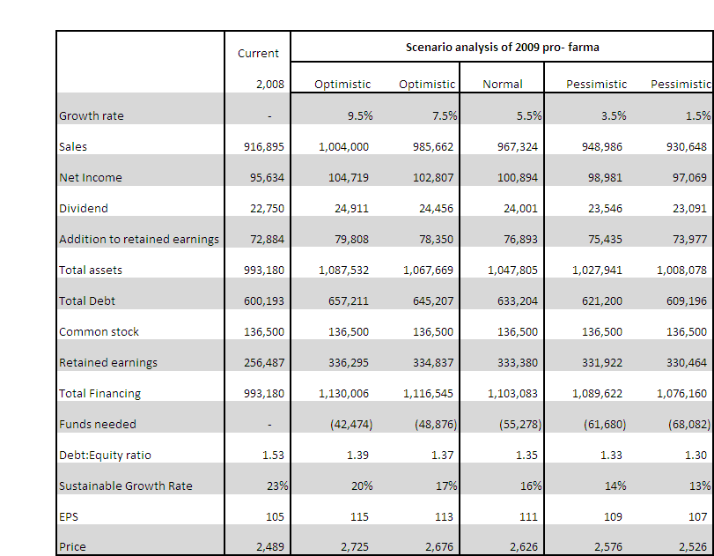
In this case study, the growth rate of 5.5% has been selected as the constant growth rate and the pro forma statement has been generated based on this growth rate. For scenario analysis, both optimistic and pessimistic scenarios are being considered.
In the above scenario analysis, we have taken the 5.5% growth rate in normal situation. If we want to be optimistic enough to predict that the economy will have a high growth and the company will also able to grow at 9.5% to 7.5%. On the other hand, the situation can also be worse enough to have a growth lower than the normal and the company may face a growth of 3.5% or even 1.5%. After analyzing the scenario of different situation we can say that the projected growth rate is appropriate for the company which will help the company to operate in the market even if the situation is worse. It gives a positive indication towards the company and increases the shareholders confidence to invest in the company’s share.
Chapter 6
Findings & Conclusion

National tube Ltd. is in this business since 1964,. Current market price/share of National Tube is BDT 2489; on the other hand company’s book value is only BDT 432, which means market price is more than 5 times higher than the book value; and it tells as there is some positive information in company’s financial performance which leads the M-B Value 5.76. Based on market price if we re-construct the balance sheet, we are have to introduce ‘Goodwill’ as intangible asset, for National tube the value of goodwill comes BDT 1.8 Bn, this goodwill basically shows the confidence of the shareholders & investors on National tube backed by some positive news. What are those positive news that boost the confidence of the investors?

The profitability Ratios show that Profit Margin, ROA, and ROE all are on the increasing trend from last year, before that company has all decreasing trend. Not only that, growth of Profit margin is sharply increased from year 2007 to year 2008. The company’s profitability growth is distinctly better in 2008 compared to performance of till year 2005-07.

During year 2008 company achieved its target sales volume & sales revenue was higher then the previous year, at the same time National tube has achieved lower selling, administrative & distribution expense contribution (lower expense against per unit of sales). These reasons lead to the profit margin steep higher trend. ROA & ROE are also showing the promising state.

Though the company’s performances indicators as Asset management, Debt management & Liquidity ratios show mixed response, Profitability ratios are significantly improved in last year. This had a positive impact on its shareholders as the market price of this share really escalated to a higher level till now. This justifies the inclusion of Goodwill in the Reconstructed Balance Sheet.
Cash flow statement shows in year 2007 the company has a net outflow scenario, but last year 2008 National tubes had a net inflow of cash. In Year 2008 total net cash inflow was BDT 3462 Mn. The increase in cash inflow can be contributed to improved situation in cash flow from operating activities as well as cash inflow from financing activities. In year 2006-07 there was cash out flow of 115Mn from ‘operating activities’, but in year 2008 there is lower net cash outflow from operating activities. Again there is a huge cash inflow from financing activities which lead to have overall a net cash inflow in year 2008. In both year impact of cash flow from investment is similar.

In comparison with direct competitor, Aziz Pipes, due to Quality inventory management, efficiency in cost control & gearing sales played key roles for National Tubes in ranking outstanding profitability performance of National tube in year 2008.

Time series analysis of M-B ratio shows that from year 2004 to year 2006 investors gradually find lack of confidence on future performance of National tubes as net income trend has a negative trend, but from year 2007 it has increased due to their higher production & inventory and in year 2008 it has further increased as investors know than production cost would be lower as the company has already had higher production inventory and sales revenue would be higher.

We have seen that dividend declaration had a significant effect on the share price of National Tubes in the year 2007 and 2008. Price fluctuated after the dividend was declared both in the years.
Price fell enormously when the declaration was made that at the record date the trading of the share would be suspended.
Using dummy variable to find effects of EPS declaration was a success in 2008. The slope coefficient’s t-statistic’s P-value is found to be 0%. This means there is statistical significance that EPS declaration has strong correlation with the share price. But the slope coefficient’s sign says that when EPS was declared, it showed that EPS rose from the previous year. But the share price fell. This part of the change of share price remains unexplained.
We assumed a hypothetical situation of capital investment for National Tubes. The project turned out to have a positive NPV of 50,011,800 tk. So it’s a project that adds value to the company.
Incorporating the value of the project in the share price result is a share price of 1657.46 taka. This is higher than the market price of 1602.5 taka in the last trading day of 2008. This shows that the project adds value to the wealth of the shareholders.
From the sensitivity analysis we can see that for 1% change in sales NPV changes 4.3% is the same direction. And for 1% change in fixed cost NPV changes by 0.72% in the opposite way. This means that NPV is more sensitive toward the change of sales than in the change of fixed cost.
The scenario analysis shows that under pessimistic scenario of sales variable NPV becomes 37,097,376 taka and the future share price becomes 1643.26 taka. And optimistic scenario of sales variable results in a NPV of 62,926,224 taka and future price of share becomes 1671.65 taka. This shows how changes in sales in different situation can affect the project, its NPV and the future market price per share. But in this case it is satisfactory that sales change doesn’t affect the share price of the company to a great extent. This can mean that the company has a diversified way to do their business that a single project is not that much strong to affect the company’s price per share.
In projecting future market price, assuming realistic one 5.5% growth rate, it has been found that the company has excess fund, which can be financed distributed to payoff long term debt and reduce the obligations of interest expenses. The projection says that assuming 5.5% growth rate, after 5 years in 2013 EPS of the company would be 137 as well as considering current P/E ratio as constant factor, in year 2013 share price would be 3253.

Initially we assumed many growth variables, but Which growth rate assumption is more appropriate? Considering current world wide economic condition, Bangladesh GDP growth rate of 5.5% as a assumption would be most appropriate, as due to recession period it would be very optimistic to assume higher growth rate.

